**Fish Profiles**

Literature Colorcoding: Western Baltic= dark blue; Central Baltic/Kattegat-Skagerrak= light blue; North Sea= yellow; North Atlantic/Atlantic= orange; Other areas/area not specified= red

**Dorsch - Atlantic cod (*Gadus morhua*) – focus on Western Baltic cod**

**Additional information**

|  |  |
| --- | --- |
| **Distribution range in the Western Baltic Sea** | * Western Baltic cod is distributed throughout the area: Sound, Belt Sea, Arkona Basin (McQueen et al. 2018) |
| **Stock size** | * SSB fluctuated around Blim since 2009, increased in the last years and is presently below Blim and below MSY Btrigger (ICES 2019; ICES 2021a), SSB 2022 forecast = 7,879 t (ICES 2021a)   BMSY=2\*Bpa (Froese et al. 2021)  MSY Btrigger=Bpa= 23,492 t (cannot be achieved in 2023 even with zero catch in 2022) (ICES 2021a)   * B/BMSY=0.17 (Western Baltic Sea) |
| **Recruitment** | * WBC recruitment has been low since 1999, in 2018 and 2019, recruitment was lowest within time series (age-1) (ICES 2019) |
| **Growth** | * Growth rates are dependent on temperature and stock. WBC: 145 mm/year on average (McQueen et al. 2020) |
| * Two genetically distinct stocks in the Baltic Sea: The Western Baltic Sea is dominated by the Western Baltic cod (WBC) with its core area in SD 22 & 24, while the Eastern Baltic cod (EBC; *Gadus morhua callarias*) inhabits mainly the central Baltic Sea east of Bornholm in ICES SD 25-32 (Bleil et al. 2009) * Core area of mixing of both stocks is the Arkona Basin (SD 24) (Eero et al. 2014) * WBC spawning takes place in the deeper, saline waters of the Kattegat, the Sound, the Little and Great Belt, the Kiel Bay, the Fehmarn Belt, and the Mecklenburg Bay and eventually in the Arkona Basin (Bleil et al. 2009; Hüssy 2011; Vitale et al. 2008) | |

**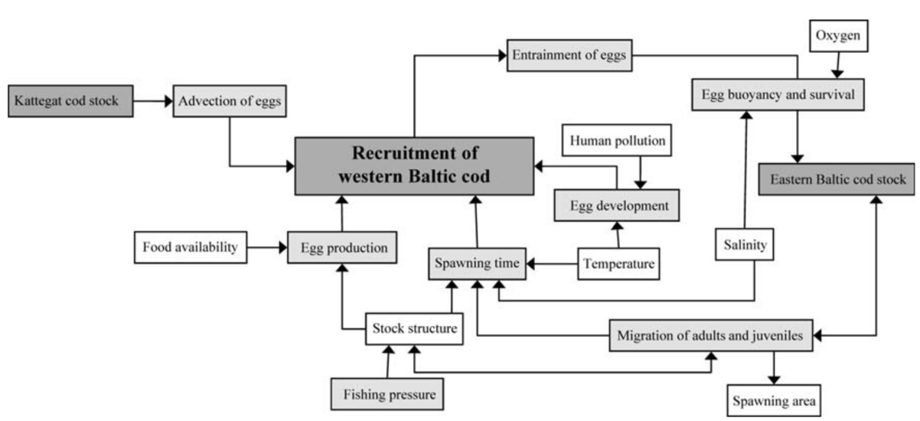**

Figure 1: Flowchart of processes and variables influencing western Baltic cod recruitment dynamics. Dark grey, cod stocks; light grey, processes; white, parameters. (Hüssy 2011)

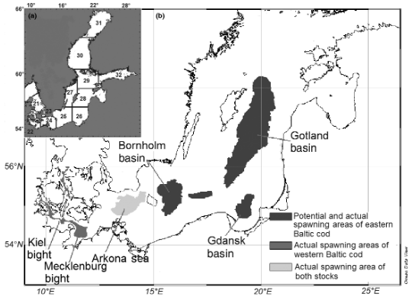

Figure 2: Current and potential spawning grounds of cod in the Baltic Sea. (Bleil et al. 2009)

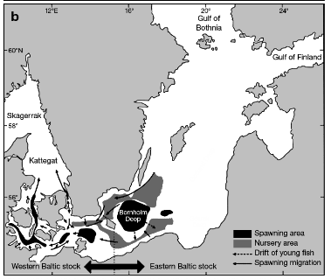

Figure 3: Spawning and nursery areas of the Western and Eastern Baltic cod stocks also including information on juvenile and adult migration. (Cardinale and Svedäng 2011)

Hüssy

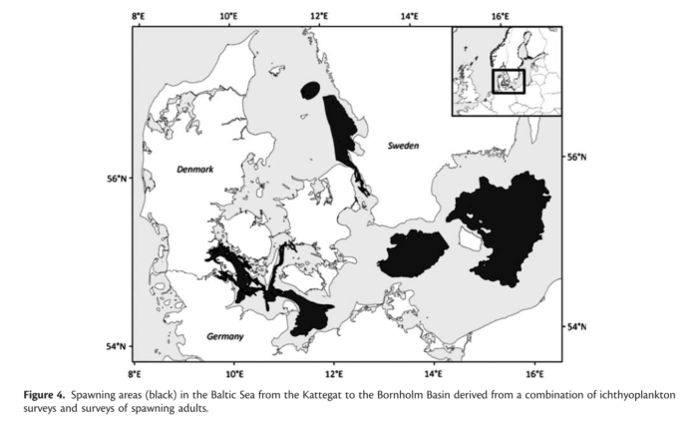(Hüssy 2011)

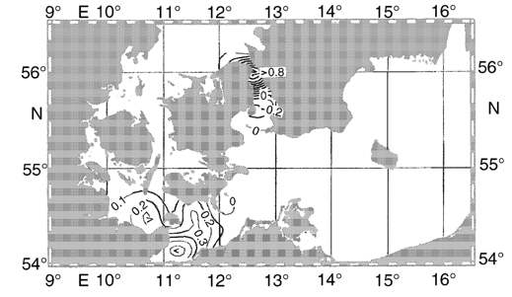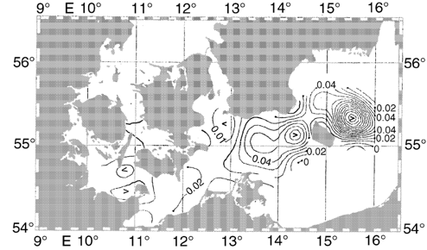

Horizontal distribution of tracers representing cod eggs Figure 5: Horizontal distribution of tracers representing cod eggs and young larvae initially released within the spawning grounds of western Baltic cod stock on 5 January of each year at (a) the end of January 1988 (contour interval 0.01 nm-3), and (b) the end of January 1993 (contour interval 0.01 nm-3). (Hinrichsen et al. 2001)

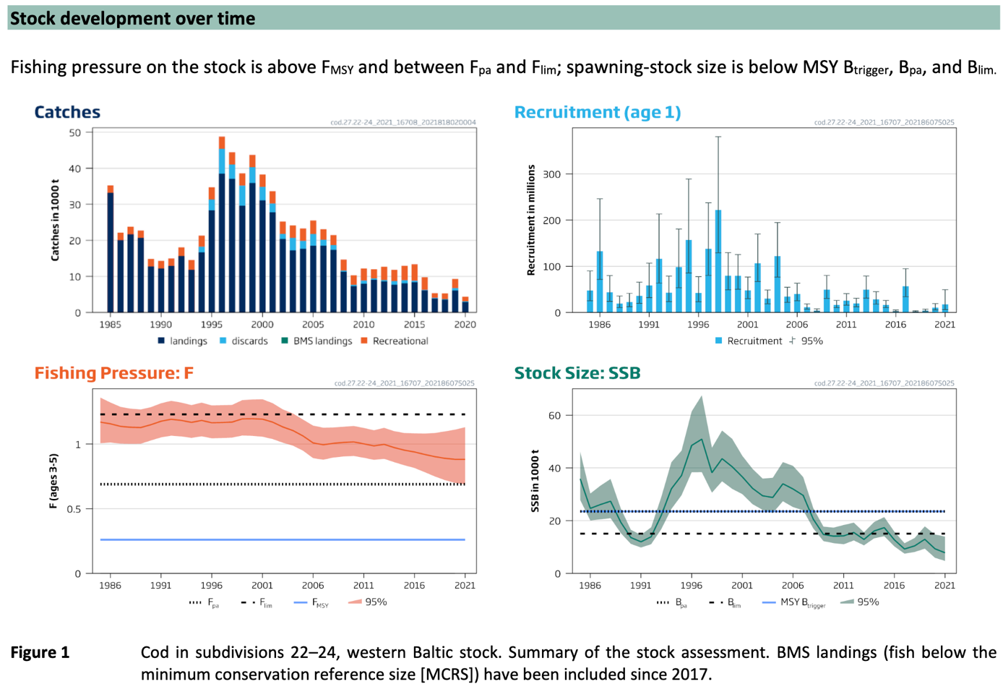

(ICES 2021a)

**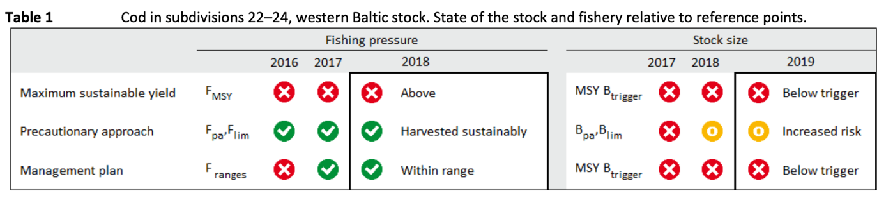**

(ICES 2019)

|  |  |
| --- | --- |
| Sensitivity attributes | Information: Western Baltic cod |
| Habitat specificity | * Spawning: salinity 18-33 psu, temperature > 2°C, oxygen > 2ml/l (Hinrichsen et al. 2012; von Westernhagen 1970) * Eggs: Salinity > 20 psu, temperature 4-8.5°C (Hüssy et al. 2012) and references therein) * Juveniles: Nearshore benthic habitats are possible key environments by pelagic and demersal stages of 0-group cod (Hüssy et al. 1997) * Adults: Main feeding grounds in shallow water < 20m but temperature restricted (Funk et al. 2020a) * Juveniles & Adults show seasonality in depth use. WBC favors shallow areas < 20 m, spring and autumn < 10 m (Funk et al. 2020b) |
| Prey specificity | * Juveniles: Ontogenetic feeding shift from planktonic prey to benthic prey at 6 cm cod size (Funk 2017), 4-5 cm (Zarkeschwari 1977), 5-7 cm (Hüssy et al. 1997) * < 4cm exclusively on pelagic prey (copepods, cladocerans) (Hüssy et al. 1997) * 4-5 cm copepods dominate but also benthic prey appears (mysids, amphipods) (Hüssy et al. 1997) * 5-7 cm dominant mysids and amphipods, with copepods minor (Hüssy et al. 1997) * 7-16 cm exclusively benthic prey with increased prey diversity (Hüssy et al. 1997) * Preferred copepod prey species have changed over the years probably due to changed availability (stomach content analysis in Funk 2017, Zarkeschwari 1977) * Adults: benthic/ demersal feeders, diverse crustaceas, annelida, echinodermata, diverse fish species: pleuronectiformes, ammodytidae, gobidae; also cannibalistic! (Funk et al. 2020a; Pachur and Horbowy 2013) * Common shore crab main prey type in shallow feeding areas – SD 22 * Clupeids main prey type in deeper areas – Arkona Basin * Food composition varies seasonally (Funk et al. 2020a; Pachur and Horbowy 2013) |
| Adult mobility | * Cod populations with different degree of migration and philopatry (sedentary residents vs. seasonal migrants vs. dispersers) 40 – 200 km (Robichaud and Rose 2004), the pattern of resident vs. migratory behaviour was also observed for cod in Skagerrak- Kattegat (Svedäng et al. 2007) * WBC stay in close proximity to the coast and shallow areas all year round < 50 m (Haase 2021), daily travelled distances 0.7-4.7 km (Haase 2021) |
| Dispersal of early life stages | * Pelagic eggs: Hatching 17-22 days after spawning (depending on temperature; (Thompson and Riley 1981; Wieland et al. 1994), drifting approx. 3 months (Hinrichsen et al. 2001) * Egg dispersal by currents (Hüssy 2011) * Larvae are transported to shallow water regions, where they settle as juveniles (Voss et al. 1999), drifting within the upper water masses, vertically depending on their buoyancy (Grønkjær and Wieland 1997; Hinrichsen et al. 2001) * Drift 40 – 200 km (Hinrichsen et al. 2003) * During mild winters (low air pressure systems with westerly winds) WBC ELS drift into Arkona and Bornholm Basin (ca. 200 km) (Hinrichsen et al. 2001) * During cold winters (high air pressure with easterly winds), retention of eggs, larvae and juveniles within their original spawning grounds may predominate (Hinrichsen et al. 2001) * See Figure 5 for more information on horizontal distribution of eggs and larvae |
| Early life stage survival & settlement requirements | * Eggs: Salinity > 20 psu, temperature 4-8.5°C (Hüssy et al. 2012 and references therein) * Egg survival depends on oxygen (Köster et al. 2001) and predation by clupeids (Köster and Möllmann 2000) * Eggs: Threshold ambient water temperature >2 and <10 °C (Hinrichsen et al. 2012; von Westernhagen 1970), ideal 4-8°C (von Westernhagen 1970), < 15 ‰ salinity threshold for egg buoyancy (von Westernhagen 1970) * Larvae: Above halocline, concentrating in depths ~25-40 m (Voss et al. 1999) * First-feeding 4-8 days after hatch (Fossum 1986) * Ten days after hatching larvae start active feeding (Hinrichsen et al. 2001) * Larval are transported to shallow water regions, where they settle as juveniles (Voss et al. 1999), larvae are migrating vertically through halocline into less saline shallow water for feeding (Grønkjær and Wieland 1997) * Transition from pelagic (drifting approx. 3 months) to demersal life (Hinrichsen et al. 2001) * Larvae & juvenile depend on availability of mesozooplankton (Voss et al. 2003), before prey-switch (< 6 cm) they feed on cladocerans, copepods, ostracodes, bivalves (size-dependent prey choice) (Funk 2017; Funk and Möllmann 2021) * High survival of larvae dependent on high food abundance of calanoid copepods (Hinrichsen et al. 2003) |
| Complexity of reproductive strategy | * Batch spawner ((Hüssy 2011) and references therein, (Nissling and Westin 1997)) * Spawning areas: deep, saline waters below 20-40 m (Hüssy 2011) * Some degree of natal homing (Hüssy 2011) * Cod males (Belt Sea cod) require >14-15 psu to activate spermatozoa, fixed stock specific characteristic (Nissling and Westin 1997) * Cod females (Belt Sea cod) require 19-21 psu for neutral egg buoyancy (Nissling and Westin 1997) * Spawning time and duration influenced by temperature (with later and more prolonged spawning in cooler years; Hüssy 2011) and salinity ((Kändler 1950), cited in Hüssy 2011) * Laboratory: no spawning at salinities < 15 ‰ (Bleil 1995) |
| Population Spawning Cycle | * Spawning period of WBC begin Jan to end-May (Bleil et al. 2009; Hüssy 2011 and references therein, Funk and Möllmann 2021) * Entire spawning season may last 7 months, peak spawning 1-2 months (Hüssy 2011 and references therein) |
| Sensitivity to increasing temperature | * Eggs: Range egg survival in Western Baltic Sea: 4-8.5 °C (Hüssy 2011 and references therein), with extreme temperature conditions < 2°C and > 10 °C negatively effecting hatching success, development and increased deformities (von Westernhagen 1970) * Cross-effect with salinity and oxygen: eggs tolerate lower salinity and lower oxygen if temperatures are low (von Westernhagen, 1970; Wieland et al., 1994). * Adults: Starvation during summer periods/depressed feeding activity – restricted to specific habitats to stay within temperature tolerance limits (Funk et al. 2020a; Funk et al. 2020b; Funk and Möllmann 2021) * Atlantic cod in general (considering pan-Atlantic distribution) inhabits waters with temperatures ranging from -1°C - 20°C, usually within a range of 0-12°C (Drinkwater 2005), thermal niche general: -1.5°C – 19°C, spawning season: 1°C-8°C (Righton et al. 2010) * WBC experience 0°C – 17 °C, mean: 6±2 °C, spawning temperature: 7 ± 2 °C (Righton et al. 2010) * Higher than average seas temperatures are correlated with low recruitment of cod (O'Brien et al. 2000; Planque and Frédou 1999) * Cod (in general) will likely spread northwards in terms of climate change (Drinkwater 2005) * Sensitivity to phenological changes: Rising sea temperatures may cause shift in spawning phenology (McQueen and Marshall 2017) |
| Sensitivity to decreasing salinity | * < 15 ‰ salinity threshold for egg buoyancy (von Westernhagen 1970) * < 20 -22 psu eggs sink to bottom where they fail to develop (von Westernhagen et al. 1988) * Cod males (Belt Sea cod) require >14-15 psu to activate spermatozoa, fixed stock specific characteristic (Nissling and Westin 1997) * Cod females (Belt Sea cod) require >19-21 psu for neutral egg buoyancy (Nissling and Westin 1997) |
| Sensitivity to Ocean Acidification | * No data/information |
| Population growth rate | * r=2\*FMSY=1\*Fpa  (Froese et al. 2017)  |  |  | | --- | --- | | Maximum growth rate (rmax) | * FMSY=0.26; Fpa= 0.69 (ICES 2021b) * r=0.52-0.69 (Western Baltic Sea) | | Von Bertalanffy K | * 0.11 (McQueen et al. 2018) | | Age at maturity (tm) | * 2 (Froese and Pauly 2021; ICES 2021b) | | Maximum age (tmax) | * 25 (ICES 2021b) | | Natural mortality (M) | * Age 0 and 1: >0.5; older 0.13-0.5 (ICES 2021b) | | Maximum length (Lmax) | * 155 cm TL (McQueen et al. 2018) | |
| Sensitivity to other stressors | * Low oxygen < 5ml/l egg survival drops sharply, no eggs survive < 2ml/l (Wieland et al. 1994, Hüssy et al. 2012 and referenced therein) * During summer risk to be exposed to/ trapped at low oxygen conditions near the coast (pers. comm. Funk 2021) * Natural predators: harbor porpoise: 26-36 % diet composition (Andreasen et al. 2017), grey seals: 15 % diet composition (Hoffmann 2019, not publ.), harbor seals: 43 % diet composition (Andersen et al. 2007), cormorants: 44% diet composition (Andersen et al. 2007) |

Andersen, S.M., J. Teilmann, P.B. Harders, E.H. Hansen, and D. Hjøllund. 2007. Diet of harbour seals and great cormorants in Limfjord, Denmark: interspecific competition and interaction with fishery. *ICES Journal of Marine Science* 64: 1235-1245.

Andreasen, H., S.D. Ross, U. Siebert, N.G. Andersen, K. Ronnenberg, and A. Gilles. 2017. Diet composition and food consumption rate of harbor porpoises (*Phocoena phocoena*) in the western Baltic Sea. *Marine Mammal Science* 33: 1053-1079.

Bleil, M. 1995. Untersuchungen zur Aufzucht von Dorsch (*Gadus morhua*) der Westlichen Ostsee. 3. Aufbau und Hälterung eines Laichfischbestandes sowie Erbrütung der gewonnenen Eier. *Informationen aus der Fischwirtschaft und Fischereiforschung* 42: 133-146.

Bleil, M., R. Oeberst, and P. Urrutia. 2009. Seasonal maturity development of Baltic cod in different spawning areas: importance of the Arkona Sea for the summer spawning stock. *Journal of Applied Ichthyology* 25: 10-17.

Cardinale, M., and H. Svedäng. 2011. The beauty of simplicity in science: Baltic cod stock improves rapidly in a ‘cod hostile’ ecosystem state. *Marine Ecology Progress Series* 425: 297-301.

Drinkwater, K.F. 2005. The response of Atlantic cod (*Gadus morhua*) to future climate change. *ICES Journal of Marine Science* 62: 1327-1337.

Eero, M., J. Hemmer-Hansen, and K. Hüssy. 2014. Implications of stock recovery for a neighbouring management unit: experience from the Baltic cod. *ICES Journal of Marine Science* 71: 1458-1466.

Fossum, P. 1986. A staging system for larval cod (*Gadus morhua* L.). *FiskDir. Skr. Ser. HavUnders.* 18: 69-76.

Froese, R., N. Demirel, G. Coro, K.M. Kleisner, and H. Winker. 2017. Estimating fisheries reference points from catch and resilience. *Fish and Fisheries* 18: 506-526.

Froese, R., and D. Pauly. 2021. Editors. 2021. Fishbase. World Wide Web electronic publication. www.fishbase.org (06/10.2021).

Froese, R., A.C. Tsikliras, G. Scarcella, and D. Gascuel. 2021. Progress towards ending overfishing in the Northeast Atlantic. *Marine Policy* 125: 104282.

Funk, S. 2017. Depth-specific patterns in distribution and food intake of cod (*Gadus morhua*) in the western Baltic Sea, Master-Thesis, University of Hamburg, Hamburg.

Funk, S., R. Frelat, C. Möllmann, A. Temming, and U. Krumme. 2020a. The forgotten feeding ground: patterns in seasonal and depth‐specific food intake of adult cod *Gadus morhua* in the western Baltic Sea. *Journal of Fish Biology* 98: 707-722.

Funk, S., U. Krumme, A. Temming, and C. Möllmann. 2020b. Gillnet fishers’ knowledge reveals seasonality in depth and habitat use of cod (*Gadus morhua*) in the Western Baltic Sea. *ICES Journal of Marine Science* 77: 1816-1829.

Funk, S., and C. Möllmann. 2021. Monitoring winter spawning activity of Western Baltic cod (*Gadus morhua*) (2021-25) Cruise No. AL549. Open Access . Alkor-Berichte, AL549 . IMF (Institute of Marine Ecosystem and Fishery Science) Hamburg, Hamburg University, Hamburg, Germany, 24 pp. DOI 10.3289/cr\_al549.

Grønkjær, P., and K. Wieland. 1997. Ontogenetic and environmental effects on vertical distribution of cod larvae in the Bornholm Basin, Baltic Sea. *Marine Ecology Progress Series* 154: 91-105.

Haase, S. 2021. Interlinked patterns in movements and otolith formation of cod (*Gadus morhua*) in the southern Baltic Sea, PhD-Thesis, University of Hamburg, Hamburg.

Hinrichsen, H.H., U. Böttcher, R. Oeberst, R. Voss, and A. Lehmann. 2001. The potential for advective exchange of the early life stages between the western and eastern Baltic cod (*Gadus morhua* L.) stocks. *Fisheries Oceanography* 10: 249-258.

Hinrichsen, H.H., K. Hüssy, and B. Huwer. 2012. Spatio-temporal variability in western Baltic cod early life stage survival mediated by egg buoyancy, hydrography and hydrodynamics. *ICES Journal of Marine Science* 69: 1744-1752.

Hinrichsen, H.H., A. Lehmann, C. Möllmann, and J.O. Schmidt. 2003. Dependency of larval fish survival on retention/dispersion in food limited environments: the Baltic Sea as a case study. *Fisheries Oceanography* 12: 425-433.

Hüssy, K. 2011. Review of western Baltic cod (*Gadus morhua*) recruitment dynamics. *ICES Journal of Marine Science* 68: 1459-1471.

Hüssy, K., H.H. Hinrichsen, and B. Huwer. 2012. Hydrographic influence on the spawning habitat suitability of western Baltic cod (*Gadus morhua*). *ICES Journal of Marine Science* 69: 1736-1743.

Hüssy, K., M.A. St John, and U. Böttcher. 1997. Food resource utilization by juvenile Baltic cod *Gadus morhua*: a mechanism potentially influencing recruitment success at the demersal juvenile stage? *Marine Ecology Progress Series* 155: 199-208.

ICES. 2019. Cod (*Gadus morhua*) in subdivisions 22-24, western Baltic stock (western Baltic Sea). In Report of the ICES Advisory Committee, 2019, cod.27.22-24, https://doi.org/10.17895/ices.advice.5587.

ICES. 2021a. Cod (*Gadus morhua*) in subdivisions 22-24, western Baltic stock (western Baltic Sea). In Report of the ICES Advisory Committee, 2021. ICES Advice 2021, cod.27.22-24, https://doi.org/10.17895/ices.advice.7744.

ICES. 2021b. Inter-Benchmark Process on Western Baltic cod (IBPWEB). ICES Scientific Reports. 3:87. 76 pp. https://doi.org/10.17895/ices.pub.5257.

Kändler, R. 1950. Jahreszeitliches Vorkommen und unperiodisches Auftreten von Fischbrut, Medusen und Dekapodenlarven im Fehmarnbelt in den Jahren 1934—1943. *Berichte der Deutschen Wissenschaftlichen Kommission für Meeresforschung* 12: 49-85 (kein Zugriff).

Köster, F.W., H.H. Hinrichsen, M.A. St. John, D. Schnack, B.R. MacKenzie, J. Tomkiewicz, and M. Plikshs. 2001. Developing Baltic cod recruitment models. II. Incorporation of environmental variability and species interaction. *Canadian Journal of Fisheries and Aquatic Sciences* 58: 1534-1556.

Köster, F.W., and C. Möllmann. 2000. Trophodynamic control by clupeid predators on recruitment success in Baltic cod? *ICES Journal of Marine Science* 57: 310-323.

McQueen, K., M. Casini, B. Dolk, S. Haase, J. Hemmer-Hansen, A. Hilvarsson, K. Hüssy, M. Mion, T. Mohr, K. Radtke, F.M. Schade, N. Schulz, and U. Krumme. 2020. Regional and stock-specific differences in contemporary growth of Baltic cod revealed through tag-recapture data. *ICES Journal of Marine Science* 77: 2078-2088.

McQueen, K., J.P. Eveson, B. Dolk, T. Lorenz, T. Mohr, F.M. Schade, and U. Krumme. 2018. Growth of cod (*Gadus morhua*) in the western Baltic Sea: estimating improved growth parameters from tag–recapture data. *Canadian Journal of Fisheries and Aquatic Sciences* 76: 1326-1337.

McQueen, K., and C.T. Marshall. 2017. Shifts in spawning phenology of cod linked to rising sea temperatures. *ICES Journal of Marine Science* 74: 1561-1573.

Nissling, A., and L. Westin. 1997. Salinity requirements for successful spawning of Baltic and Belt Sea cod and the potential for cod stock interactions in the Baltic Sea. *Marine Ecology Progress Series* 152: 261-271.

O'Brien, C.M., C.J. Fox, B. Planque, and J. Casey. 2000. Climate variability and North Sea cod. *Nature* 404: 142-142.

Pachur, M.E., and J. Horbowy. 2013. Food composition and prey selection of cod, *Gadus morhua* (Actinopterygii: Gadiformes: Gadidae), in the southern Baltic Sea *Acta Ichthyologica et Piscatoria* 43: 109-118.

Planque, B., and T. Frédou. 1999. Temperature and the recruitment of Atlantic cod (*Gadus morhua*). *Canadian Journal of Fisheries and Aquatic Sciences* 56: 2069-2077.

Righton, D.A., K.H. Andersen, F. Neat, V. Thorsteinsson, P. Steingrund, H. Svedäng, K. Michalsen, H.H. Hinrichsen, V. Bendall, S. Neuenfeldt, P. Wright, P. Jonsson, G. Huse, J. van der Kooij, H. Mosegaard, K. Hüssy, and J. Metcalfe. 2010. Thermal niche of Atlantic cod *Gadus morhua*: limits, tolerance and optima. *Marine Ecology Progress Series* 420: 1-13.

Robichaud, D., and G.A. Rose. 2004. Migratory behaviour and range in Atlantic cod: inference from a century of tagging. *Fish and Fisheries* 5: 185-214.

Svedäng, H., D. Righton, and P. Jonsson. 2007. Migratory behaviour of Atlantic cod *Gadus morhua*: natal homing is the prime stock-separating mechanism. *Marine Ecology Progress Series* 345: 1-12.

Thompson, B.M., and J.D. Riley. 1981. Egg and larval development studies in North Sea cod (*Gadus morhua* L). *Rapports et procès-verbaux des Réunions. Conseil International pour l’Éxploration de la Mer* 178: 553-559.

Vitale, F., P. Börjesson, H. Svedäng, and M. Casini. 2008. The spatial distribution of cod (*Gadus morhua* L.) spawning grounds in the Kattegat, eastern North Sea. *Fisheries Research* 90: 36-44.

von Westernhagen, H. 1970. Erbrütung der Eier von Dorsch (*Gadus morhua*), Flunder (*Pleuronectes ﬂesus*) und Scholle (*Pleuronectes platessa*) unter kombinierten Temperatur- und Salzgehaltsbedingungen. *Helgoländer Wissenschaftliche Meeresuntersuchungen, 21, 21–102.*

von Westernhagen, H., V. Dethlefsen, P. Cameron, J. Berg, and G. Fürstenberg. 1988. Developmental defects in pelagic fish embryos from the western Baltic. *Helgoland Marine Research* 42: 13-36.

Voss, R., H.-H. Hinrichsen, and M.S.T. John. 1999. Variations in the drift of larval cod (*Gadus morhua* L.) in the Baltic Sea: combining field observations and modelling. *Fisheries Oceanography* 8: 199-211.

Voss, R., F.W. Köster, and M. Dickmann. 2003. Comparing the feeding habits of co-occurring sprat (*Sprattus sprattus*) and cod (*Gadus morhua*) larvae in the Bornholm Basin, Baltic Sea. *Fisheries Research* 63: 97-111.

Wieland, K., U. Waller, and D. Schnack. 1994. Development of Baltic cod eggs at different levels of temperature and oxygen content. *Dana* 10: 163-177.

Zarkeschwari, N. 1977. Nahrungsuntersuchungen am Dorsch (*Gadus morhua*) im Flachwasser vor Surendorf (Kieler Bucht), PhD Thesis, University of Kiel, Kiel.

**Atlantischer Hering - Atlantic herring (*Clupea harengus*)**

**Additional information**

|  |  |
| --- | --- |
| **Distribution range in the Western Baltic Sea** | * Eastern part of North Sea, Skagerrak-Kattegat, Öresund, along the Western Baltic Sea around Rügen (SD 22, 23, 24) (ICES 2020; Nielsen et al. 2001) |
| **Stock size** | * The stock has decreased consistently from mid 2000s to a historical low in 2019, with the new Blim (120 kt) the stock has been in a state of impaired recruitment since 2007 (ICES 2020) * SSB decreased constantly during the second half of the 2000s, lowest value was about 70,000 t in 2011, has been below Blim since 2007 (ICES 2020) * BMSY=2\*Bpa (Froese et al. 2021) * MSY Btrigger=Bpa= 150,000 t; SSB(2021)= 65,046 t (ICES 2021), B/BMSY=0.22 (Western Baltic Sea) |
| **Recruitment** | * Recruitment decreased since mid-2000s * Decline in the last five years with a historical low value in 2019 of 778,899 thousands (ICES 2020) |
| **Growth** | * Western Baltic larvae: 0.13-0.26 mm/d (4.8-11.2°C) (Weber 1971); 0.21-0.25 mm/d (8°C) (Klinkhardt 1986a; Oeberst et al. 2009) * Larvae from Archipelago Sea: growth rate differed between areas: 0.18-0.52 mm/d (depending on temp.): increase of 1°C= increase in growth rate of 0.043 mm/d (Hakala et al. 2003) |
| * Two different spawning forms in Western Baltic Sea: Autumn and spring herring (Parmanne et al. 1994) * Successful reproduction throughout the entire Baltic Sea (different populations) (Ojaveer 1981) | |

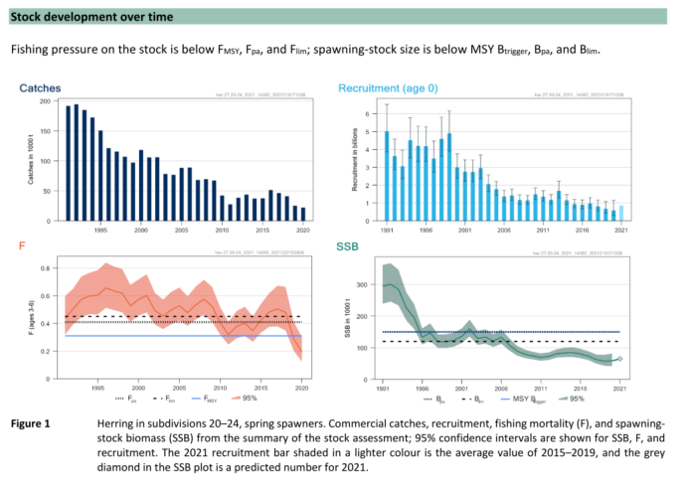(ICES 2021)

|  |  |
| --- | --- |
| Sensitivity attributes | Information: Herring |
| Habitat specificity | * Herring rely on inshore, transitional waters (estuaries, lagoons, bays) for spawning and larval retention (Western Baltic Sea) (Polte et al. 2017) * Litho-phytophilous spawner (Balon 1975), spawning on benthic substrates in 1-5 m water depth, according to distribution of vegetation * Occurrence water depth: Spawning in 1-5 m, according to distribution of vegetation (Klinkhardt 1996; Kotterba et al. 2014; Scabell 1988) |
| Prey specificity | * Adults are zooplanktivorous, autumn herring prey also on gobies (Western Baltic Sea) (Kotterba 2015) * Central Baltic: dominate prey item: *Pseudocalanus* sp. (Möllmann et al. 2004) |
| Adult mobility | * High migratory between summer feeding grounds in Skagerrak-Kattegat and inshore coastal waters along the Western Baltic coastline (Jönsson and Biester 1981; Poulsen et al. 2000) |
| Dispersal of early life stages | * Benthic eggs: development time (depends on temperature): 12 days at 10°C (Klinkhardt 1984a; Peck et al. 2012) * Larvae remain in inshore nursery areas: Active habitat selection (Polte et al. 2017) |
| Early life stage survival & settlement requirements | * Duration of yolk-sac stage: 6.5 days at 8 °C (Klinkhardt 1996), critical first feeding period * At sizes 25-30 mm, schooling behavior, migration to outer coastal areas (Blaxter and Hunter 1982; Klinkhardt 1996) * Western Baltic larvae feeding on zooplankton (copepods, nauplii and copepodite stages) (Paulsen 2016; Paulsen et al. 2014) |
| Complexity of reproductive strategy | * Demersal eggs attached to substrates (Polte et al. 2014; Scabell 1988) * Bet-hedging strategists, spreading spawning in waves over time (Arula et al. 2014; Lambert and Ware 1984) * Cohorts with different survival bottlenecks (first cohort: bottleneck on larval stage, second cohort: bottleneck on egg stage) (Polte et al. 2014) * Initial spawning is triggered by temperature (threshold 4°C) (Polte et al. 2021) * Specific vegetated spawning areas serve as important nurseries (Moll 2018) * Precise homing to natal spawning areas with straying behavior (Moll et al. in prep., personal communication) |
| Population Spawning Cycle | * Spring spawning population, spawning time from March-May |
| Sensitivity to increasing temperature | * Threshold spawning: 4°C (Polte et al. 2021) * Egg development: 7-13 °C * Atlantic herring: upper thermal limit for viable eggs is about 10-12°C (Blaxter and Hunter 1982) * Temperature optimum: 5-17°C successful hatching (Peck et al. 2012) * Larvae: > 17°C (heart problems) (Moyano et al. 2020) * Smaller size of hatched larvae at higher temperatures (Peck et al. 2012) * Sensitivity to phenological changes: During warm winter periods: shift in spawning phenology/time (earlier spawning) (Polte et al. 2021), mismatch of prey items |
| Sensitivity to decreasing salinity | * High salinity tolerance 4-35 psu (Klinkhardt 1986a; Klinkhardt 1986b), threshold egg survival: >4 psu (Klinkhardt 1984b) * Larvae: critical values 2-3 psu (Illing et al. 2016) |
| Sensitivity to Ocean Acidification | * Low pH-values have a direct impact on herring reproduction * pH-value reduction from 8-7, indicating decrease in protein biosynthesis (Franke and Clemmesen 2011) |
| Population growth rate | * r=2\*FMSY=1\*Fpa (Froese et al. 2017)  |  |  | | --- | --- | | Maximum growth rate (rmax) | * FMSY=0.31; Fpa= 0.41 (ICES 2021) * r=0.62 (Western Baltic Sea) | | Von Bertalanffy K | * 0.28-0.41 (Western Baltic Sea) | | Age at maturity (tm) | * 3 years (Western Baltic Sea) | | Maximum age (tmax) | * 10 years (Baltic Sea) | | Natural mortality (M) | * 0.36 (Southern Baltic Sea) | | Maximum length (Linf) | * 31 cm TL |  * ([www.fishbase.org](http://www.fishbase.org), (Froese and Pauly 2021)) |
| Sensitivity to other stressors | * Low oxygen below 50% of saturation: larval size at hatching was reduced (Braum 1973) * Eggs can tolerate a decreased oxygen supply, but egg development was reduced and embryos were malformed (Braum 1985) * Pollution: Oil spills (Hose et al. 1996; Incardona et al. 2012; Norcross et al. 1996) * Predation on herring eggs (Kotterba et al. 2014; Kotterba et al. 2017) * Eutrophication related cascade effects: Low substrate complexity and algae exudates due to eutrophication (von Nordheim et al. 2018; von Nordheim et al. 2020) * Storm impact on eggs attached to vegetation (Moll et al. 2018) |

Arula, T., H. Ojaveer, and R. Klais. 2014. Impact of extreme climate and bioinvasion on temporal coupling of spring spawning (*Clupea harengus m*.) larvae and their prey. *Marine Environmental Research* 102: 102-109.

Balon, E. 1975. Reproductive Guilds of Fishes: A proposal and definition. *Journal of the Fisheries Research Board of Canada* 32.

Blaxter, J.H.S., and J.R. Hunter. 1982. *The Biology of Clupeoid Fishes*. Academic Press Inc. (London) Ltd. Published by Elsevier Ltd.

Franke, A., and C. Clemmesen. 2011. Effect of ocean acidification on early life stages of Atlantic herring (*Clupea harengus* L.). *Biogeosciences* 8: 3697-3707.

Froese, R., N. Demirel, G. Coro, K.M. Kleisner, and H. Winker. 2017. Estimating fisheries reference points from catch and resilience. *Fish and Fisheries* 18: 506-526.

Froese, R., and D. Pauly. 2021. Editors. 2021. Fishbase. World Wide Web electronic publication. www.fishbase.org (06/10.2021).

Froese, R., A.C. Tsikliras, G. Scarcella, and D. Gascuel. 2021. Progress towards ending overfishing in the Northeast Atlantic. *Marine Policy* 125: 104282.

Hakala, T., M. Viitasalo, H. Rita, E. Aro, J. Flinkman, and I. Vuorinen. 2003. Temporal and spatial variation in the growth rates of Baltic herring (*Clupea harengus membras* L.) larvae during summer. *Marine Biology* 142: 25-33.

Hose, J.E., M.D. McGurk, G.D. Marty, D.E. Hinton, E.D. Brown, and T.T. Baker. 1996. Sublethal effects of the Exxon Valdez oil spill on herring embryos and larvae: morphological, cytogenetic, and histopathological assessments, 1989-1991. *Canadian Journal of Fisheries and Aquatic Sciences* 53: 2355-2365.

ICES. 2020. Herring Assessment Working Group for the Area South of 62°N (HAWG). *ICES Scientific Reports* 2:60: 1151 pp.

ICES. 2021. Herring (*Clupea harengus*) in subdivisions 20-24, spring spawners (Skagerrak, Kattegat, and western Baltic). In Report of the ICES Advisory Committee, 2021. ICES Advice 2021, her.27.20-24, https://doi.org/10.17895/ices.advice.7766.

Illing, B., M. Moyano, M. Hufnagl, and M.A. Peck. 2016. Projected habitat loss for Atlantic herring in the Baltic Sea. *Marine Environmental Research* 113: 164-173.

Incardona, J.P., C.A. Vines, B.F. Anulacion, D.H. Baldwin, H.L. Day, B.L. French, J.S. Labenia, T.L. Linbo, M.S. Myers, O.P. Olson, C.A. Sloan, S. Sol, F.J. Griffin, K. Menard, S.G. Morgan, J.E. West, T.K. Collier, G.M. Ylitalo, G.N. Cherr, and N.L. Scholz. 2012. Unexpectedly high mortality in Pacific herring embryos exposed to the 2007 *Cosco Busan* oil spill in San Francisco Bay. *Proceedings of the National Academy of Sciences of the United States of America* 109: E51-E58.

Jönsson, N., and E. Biester. 1981. Wanderbewegungen des Rügenschen Frühjahrsherings in den Küsten- und Boddengewässern der DDR. Fischerei-Forschung 19: 47-51.

Klinkhardt, M. 1984a. Erste Ergebnisse von experimentellen Felduntersuchungen am Laich von Rügenschen Frühjahrsheringen. *Fischerei-Forschung* 22: 76-78.

Klinkhardt, M. 1984b. Zum Einfluß des Salzgehaltes auf die Befruchtungsfähigkeit des Laiches der Rügenschen Frühjahrsheringe. *Fischerei-Forschung* 22: 73-75.

Klinkhardt, M. 1986a. Ergebnisse von Untersuchungen zur Schlupf- und Dottersackphase der Larven von Rügenschen Frühjahrsheringen (*Clupea harengus* L.). *Fischerei-Forschung* 24: 28-30.

Klinkhardt, M. 1986b. Gedanken zur Abhängigkeit der Laichentwicklung Rügenscher Frühjahrsheringe (*Clupea harengus* L.) von Umweltparametern. *Fischerei-Forschung Rostock* 24: 22-27.

Klinkhardt, M. 1996. *Der Hering*. Magdeburg, Germany: Spectrum Akademischer Verlag.

Kotterba, P. 2015. Atlantic herring (*Clupea harengus*) within the estuarine food web of a southern Baltic Sea lagoon. PhD-Thesis, University of Hamburg, Hamburg.

Kotterba, P., C. Kühn, C. Hammer, and P. Polte. 2014. Predation of threespine stickleback (*Gasterosteus aculeatus*) on the eggs of Atlantic herring (*Clupea harengus*) in a Baltic Sea lagoon. *Limnology and Oceanography* 59: 578-587.

Kotterba, P., D. Moll, C. Hammer, M.A. Peck, D. Oesterwind, and P. Polte. 2017. Predation on Atlantic herring (*Clupea harengus*) eggs by the resident predator community in coastal transitional waters. *Limnology and Oceanography* 62: 2616-2628.

Lambert, T.C., and D.M. Ware. 1984. Reproductive Strategies of Demersal and Pelagic Spawning Fish. *Canadian Journal of Fisheries and Aquatic Sciences* 41: 1565-1569.

Moll, D. 2018. Contribution of coastal nursery areas to the spring-spawning population of Atlantic herring (*Clupea harengus*) in the Western Baltic Sea, PhD-Thesis, University of Hamburg, Hamburg.

Moll, D., P. Kotterba, L. von Nordheim, and P. Polte. 2018. Storm-Induced Atlantic Herring (*Clupea harengus*) Egg Mortality in Baltic Sea Inshore Spawning Areas. *Estuaries and Coasts* 41: 1-12.

Möllmann, C., G. Kornilovs, M. Fetter, and F.W. Köster. 2004. Feeding ecology of central Baltic Sea herring and sprat. *Journal of Fish Biology* 65: 1563-1581.

Moyano, M., B. Illing, P. Polte, P. Kotterba, Y. Zablotski, T. Gröhsler, P. Hüdepohl, S.J. Cooke, and M.A. Peck. 2020. Linking individual physiological indicators to the productivity of fish populations: A case study of Atlantic herring. *Ecological Indicators* 113: 106146.

Nielsen, J.R., B. Lundgren, T.F. Jensen, and K.-J. Staehr. 2001. Distribution, density and abundance of the western Baltic herring (*Clupea harengus*) in the Sound (ICES Subdivision 23) in relation to hydrographical features. *Fisheries Research* 50: 235-258.

Norcross, B.L., J.E. Hose, M. Frandsen, and E.D. Brown. 1996. Distribution, abundance, morphological condition, and cytogenetic abnormalities of larval herring in Prince William Sound, Alaska, following the Exxon Valdez oil spill. *Canadian Journal of Fisheries and Aquatic Sciences* 53: 2376-2387.

Oeberst, R., M. Dickey-Collas, and R.D.M. Nash. 2009. Mean daily growth of herring larvae in relation to temperature over a range of 5–20°C, based on weekly repeated cruises in the Greifswalder Bodden. *ICES Journal of Marine Science* 66: 1696-1701.

Ojaveer, E. 1981. Influence of temperature, salinity, and reproductive mixing of Baltic herring groups on its embryonal development. *Rapports et Procès-verbaux des Réunions. Conseil International pour l’Éxploration de la Mer* 178: 409-415.

Parmanne, R., O. Rechlin, and B. Sjöstrand. 1994. Status and future of herring and sprat stocks in the Baltic Sea. *Dana* 10: 29-59.

Paulsen, M. 2016. Prey quantity and quality effects on larval Atlantic herring (*Clupea harengus* L.) growth in the western Baltic Sea, University of Hamburg.

Paulsen, M., C. Clemmesen, and A.M. Malzahn. 2014. Essential fatty acid (docosahexaenoic acid, DHA) availability affects growth of larval herring in the field. *Marine Biology* 161: 239-244.

Peck, M.A., P. Kanstinger, L. Holste, and M. Martin. 2012. Thermal windows supporting survival of the earliest life stages of Baltic herring (*Clupea harengus*). *ICES Journal of Marine Science* 69: 529-536.

Polte, P., T. Gröhsler, P. Kotterba, L. von Nordheim, D. Moll, J. Santos, P. Rodriguez-Tress, Y. Zablotski, and C. Zimmermann. 2021. Reduced Reproductive Success of Western Baltic Herring (*Clupea harengus*) as a Response to Warming Winters. *Frontiers in Marine Science* 8.

Polte, P., P. Kotterba, C. Hammer, and T. Gröhsler. 2014. Survival bottlenecks in the early ontogenesis of Atlantic herring (*Clupea harengus*, L.) in coastal lagoon spawning areas of the western Baltic Sea. *ICES Journal of Marine Science* 71: 982-990.

Polte, P., P. Kotterba, D. Moll, and L. von Nordheim. 2017. Ontogenetic loops in habitat use highlight the importance of littoral habitats for early life-stages of oceanic fishes in temperate waters. *Scientific Reports* 7:42709.

Poulsen, S., J.R. Nielsen, R. Holst, and K.-J. Staehr. 2000. An Atlantic herring (*Clupea harengus*) size selection model for experimental gill nets used in the Sound (ICES Subdivision 23). *Canadian Journal of Fisheries and Aquatic Sciences* 57: 1551-1561.

Scabell, J. 1988. Der Rügensche Frügjahrshering - das Laichgeschehen. Ph.D. thesis, University of Rostock.

von Nordheim, L., P. Kotterba, D. Moll, and P. Polte. 2018. Impact of Spawning Substrate Complexity on Egg Survival of Atlantic Herring (*Clupea harengus*, L.) in the Baltic Sea. *Estuaries and Coasts* 41: 549-559.

von Nordheim, L., P. Kotterba, D. Moll, and P. Polte. 2020. Lethal effect of filamentous algal blooms on Atlantic herring (*Clupea harengus*) eggs in the Baltic Sea. *Aquatic Conservation: Marine and Freshwater Ecosystems* 30: 1362-1372.

Weber, W. 1971. Die Laichplätze des Herings (*Clupea harengus* L.) der westlichen Ostsee. *Kieler Meeresforschung* 27: 194-208.

**Europäische Sprotte - European sprat (*Sprattus sprattus*)**

**Additional information**

|  |  |
| --- | --- |
| **Distribution range in the Western Baltic Sea** | * From the Belt Seas and western Baltic (SD 22 and 24), to the Quark area in the north (SD30) to the northeastern part of the Gulf of Finland (SD32) (Aro 1989) * Pomeranian Bay (Dudko et al. 2015; Więcaszek et al. 2019) |
| **Stock size** | * Year-class 2019-2020 are above average and stock is predicted to increase to about 1,2 million tonnes in 2023 (ICES 2021) * SSB increased in 2016-2017, showing a decreasing trend (see Figure, ICES Advice 2020) (Baltic Sea) (ICES 2020b) * Baltic Sea sprat stock size depends on environmental factors as well as on Prey-Predator relationship (size of cod stock) (Köster et al. 2001; Möllmann et al. 2004) * BMSY=2\*Bpa (Froese et al. 2021) * MSY Btrigger=Bpa= 570,000 t; SSB(2020)=873,000 t (ICES 2020b), B/BMSY=0.76 (Baltic Sea) |
| **Recruitment** | * Variability according to thermal and salinity conditions (Baltic Sea) (Ojaveer and Kalejs 2010) |
| **Growth** | * Short-lived, fast growing, early maturing (Heath et al. 2012) |
| * In the Baltic Sea, sprat (*Sprattus sprattus*) is an ecologically- and commercially important pelagic ﬁsh species (Kornilovs et al. 2001; Rudstam et al. 1994), being both prey for top predators (e.g. Atlantic cod (*Gadus morhua*) and harbor porpoise (*Phocoena phocoena*)) and predator on zooplankton and ﬁsh eggs (Arrhenius and Hansson 1993; Möllmann and Köster 1999) * During recent two decades the stock distribution has been changing with tendency to increase density in north-eastern Baltic , especially in autumn (ICES 2020a) * Natural mortality varied between years and ages as an effect of cod predation (ICES 2021) * Genetic differences between Baltic Sea and the North Sea/Kattegat-Skagerrak area (Limborg et al. 2009; Quintela et al. 2020) * One important environmental factor influencing sprat recruitment success is water temperature | |

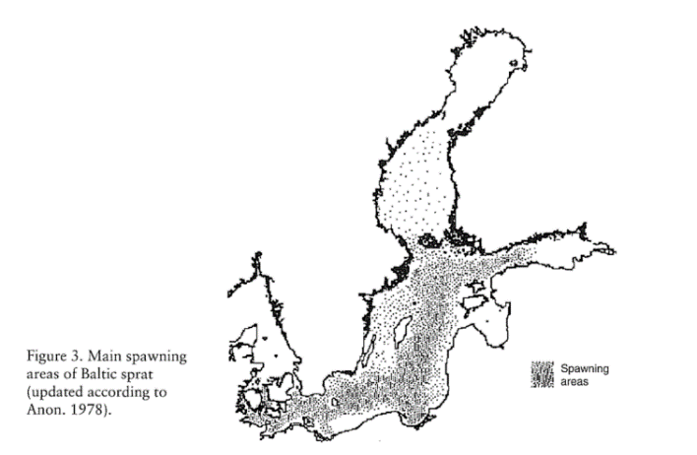 (Parmanne et al. 1994)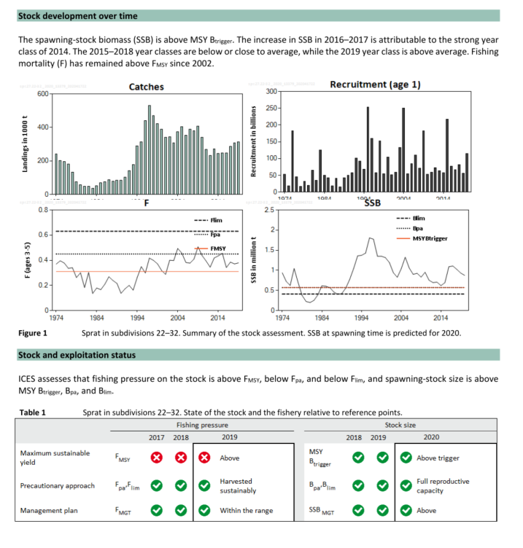(ICES 2020b)

|  |  |
| --- | --- |
| Sensitivity attributes | Information: Sprat |
| Habitat specificity | * Overwintering in central/deep parts of the Baltic Sea, adults overwinter in water temp. ≥ 4°C, below the halocline (Parmanne et al. 1994; Rechlin 1967) * Spawning grounds are located in the central Baltic Sea within deep Basins (Haslob 2011): Bornholm Basin, Gdansk Deep and Gotland Basin (Parmanne et al. 1994) * Baltic sprat is able to adapt its reproductive tactics to the highly variable pelagic habitat of the Baltic Sea (Döring et al. 2018) * Mass spawning occurs in the coastal slope, above 20-30 m to 140-160 m (Ojaveer and Kalejs 2010) * Immigration to central and deepest part of Baltic proper: forming winter shoals (Parmanne et al. 1994) |
| Prey specificity | * Juveniles: After metamorphosis (32-41 mm): feeding on cladocerans, bivalve larvae, mysids (North Sea) (De Silva 1973; ICES 2006; Russell 1976) * Adults: Calanoid copepods (*Temora longicornis*) (Central Baltic Sea) (Möllmann et al. 2004) * Prey preferences shifted between day and night: During day *T. longicornis* and during night *Podon* spp. (Central Baltic Sea) (Bernreuther et al. 2013) |
| Adult mobility | * Migrating from more coastal areas to offshore parts of the Baltic basins, forming feeding shoals (Aro 1989; Lindquist 1971) * Diurnal vertical migration: near bottom (day), schools moving to surface at dusk (Central Baltic Sea) (Nilsson et al. 2003) |
| Dispersal of early life stages | * Eggs and larvae are pelagic * Depending on temperature: 5 days post fertilization at 14.7°C (Petereit et al. 2008) |
| Early life stage survival & settlement requirements | * Larvae feed on diatoms, copepods (*Temora* and *Acartia* spp.) important (Köster et al. 2003; Möllmann et al. 2004) * first-feeding larvae early in the spawning season prey exclusively upon microplankton, small larvae fed mainly upon nauplii of the copepods *Acartia* spp., *Temora longicornis* and *Centropages hamatus* (ca. 65%), whereas larger larvae consumed up to 80% *Acartia* spp. copepodites and adults, as well as cladocerans (Dickmann et al. 2007; Voss et al. 2003) * Increased mortality observed at temperatures < 5°C (Nissling 2004) * Optimal thermal windows for growth and survival change during early life stages: Eggs (5-17°C), early feeding larvae (5-12°C) (Peck et al. 2012) * Larvae (>10 mm): change in diel migration (whereas larvae migrated to surface by night, staying in 30-50 m deep by day (~1990)), larvae showed no dial vertical migration between (1998-2002), remaining in warm, near-surface water by day and night) (Voss et al. 2007) |
| Complexity of reproductive strategy | * Multiple batch spawners, repeated spawning throughout season (Haslob 2011; ICES 2006) * Spawning grounds are located in the central Baltic Sea within deep Basins (Haslob 2011) * Main spawning areas includes Baltic Proper, western and central Gulf of Finland and in some years the western Gulf of Riga (Ojaveer and Kalejs 2010) * Spawning starts in deep water, migrating during season to warmed-up surface waters (Parmanne et al. 1994) * Spawning at depths: 90-110 m in the Bornholm, Stolpe and Gulf of Gdansk areas in Feb.-March, March to July (Baltic Sea) (Petereit et al. 2008) * According to lower salinity: egg buoyancy is restricted to more saline, deeper waters (water depths 40-65 m) (Petereit et al. 2008) |
| Population Spawning Cycle | * Spawning season from March to late June (Baltic Sea) (Haslob 2011; Petereit et al. 2008) |
| Sensitivity to increasing temperature | * Benefit from rising temperatures, low temperatures suppress growth and gonadal development (MacKenzie and Köster 2004), key variable for recruitment and population dynamics * Increased larval mortality observed at temperatures < 5°C (Nissling 2004) * Optimal thermal windows for growth and survival change during early life stages: Eggs (5-17°C), early feeding larvae (5-12°C) (Peck et al. 2012) * Benefit from rising temperatures, low temperatures suppress growth and gonadal development (MacKenzie and Köster 2004), key variable for recruitment and population dynamics * At high temperatures (17.4-20°C), hatching occurred prematurely before many of the eggs had reached stage IV (larvae spreading the full circumference of egg) (North Sea) (Thompson et al. 1981) * Normal reproduction: 6-12°C (citation in Ojaveer and Kalejs 2010), 6-18.5°C, sprat is capable to develop successfully over a wide range of temperatures (North Sea) (Thompson et al. 1981) * Threshold below 3.4 °C and above 14.7°C (Baltic Sea) (Petereit et al. 2008) * Recruitment was highest at intermediate water temperatures experienced during spawning (5.0 and 9.0 °C) but tended to be lower at colder (<3 °C) and warmer (⩾11 °C) waters (Baltic Sea) (MacKenzie and Köster 2004) * Baltic sprat model predicted reduced maximum body sizes with increasing temperature (Frisk et al. 2015) |
| Sensitivity to decreasing salinity | * Tolerance to a wide range of salinities, also abundant in estuarine habitats (ICES 2006), in the North Sea (30-33 psu) * Reproduction: 5-6 psu (Baltic Sea) (Ojaveer and Kalejs 2010) |
| Sensitivity to Ocean Acidification | * No data/information |
| Population growth rate | * r=2\*FMSY=1\*Fpa (Froese et al. 2017)  |  |  | | --- | --- | | Maximum growth rate (rmax) | * FMSY=0.26 (Baltic Sea) (ICES 2021) * r= 0.52 (Baltic Sea) | | Von Bertalanffy K | * 0.68-1.02 (Western Baltic Sea) | | Age at maturity (tm) | * 1.2 (Baltic Sea) | | Maximum age (tmax) | * 6 (Baltic Sea, Bay of Gdansk) | | Natural mortality (M) | * 0.7 (Western Baltic Sea) | | Maximum length (Linf) | * 14.7 cm |  * ([www.fishbase.org](http://www.fishbase.org), (Froese and Pauly 2021)) |
| Sensitivity to other stressors | * Suggestion that sprat will be robust to the expected changes in pH (Havenhand 2012) * Egg survival depends on wind conditions, high wind stress results in high mortality of eggs distributed during these months in upper water layers, wind conditions also impact feeding success in larvae (Köster et al. 2003) * In Norwegian fjords/overwintering areas: lower tolerable oxygen content was ~0.5 ml O2/l (~7 % O2 saturation) (Kaartvedt et al. 2009) * Vertical distribution threshold: 5°C and 1 ml/l (Stepputtis 2006) |

Aro, E. 1989. A review of migration patterns in the Baltic. *Rapports et Proces-verbaux des Réunions. Conseil International pour l’Éxploration de la Mer* 190: 72-96.

Arrhenius, F., and S. Hansson. 1993. Food consumption of larval, young and adult herring and sprat in the Baltic Sea. *Marine Ecology Progress Series* 96: 125-137.

Bernreuther, M., J. Schmidt, D. Stepputtis, and A. Temming. 2013. Vertically resolved prey selectivity and competition of Baltic herring *Clupea harengus* and sprat *Sprattus sprattus*. *Marine Ecology Progress Series* 489: 177-195.

De Silva, S.S. 1973. Abundance, structure, growth and origin of inshore clupeid populations of the west coast of Scotland. *Journal of Experimental Marine Biology and Ecology* 12: 119-144.

Dickmann, M., C. Möllmann, and R. Voss. 2007. Feeding ecology of Central Baltic sprat *Sprattus sprattus* larvae in relation to zooplankton dynamics: implications for survival. *Marine Ecology Progress Series* 342: 277-289.

Döring, J., H. Hauss, and H. Haslob. 2018. Spatial and seasonal variability in reproductive investment of Baltic sprat. *Fisheries Research* 204: 49-60.

Dudko, S., S. Król, K. Wojnar, and W. Wawrzyniak. 2015. Charakterystyka rybacka ichtiofauny Zatoki Pomorskiej (w oparciu o wyniki monitoring połowowego wykonanago w latach 2011–2014). [Fisheries characteristics of ichthyofauna of Pomeranian Bay (Based on the results of fishing monitoring carried out within 2011–2014)]. Wydawnictwo Josephs’s Sons, Szczecin, Poland. [In Polish.] http://fishbayproject.pl/files/fishbay\_publikacja.pdf.

Frisk, C., K.H. Andersen, A. Temming, J.P. Herrmann, K.S. Madsen, and G. Kraus. 2015. Environmental effects on sprat (*Sprattus sprattus*) physiology and growth at the distribution frontier: A bioenergetic modelling approach. *Ecological Modelling* 299: 130-139.

Froese, R., N. Demirel, G. Coro, K.M. Kleisner, and H. Winker. 2017. Estimating fisheries reference points from catch and resilience. *Fish and Fisheries* 18: 506-526.

Froese, R., and D. Pauly. 2021. Editors. 2021. Fishbase. World Wide Web electronic publication. www.fishbase.org (06/10.2021).

Froese, R., A.C. Tsikliras, G. Scarcella, and D. Gascuel. 2021. Progress towards ending overfishing in the Northeast Atlantic. *Marine Policy* 125: 104282.

Haslob, H. 2011. Reproductive ecology of Baltic sprat and its application in stock assessmet, PhD-Thesis, University of Kiel, Kiel.

Havenhand, J.N. 2012. How will ocean acidification affect Baltic sea ecosystems? an assessment of plausible impacts on key functional groups. *Ambio* 41: 637-644.

Heath, M.R., F.C. Neat, J.K. Pinnegar, D.G. Reid, D.W. Sims, and P.J. Wright. 2012. Review of climate change impacts on marine fish and shellfish around the UK and Ireland. 22: 337-367.

ICES. 2006. North Sea fish species fact sheets. *Sprattus sprattus*. *Available at ICES website https://www.ices.dk/data/maps/Pages/ICES-FishMap.aspx*.

ICES. 2020a. Baltic Fisheries Assessment Working Group (WGBFAS). ICES Scientific Reports. 2:45. 643 pp. http://doi.org/10.17895/ices.pub.6024

ICES. 2020b. Sprat (*Sprattus sprattus*) in subdivisions 22–32 (Baltic Sea). In Report of the ICES Advisory Committee, 2020. ICES Advice 2020, spr.27.22-32. https://doi.org/10.17895/ices.advice.5879. .

ICES. 2021. Baltic Fisheries Assessment Working Group (WGBFAS). ICES Scientific Reports. 3:53. 717 pp. https://doi.org/10.17895/ices.pub.8187.

Kaartvedt, S., A. Røstad, and T.A. Klevjer. 2009. Sprat Sprattus sprattus can exploit low oxygen waters for overwintering. *Marine Ecology Progress Series* 390: 237-249.

Kornilovs, G., L. Sidrevics, and J.W. Dippner. 2001. Fish and zooplankton interaction in the Central Baltic Sea. *ICES Journal of Marine Science* 58: 579-588.

Köster, F.W., H.-H. Hinrichsen, D. Schnack, M.A.S. John, B.R. Mackenzie, J. Tomkiewicz, C. Möllmann, G. Kraus, M. Plikshs, A. Makarchouk, and E. Aro. 2003. Recruitment of Baltic cod and sprat stocks: identification of critical life stages and incorporation of environmental variability into stock-recruitment relationships. *Scientia Marina* 67: 129-154.

Limborg, M.T., J.S. Pedersen, J. Hemmer-Hansen, J. Tomkiewicz, and D. Bekkevold. 2009. Genetic population structure of European sprat Sprattus sprattus: differentiation across a steep environmental gradient in a small pelagic fish. *Marine Ecology Progress Series* 379: 213-224.

Lindquist, A. 1971. Contribution to the knowledge of the Baltic sprat, (*Sprattus sprattus*). . *ICES Document CM 1971/H:19.9 pp.*

MacKenzie, B.R., and F.W. Köster. 2004. Fish Production and Climate: Sprat in the Baltic Sea. *Ecology* 85: 784-794.

Möllmann, C., G. Kornilovs, M. Fetter, and F.W. Köster. 2004. Feeding ecology of central Baltic Sea herring and sprat. *Journal of Fish Biology* 65: 1563-1581.

Möllmann, C., and F.W. Köster. 1999. Food consumption by clupeids in the Central Baltic: evidence for top-down control? *ICES Journal of Marine Science* 56: 100-113.

Nilsson, L.A.F., U.H. Thygesen, B. Lundgren, B.F. Nielsen, J.R. Nielsen, and J.E. Beyer. 2003. Vertical migration and dispersion of sprat (*Sprattus sprattus*) and herring (*Clupea harengus*) schools at dusk in the Baltic Sea. *Aquatic Living Resources* 16: 317-324.

Nissling, A. 2004. Effects of temperature on egg and larval survival of cod (*Gadus morhua)* and sprat (*Sprattus sprattus*) in the Baltic Sea — implications for stock development. In Biology of the Baltic Sea, ed. H. Kautsky and P. Snoeijs, 115-123. Dordrecht: Springer Netherlands.

Parmanne, R., O. Rechlin, and B. Sjöstrand. 1994. Status and future of herring and sprat stocks in the Baltic Sea. *Dana* 10: 29-59.

Peck, M.A., H. Baumann, M. Bernreuther, C. Clemmesen, J.-P. Herrmann, H. Haslob, B. Huwer, P. Kanstinger, F.W. Köster, C. Petereit, A. Temming, and R. Voss. 2012. Reprint of: The ecophysiology of Sprattus sprattus in the Baltic and North Seas. *Progress in Oceanography* 107: 31-46.

Petereit, C., H. Haslob, G. Kraus, and C. Clemmesen. 2008. The influence of temperature on the development of Baltic Sea sprat (*Sprattus sprattus*) eggs and yolk sac larvae. *Marine Biology* 154: 295-306.

Quintela, M., C. Kvamme, D. Bekkevold, R.D.M. Nash, E. Jansson, A.G. Sørvik, J.B. Taggart, Ø. Skaala, G. Dahle, and K.A. Glover. 2020. Genetic analysis redraws the management boundaries for the European sprat. *Evolutionary Applications* 13: 1906-1922.

Rechlin, O. 1967. Beobachtungen zum Vorkommen, zur Verbreitung und zum Verhalten von Überwinterungsschwärmen des Sprotts (*Sprattus sprattus* L.) in der nordöstlichen Ostsee. *Fischerei-Forschung* 5: 33-38.

Rudstam, L.G., G. Aneer, and M. Hildén. 1994. Top-down control in the pelagic Baltic ecosystem. *Dana* 10: 105-129.

Russell, F.S. 1976. *The Eggs and Planktonic Stages of British Marine Fishes*. London: Academic Press.

Stepputtis, D. 2006. Distribution patterns of Baltic sprat (*Sprattus sprattus* L.) - causes and consequences, University of Kiel.

Thompson, B.M., S.P. Milligan, and J.H. Nichols. 1981. The development rates of sprat (*Sprattus sprattus* L.) eggs over a range of temperatures. *ICES Document CM 1981/H:15 pp.*

Voss, R., F.W. Köster, and M. Dickmann. 2003. Comparing the feeding habits of co-occurring sprat (*Sprattus sprattus*) and cod (*Gadus morhua*) larvae in the Bornholm Basin, Baltic Sea. *Fisheries Research* 63: 97-111.

Voss, R., J.O. Schmidt, and D. Schnack. 2007. Vertical distribution of Baltic sprat larvae: changes in patterns of diel migration? *ICES Journal of Marine Science* 64: 956-962.

Więcaszek, B., E. Sobecka, S. Keszka, R. Panicz, K. Górecka, A. Linowska, and S. Król. 2019. Three new records of fishes and their parasite fauna from Pomeranian Bay, Baltic Sea. *Acta Ichthyologica et Piscatoria* 49: 65-73.

**Makrele - Atlantic mackerel (*Scomber scombrus*)**

**Additional information**

|  |  |
| --- | --- |
| **Distribution range in the Western Baltic Sea** | * North Sea, Skagerrak, Kattegat and inner Danish waters (Jansen and Gislason 2011), also caught in the Western Baltic Sea (around Kiel and Rügen) (Rummel et al. 2016) |
| **Stock size** | * SSB increased since 2007, reaching a maximum in 2014, declining trend since then (Northeast Atlantic and adjacent waters) (ICES 2020a) * Spawning-stock size is above MSY Btrigger, Bpa and Blim (ICES 2021) * BMSY=2\*Bpa (Froese et al. 2021) * MSY Btrigger=Bpa= 2,580,000 t; SSB(2021)=3,510,849 t (ICES 2020c; ICES 2021), B/BMSY=0.68 (Northeast Atlantic and adjacent waters) |
| **Recruitment** | * Recruitment variable, on a higher level since 2001, highest recruitment in time-series in 2018 and 2019 (see Figure 1 (ICES 2021) * Recruitment is rather stable and significant part of the variability has been explained by an index of wind induced turbulence (Borja et al. 2002) |
| **Growth** | * At an average temperature of 15- 17°C. *S. scombrus* grew at a rate of about 0.64-0.81 mm/d in St. Georges Bay, which is very similar to the average growth rate from birth to metamorphosis (0.73mm/d) estimated from calculations (Ware and Lambert 1985) |
| * In the North East Atlantic (NEA) mackerel spawn from the Mediterranean Sea in the south to the Faroe Islands in the North and from Hatton Bank in the West to Kattegat in the East (Jansen and Gislason 2013) * Separation of mackerel on the eastern and western side of the Atlantic (from tagging studies) (Jansen and Gislason 2013) * Mackerel in the eastern Atlantic: divided into three spawning components according to spawning areas: Southern (Gibraltar to southern Biscay), Western (Biscay to northwest Scotland) and North Sea, North Sea component is considered to be a distinct stock (Jansen and Gislason 2011) * Stock is highly migratory and widely distributed throughout the Northeast Atlantic with significant fisheries in most ICES subareas; mackerel fishery takes place from Oct. through to March of the subsequent year (ICES 2020b) * Declining trend in the weights-at-age of fish 6 years and older since the mid-2000s (ICES 2020c) | |

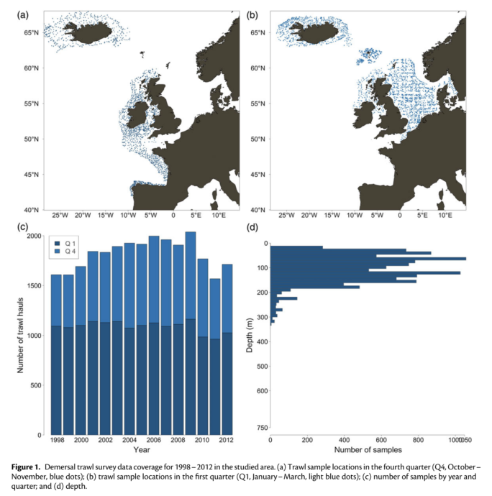(Jansen et al. 2015)

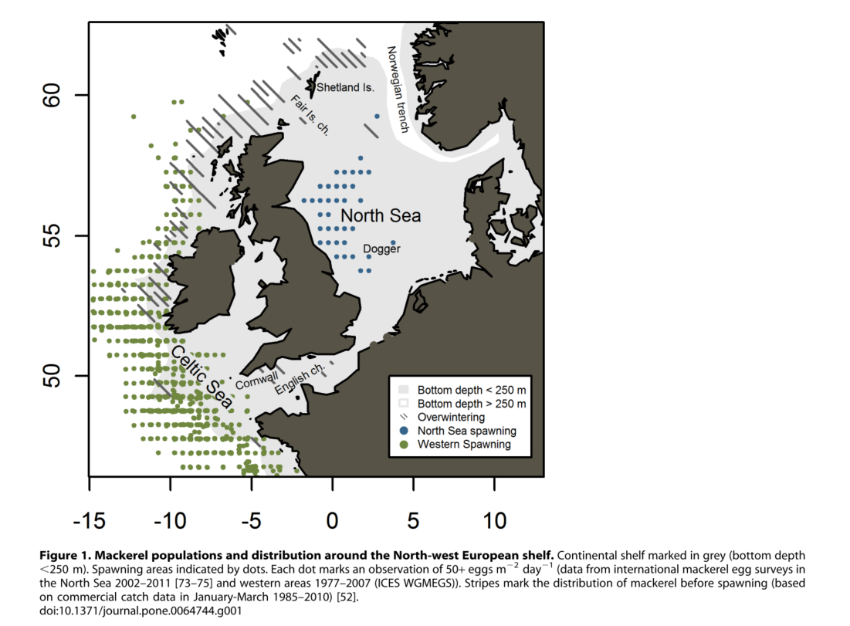

**Figure 2**: Mackerel populations and distribution around the North-west European shelf. Continental shelf marked in grey (bottom depth < 250 m). Spawning areas indicated by dots. Each dot marks an observation of 50+ eggs m2/day (data from international mackerel egg surveys in the North Sea 2002–2011 and western areas 1977–2007 (ICES WGMEGS)). Stripes mark the distribution of mackerel before spawning (based on commercial catch data in January-March 1985–2010). (Jansen and Gislason 2013)

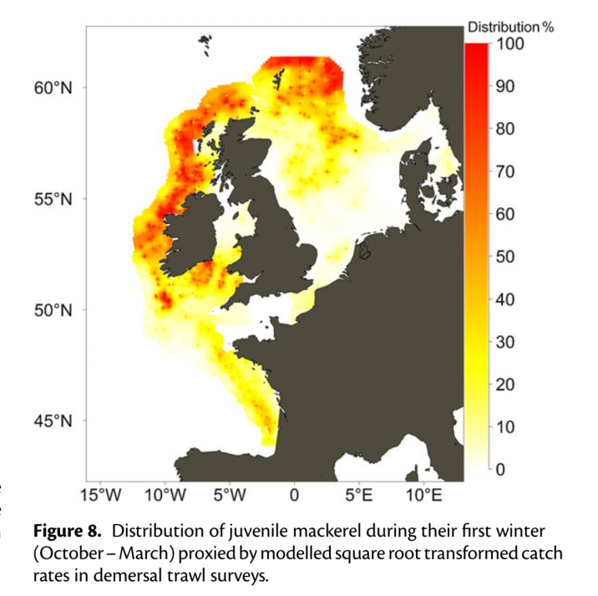(Jansen et al. 2015)

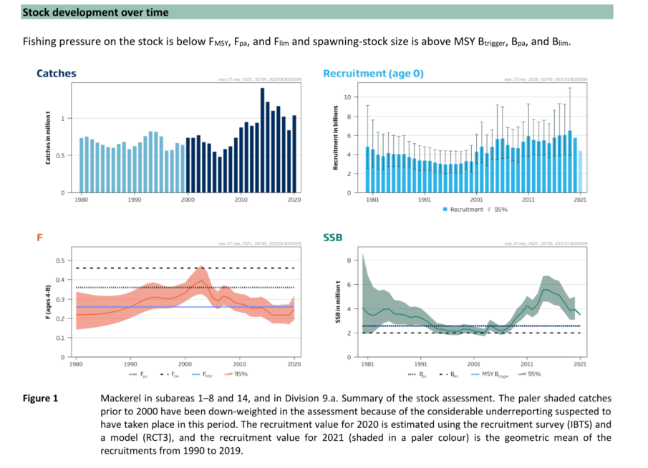(ICES 2021)

|  |  |
| --- | --- |
| Sensitivity attributes | Information: Mackerel |
| Habitat specificity | * Typically epipelagic species, mainly caught in shelf seas and along shelf edges in waters of 15-200 m depth (citation in (ICES 2006; Jansen et al. 2015) * Mackerel are predominantly distributed above the thermocline, often near the surface during summer feeding period (Nøttestad et al. 2015) * During the wintering and pre-spawning period in March, mackerel are practically not feeding, stay deep close to the bottom, have a high degree of patchiness, aggregate in large and dense shoals for protection from predators, and further reduce their swimming behaviour to save energy before spawning (citation in (Nøttestad et al. 2015) * Spawning: Optimal spawning habitats were modelled: Areas with sea surface temperature (10-16.5°C), salinity above 31 and depths < 120 m (Gulf of St. Lawrence, North Atlantic) (Mbaye et al. 2020) * Spawning takes place in the central North Sea and to a lesser degree also in Skagerrak-Kattegat (see citations in Jansen and Gislason 2011) * In the North Sea and Kattegat/Skagerrak high egg abundances are found above the thermocline (Ware and Lambert 1985; Trenkel et al. 2014) * After spawning mackerel redistributes in the North Sea or migrates into nearby waters such as the Skagerrak, Kattegat, the Sound, the Belt Sea and the western Baltic Sea (Jansen and Gislason 2011) * North Sea mackerel overwinters in deeper parts of Skagerrak (see citations in Jansen and Gislason 2011), it is also stated that North Sea mackerel overwinter in the Norwegian trench and of the Shetlands and Orkneys and Ireland (1980s) (Agnalt 1989; Bakken and Westgård 1986) * Nursery areas: Most important nursery areas for the NEA mackerel appeared to be around Ireland, north and west of Scotland, in the northern North Sea north of 59°N, and, to some extent, also in the Bay of Biscay (see Fig. 8) (Jansen et al. 2015) |
| Prey specificity | * Juveniles (21-29 cm): Euphausiids, crustacean larvae and other zooplankton (in spring); gelatinous zooplankton (Spain, Atlantic) (Olaso et al. 2005) * Adults (30-45 cm): Euphausiids, cannibalistic (feeding on their own eggs in spring), blue whiting (in autumn) (Spain, Atlantic) (Olaso et al. 2005) * Feeding on hydromedusa *Aglantha digitale* (occurrence in temperate and boreal waters) (Runge et al. 1987) * Main zooplankton prey species in the North Sea are: Copepods (mainly *Calanus finmarchicus*) (preference/feeding selectivity for older development stages (Prokopchuk and Sentyabov 2006)), euphausiids (mainly *Meganyctiphanes norvegica*), while primary fish prey species are: sandeel, herring, sprat, and Norway pout (North Sea) (ICES 2017) |
| Adult mobility | * High migratory (ICES 2020b) * Adults perform extensive migrations between overwintering (deep water along the edge of continental shelf (Shetlands, Norwegian Deeps, Skagerrak), spawning (central North Sea) and feeding grounds (Nordic Seas (Norwegian, Iceland, Greenland Seas)) (Nøttestad et al. 2015) and Northern North Sea (ICES 2006) |
| Dispersal of early life stages | * Pelagic eggs and larvae (movement restricted to the vertical dimension) (Jansen et al. 2015) * Passive drift with currents until they start vertical migration (Jansen and Gislason 2013) * Winds and currents play an important role in the passive transport of larvae toward nursery grounds (Bartsch et al. 2004) * Eggs, larvae and early post-larvae drift passively, but they become increasingly mobile as they increase in size (Bartsch 2005) * At 13°C the eggs hatch in about 5.9 days (142 h) compared with 2.9 days (69 h) at 20°C (Ware and Lambert 1985) |
| Early life stage survival & settlement requirements | * Eggs are pelagic (Trenkel et al. 2014), majority is distributed from 30-70 m (depth varies with season, diameter and thermocline) (Studholme et al. 1999) * Larvae prey on copepod eggs and nauplii (*Calanus finmarchicus*) (Ringuette et al. 2002) * Diet of larvae (4.5->5 mm) composed of the nauplii of *Acartia hudsonica*, *Temora longicornis* and *Pseudocalanus* sp. and some copepodites of *A. hudsonica* and *T. longicornis* and smaller proportions of phytoplankton (Peterson and Ausubel 1984) * Mackerel > 6.5 mm were cannibalistic, eating larvae of 3.5-4.5 mm in length (Peterson and Ausubel 1984) * By 8 mm stage: mackerel began to eat other fish larvae (Ware and Lambert 1985) * high abundance of the preferred prey at the onset of exogenous feeding and relatively warm temperature during the larval growth season are important prerequisites for the emergence of a strong year class in Atlantic mackerel (Robert et al. 2009) * During early development the larvae undergo a major change in body form which probably enhances their success in capturing active grey and in avoiding predators (Ware and Lambert 1985) * Feeding behaviour in larvae: Onset of feeding was ~ 3.8-4.5 mm (Ware and Lambert 1985) * Metamorphosis is reached at 15 mm (Ware and Lambert 1985) |
| Complexity of reproductive strategy | * Serial or batch-spawner (Studholme et al. 1999) * Spawning migration starts in spring at a surface temperature of 7-8°C, peak spawning occurs about 26 days later, when water temperatures has warmed to 13°C (Gulf of Lawrence, North Atlantic) (Ware and Lambert 1985) * Large ﬁsh arrived earlier at spawning grounds and left later than the small mackerel (Jansen and Gislason 2011) * Juveniles are regularly found in Icelandic waters (Astthorsson et al. 2012): Indication of new nursery areas due to northern expansion (Brunel et al. 2018) * Atlantic mackerel display isolated and different life-cycle patterns across the Atlantic Ocean (Jansen and Gislason 2013) |
| Population Spawning Cycle | * One clear seasonal peak per year (Froese and Pauly 2021) * Main spawning period is mid-May to late June/July (North Sea/Skagerrak) (Agnalt 1989; Jansen and Gislason 2011) * “All at once” egg release (spawning about a 2 month period, rather concentrated within a 2 week span) (Lambert and Ware 1984) |
| Sensitivity to increasing temperature | * Atlantic mackerel (*Scomber scombrus*) is one Northeast U.S. Shelf species identified as vulnerable and exposed to climate change (Hare et al. 2016) * Distribution expanding further north into Icelandic waters during warmer periods (Astthorsson et al. 2012) * Northeastern Atlantic mackerel is expected to continue tracking its thermal niche, those changes in the distribution might have severe impact on the recruitment since the leading-edge areas might not ﬁt all the needs for egg and larvae development (Bruge et al. 2016) * Spawning migration starts in spring at a surface temperature of 7-8°C, peak spawning occurs about 26 days later, when water temperatures has warmed to 13°C (Gulf of Lawrence, North Atlantic) (Ware and Lambert 1985) * Eggs are found over a wide temperature range: 8-18°C (Reid 2001), with thermal optimum at 10-15°C (Brunel et al. 2018; Reid 2001) * Egg mortality low between 11-13°C, high at 8.6°C (Mendiola et al. 2006) * Thermal thresholds: <5-6°C or >15-16°C (citation in (Studholme et al. 1999) * Temperature clearly plays a role in the modiﬁcation of the pre-spawning migration (Trenkel et al. 2014) * Sensitivity to phenological changes: Time of spawning is related to surface temperature (Jansen and Gislason 2011)   In warm years, mackerel in the North Sea spawn earlier than in cold years (Jansen and Gislason 2011)   * Mackerel spawning distribution is expected to shift westward (32 to 117 km) and northward (0.5 to 328 km) (Bruge et al. 2016) |
| Sensitivity to decreasing salinity | * High egg mortality to low salinity of 23 psu (Long Island Sound) (Peterson and Ausubel 1984) * Eggs can be found in waters ranging from estuaries (18-25 psu) to full seawater (>30 psu); Mortality is higher at lower salinities (<25 psu) (Studholme et al. 1999) * Larvae are found in estuaries (< 25 psu), largest abundances are found in higher salinities (> 30 psu); Mortality may be related to salinities of < 23 psu (Studholme et al. 1999) * Juveniles found in some inshore bays and estuaries as well as offshore at salinities > 25 psu (Studholme et al. 1999) * Adults found in open sea although occasionally in open bays with lower salinity limits of ~ 25 psu (Studholme et al. 1999) * In some estuaries along the northwestern Atlantic, Atlantic mackerel (adults and juveniles) were found in the mixing zone (0.5-25 psu) between June-Sept. (see Table 1 in (Studholme et al. 1999) |
| Sensitivity to Ocean Acidification | * No data/information |
| Population growth rate | * r=2\*FMSY=1\*Fpa  (Froese et al. 2017)  |  |  | | --- | --- | | Maximum growth rate (rmax) | * Prior r=0.47 * FMSY=0.26; Fpa=0.36 (ICES 2021) * r=0.36-0.52 (North Atlantic) | | Von Bertalanffy K | * 0.43 (North Sea)-0.84 (Central North Sea) | | Age at maturity (tm) | * 2-3 year (Northeast Atlantic) (citation in Trenkel et al. 2014 ) | | Maximum age (tmax) | * 21 years (Ireland) | | Natural mortality (M) | * 0.13-0.15 (France, Southern North Sea; Northwest Atlantic) | | Maximum length (Linf) | * 42.0 cm TL |  * ([www.fishbase.org](http://www.fishbase.org), (Froese and Pauly 2021)) |
| Sensitivity to other stressors | * Mackerel > 6.5 mm: Cannibalistic (Peterson and Ausubel 1984) * Ocean acidification, deoxygenation and changes in prey composition could have deleterious effects on Atlantic mackerel (Boyd et al. 2020) |

Agnalt, A.L. 1989. Long-term changes in growth and age at maturity of mackerel, *Scomber scombrus* L., from the North Sea. *Journal of Fish Biology* 35: 305-311.

Astthorsson, O.S., H. Valdimarsson, A. Gudmundsdottir, and G.J. Óskarsson. 2012. Climate-related variations in the occurrence and distribution of mackerel (*Scomber scombrus*) in Icelandic waters. *ICES Journal of Marine Science* 69: 1289-1297.

Bakken, E., and T. Westgård. 1986. Intermixture of the North Sea and Western Mackerel stocks determined by analyses of Norwegian tagging data. *ICES CM 1986/H:65, 18 pp.*

Bartsch, J. 2005. The influence of spatio-temporal egg production variability on the modelled survival of the early life history stages of mackerel (*Scomber scombrus*) in the eastern North Atlantic. *ICES Journal of Marine Science* 62: 1049-1060.

Bartsch, J., D. Reid, and S.H. Coombs. 2004. Simulation of mackerel (*Scomber scombrus*) recruitment with an individual-based model and comparison with field data. *Fisheries Oceanography* 13: 380-391.

Borja, A., A. Uriarte, and J. Egaña. 2002. Environmental factors and recruitment of mackerel, *Scomber scombrus* L. 1758, along the north-east Atlantic coasts of Europe. *Fisheries Oceanography* 11: 116-127.

Boyd, R., R. Thorpe, K. Hyder, S. Roy, N. Walker, and R. Sibly. 2020. Potential Consequences of Climate and Management Scenarios for the Northeast Atlantic Mackerel Fishery. *Frontiers in Marine Science* 7:639.

Bruge, A., P. Alvarez, A. Fontán, U. Cotano, and G. Chust. 2016. Thermal Niche Tracking and Future Distribution of Atlantic Mackerel Spawning in Response to Ocean Warming. *Frontiers in Marine Science* 3:86.

Brunel, T., C.J.G. van Damme, M. Samson, and M. Dickey-Collas. 2018. Quantifying the influence of geography and environment on the northeast Atlantic mackerel spawning distribution. *Fisheries Oceanography* 27: 159-173.

Froese, R., N. Demirel, G. Coro, K.M. Kleisner, and H. Winker. 2017. Estimating fisheries reference points from catch and resilience. *Fish and Fisheries* 18: 506-526.

Froese, R., and D. Pauly. 2021. Editors. 2021. Fishbase. World Wide Web electronic publication. www.fishbase.org (06/10.2021).

Froese, R., A.C. Tsikliras, G. Scarcella, and D. Gascuel. 2021. Progress towards ending overfishing in the Northeast Atlantic. *Marine Policy* 125: 104282.

Hare, J.A., W.E. Morrison, M.W. Nelson, M.M. Stachura, E.J. Teeters, R.B. Griffis, M.A. Alexander, J.D. Scott, L. Alade, R.J. Bell, A.S. Chute, K.L. Curti, T.H. Curtis, D. Kircheis, J.F. Kocik, S.M. Lucey, C.T. McCandless, L.M. Milke, D.E. Richardson, E. Robillard, H.J. Walsh, M.C. McManus, K.E. Marancik, and C.A.J.P.O. Griswold. 2016. A Vulnerability Assessment of Fish and Invertebrates to Climate Change on the Northeast U.S. Continental Shelf. 11: e0146756.

ICES. 2006. North Sea fish species fact sheets. *Scomber scombrus*. *Available at ICES website https://www.ices.dk/data/maps/Pages/ICES-FishMap.aspx*.

ICES. 2017. Stock Annex: Mackerel (*Scomber scombrus*) in subareas 1-7 and 14 and divisions 8.a-e, 9.a (the Northeast Atlantic and adjacent waters). WorkingGroup on Widely Distributed Stocks (WGWIDE), September 2017.

ICES. 2020a. Mackerel (*Scomber scombrus*) in subareas 1–8 and 14, and Division 9.a (the Northeast Atlantic and adjacent waters). In Report of the ICES Advisory Committee, 2020. ICES Advice 2020, mac.27.nea. https://doi.org/10.17895/ices.advice.5907.

ICES. 2020b. Working Group on Widely Distributed Stocks (WGWIDE). ICES Scientific Reports. 2:82. 1019 pp. http://doi.org/10.17895/ices.pub.7475.

ICES. 2020c. Workshop on Management Strategy Evaluation of Mackerel (WKMSEMAC). ICES Scientific Reports. 2:74. 175 pp. http://doi.org/10.17895/ices.pub.7445.

ICES. 2021. Mackerel (*Scomber scombrus*) in subareas 1-8 and 14 and division 9.a (the Northeast Atlantic and adjacent waters). In Report of the ICES Advisory Committee, 2021. ICES Advice 2021, mac.27.nea. https://doi.org/10.17895/ices.advice.7789.

Jansen, T., and H. Gislason. 2011. Temperature affects the timing of spawning and migration of North Sea mackerel. *Continental Shelf Research* 31: 64-72.

Jansen, T., and H. Gislason. 2013. Population Strucuture of Atlantic Mackerel (*Scomber scombrus*). *PLoS ONE* 8(5): e64744.

Jansen, T., K. Kristensen, J. van der Kooij, S. Post, A. Campbell, K.R. Utne, P. Carrera, J.A. Jacobsen, A. Gudmundssdottir, B.A. Roel, and E.M.C. Hatfield. 2015. Nursery areas and recruitment variation of Northeast Atlantic mackerel (*Scomber scombrus*). *ICES Journal of Marine Science* 72: 1779-1789.

Lambert, T.C., and D.M. Ware. 1984. Reproductive Strategies of Demersal and Pelagic Spawning Fish. *Canadian Journal of Fisheries and Aquatic Sciences* 41: 1565-1569.

Mbaye, B., T. Doniol-Valcroze, P. Brosset, M. Castonguay, E. Van Beveren, A. Smith, C. Lehoux, D. Brickman, Z. Wang, and S. Plourde. 2020. Modelling Atlantic mackerel spawning habitat suitability and its future distribution in the north-west Atlantic. 29: 84-99.

Mendiola, D., P. Alvarez, U. Cotano, E. Etxebeste, and A.M. de Murguia. 2006. Effects of temperature on development and mortality of Atlantic mackerel fish eggs. *Fisheries Research* 80: 158-168.

Nøttestad, L., K.R. Utne, G.J. Óskarsson, S.Þ. Jónsson, J.A. Jacobsen, Ø. Tangen, V. Anthonypillai, S. Aanes, J.H. Vølstad, M. Bernasconi, H. Debes, L. Smith, S. Sveinbjörnsson, J.C. Holst, T. Jansen, and A. Slotte. 2015. Quantifying changes in abundance, biomass, and spatial distribution of Northeast Atlantic mackerel (*Scomber scombrus*) in the Nordic seas from 2007 to 2014. *ICES Journal of Marine Science* 73: 359-373.

Olaso, I., J.L. Gutiérrez, B. Villamor, P. Carrera, L. Valdés, and P. Abaunza. 2005. Seasonal changes in the north-eastern Atlantic mackerel diet (*Scomber scombrus*) in the north of Spain (ICES Division VIIIc). *Journal of the Marine Biological Association of the United Kingdom* 85: 415-418.

Peterson, W.T., and S.J. Ausubel. 1984. Diets and selective feeding by larvae of Atlantic mackerel *Scomber scombrus* on zooplankton. *Marine Ecology Progress Series* 17: 65-75.

Prokopchuk, I., and E. Sentyabov. 2006. Diets of herring, mackerel, and blue whiting in the Norwegian Sea in relation to *Calanus finmarchicus* distribution and temperature conditions. *ICES Journal of Marine Science* 63: 117-127.

Reid, D.G. 2001. SEFOS — shelf edge fisheries and oceanography studies: an overview. *Fisheries Research* 50: 1-15.

Ringuette, M., M. Castonguay, J.A. Runge, and F. Grégoire. 2002. Atlantic mackerel (*Scomber scombrus*) recruitment fluctuations in relation to copepod production and juvenile growth. *Canadian Journal of Fisheries and Aquatic Sciences* 59: 646-656.

Robert, D., M. Castonguay, and L. Fortier. 2009. Effects of preferred prey density and temperature on feeding success and recent growth in larval mackerel of the southern Gulf of St. Lawrence. *Marine Ecology Progress Series* 377: 227-237.

Rummel, C.D., M.G.J. Löder, N.F. Fricke, T. Lang, E.-M. Griebeler, M. Janke, and G. Gerdts. 2016. Plastic ingestion by pelagic and demersal fish from the North Sea and Baltic Sea. *Marine Pollution Bulletin* 102: 134-141.

Runge, J.A., P. Pepin, and W. Silvert. 1987. Feeding behavior of the Atlantic mackerel *Scomber scombrus* on the hydromedusa *Aglantha digitale*. *Marine Biology* 94: 329-333.

Studholme, A.L., D.B. Packer, P.L. Berrien, D.L. Johnson, C.A. Zetlin, and W.W. Morse. 1999. Essential Fish Habitat Source Document: Atlantic Mackerel *Scomber scombrus*, Life History and Habitat Characteristics. *NOAA Technical Memorandum NMFS-NE-141*.

Trenkel, V.M., G. Huse, B.R. MacKenzie, P. Alvarez, H. Arrizabalaga, M. Castonguay, N. Goñi, F. Grégoire, H. Hátún, T. Jansen, J.A. Jacobsen, P. Lehodey, M. Lutcavage, P. Mariani, G.D. Melvin, J.D. Neilson, L. Nøttestad, G.J. Óskarsson, M.R. Payne, D.E. Richardson, I. Senina, and D.C. Speirs. 2014. Comparative ecology of widely distributed pelagic fish species in the North Atlantic: Implications for modelling climate and fisheries impacts. *Progress in Oceanography* 129: 219-243.

Ware, D.M., and T.C. Lambert. 1985. Early Life History of Atlantic Mackerel (*Scomber scombrus*) in the Southern Gulf of St. Lawrence. *Canadian Journal of Fisheries and Aquatic Sciences* 42(3):577-592.

**Wittling - Whiting (*Merlangius merlangus*)**

**Additional information**

|  |  |
| --- | --- |
| **Distribution range in the Western Baltic Sea** | * North Sea, Skagerrak and Kattegat, Western part of Baltic Sea (Heessen et al. 2015), area east of Bornholm (Nielsen et al. 2014), SD 22 Fehmarn Belt and SD 24 Arkona Sea (Ross et al. 2016) * Distribution limit Kiel area (Western Baltic Sea) (Expert information) |
| **Stock size** | * BMSY=2\*Bpa (Froese et al. 2021) * North Sea: MSY Btrigger/Bpa= 166,708 t (ICES 2019a); SSB(2021)=180,147 t (ICES 2020a), B/BMSY=0.54 (North Sea) * Skagerrak-Kattegat: According to (ICES 2019b), state of stock is unknown, biomass index is rather stable since 2014, showing a slight decreasing trend after 2018 (ICES 2020b) |
| **Recruitment** | * No data/information |
| **Growth** | * Growth curves differ significantly between areas (Western Baltic Sea/North Sea) and sexes: Females show higher growth rates than males (North Sea), this difference is less pronounced in the Western Baltic Sea (Ross et al. 2018) * Relatively slow grow after first year of life, individual variation (North Sea) (Hislop et al. 1991) |
| * No reproduction in the Baltic Sea, small juveniles are caught in Kattegat-Survey (Oct.) (Expert information) * Commercially important species in the North Sea (Ross et al. 2016) * Important massive occurrence in some years, in 2018/19 two massive occurrence, prey on crustaceans: Negative impact on shrimp fishery (North Sea) (Expert information) | |

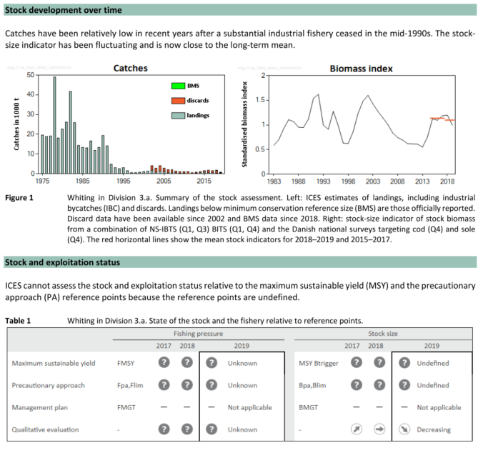(ICES 2020b)

C:\Users\moll\Desktop\whiting.tif

(Heessen et al. 2015)

|  |  |
| --- | --- |
| Sensitivity attributes | Information: Whiting |
| Habitat specificity | * Marine, brackish, benthopelagic (Froese and Pauly 2021) * Mainly on mud and grave bottoms, also on sand and rock (Froese and Pauly 2021) * Whiting showed high plasticity in spawning ground selection with extensive areas in North Sea (González-Irusta and Wright 2017) * Pelagic juveniles often associate with jellyfish near surface (Hay et al. 1990) * Older juveniles often abundant in coastal waters, including estuaries (Heessen et al. 2015) * North Sea nursery area: Scottish West coast (Tobin et al. 2010) * Spatial pattern of Sea Surface Temperature appears to affect spatial distribution in northern North Sea during winter and spring, not in summer (ICES 2006; Zheng et al. 2002) * Higher densities of age-1 whiting were also associated with fine sediments and peaked at 60 m, but this influence was also dependent on proximity to shore * Mature fish, while showing no association with any particular sediment type, were strongly associated with depths >60 m (Burns et al. 2019) * Occurrence in water depth: Ranges from shallow inshore waters (>10 m) to 550 m, high numbers in range 30-150 m, Baltic Sea largely restricted to shallower, western waters (Heessen et al. 2015) |
| Prey specificity | * *M. merlangus* are more opportunistic (Shaw et al. 2008) * Adults: Clupeids (~90% of the diet in Western Baltic Sea), dominated by *Clupea harengus* and *Sprattus sprattus* almost exclusively, sometimes also crustaceans (Pihl 1994; Ross et al. 2016) * Juveniles: Gobies, brown shrimps and polychaetes, piscivorous at smaller size in Western Baltic Sea (~10-20 cm) (Ross et al. 2016) |
| Adult mobility | * Part of Skagerrak population is thought to migrate into the north-eastern North Sea to spawn (ICES 2006) * Adult whiting have the ability to migrate large distances, tagging study showed they remained within 100 km of their release site (Tobin et al. 2010) |
| Dispersal of early life stages | * Pelagic eggs and larvae (Froese and Pauly 2021) * Pelagic phase last for ~ 6 months, before settled juveniles migrate to shallow inshore waters (remain there for further 6 months (Tobin et al. 2010) * Duration: Hatching after 10 days, depending on temperature (Heessen et al. 2015; Russell 1976) |
| Early life stage survival & settlement requirements | * Pelagic phase last for ~ 6 months, before settled juveniles migrate to shallow inshore waters (remain there for further 6 months (Tobin et al. 2010) * Most whiting mature by age 2 and individuals spawn repeatedly (North Sea) (González-Irusta and Wright 2017; Hislop 1975) |
| Complexity of reproductive strategy | * Spawning in batches over a long period (Hislop 1975) * Spawning: Jan (southern North Sea) to July in northern part (citations within (ICES 2006) * Lack of evidence for return migrations: opportunistic and non-philopatric recruitment strategy within population (Tobin et al. 2010) * High spatial fidelity to spawning site (Loots et al. 2011) |
| Population Spawning Cycle | * Spawning: Jan (southern North Sea) to July in northern part (citations within (ICES 2006), spawning in batches over a long period (Hislop 1975) |
| Sensitivity to increasing temperature | * Cold thermal preference, specialist with narrow thermal range (Dulvy et al. 2008) * Temperature effect on swimming speed, higher at higher temperatures (Özbilgin 2002) * Adults are found in shallow waters, at temperatures between 6-9°C (during spawning) (North Sea) (Loots et al. 2011) * Sensitivity to phenological changes: Existing corr. with preceding winter-T (North Sea) (Greve et al. 2005) |
| Sensitivity to decreasing salinity | * Salinity is affecting geographical distribution (Loots et al. 2011) |
| Sensitivity to Ocean Acidification | * No data/information |
| Population growth rate | * r=2\*FMSY=1\*Fpa (Froese et al. 2017)  |  |  | | --- | --- | | Maximum growth rate (rmax) | * FMSY=0.17; Fpa=0.33 (North Sea) (ICES 2019a) * r= 0.34 (North Sea) | | Von Bertalanffy K | 0.25 (Baltic Sea); 0.16-0.69 (Skagerrak-Kattegat) | | Age at maturity (tm) | 1-2 (North Sea) | | Maximum age (tmax) | 11 (Ireland, Celtic Sea) | | Natural mortality (M) | 0.34 (UK Scotland) | | Maximum length (Linf) | 41.3 cm TL |  * ([www.fishbase.org](http://www.fishbase.org), (Froese and Pauly 2021)) |
| Sensitivity to other stressors | * No data/information |

Burns, N. M., D. M. Bailey, and P. J. Wright. 2019. A method to improve fishing selectivity through age targeted fishing using life stage distribution modelling. *PLOS ONE* 14 (4): e0214459. doi: 10.1371/journal.pone.0214459.

Dulvy, N. K., S. I. Rogers, S. Jennings, V. Stelzenmüller, S. R. Dye, and H. R. Skjoldal. 2008. Climate change and deepening of the North Sea fish assemblage: a biotic indicator of warming seas. *Journal of Applied Ecology* 45 (4): 1029–1039. doi: 10.1111/j.1365-2664.2008.01488.x.

Froese, R., N. Demirel, G. Coro, K.M. Kleisner, and H. Winker. 2017. Estimating fisheries reference points from catch and resilience. *Fish and Fisheries* 18: 506-526.

Froese, R., and D. Pauly. 2021. Editors. 2021. Fishbase. World Wide Web electronic publication. www.fishbase.org (06.2021).

Froese, R., A.C. Tsikliras, G. Scarcella, and D. Gascuel. 2021. Progress towards ending overfishing in the Northeast Atlantic. *Marine Policy* 125: 104282.

González-Irusta, J.M., and P.J. Wright. 2017. Spawning grounds of whiting (*Merlangius merlangus*). *Fisheries Research* 195: 141-151.

Greve, W., S. Prinage, H. Zidowitz, J. Nast, and F. Reiners. 2005. On the phenology of North Sea ichthyoplankton. *ICES Journal of Marine Science* 62: 1216-1223.

Hay, S.J., J.R.G. Hislop, and A.M. Shanks. 1990. North Sea Scyphomedusae; summer distribution, estimated biomass and significance particularly for 0-group Gadoid fish. *Netherlands Journal of Sea Research* 25: 113-130.

Heessen, H.J.L., N. Daan, and J. Ellis. 2015. *Fish atlas of the Celtic Sea, North Sea and Baltic Sea - Based on international research-vessel surveys*. Wageningen, Netherlands: Wageningen Academic Publishers.

Hislop, J.R.G. 1975. The breeding and growth of whiting, *Merlangius merlangus* in captivity. *ICES Journal of Marine Science* 36: 119-127.

Hislop, J.R.G., A.P. Robb, M.A. Bell, and D.W. Armstrong. 1991. The diet and food consumption of whiting (*Merlangius merlangus*) in the North Sea. *ICES Journal of Marine Science* 48: 139-156.

ICES 2006. North Sea fish species fact sheets. *Merlangius merlangus*. *Available at ICES website https://www.ices.dk/data/maps/Pages/ICES-FishMap.aspx*.

ICES. 2019a. Whiting (*Merlangius merlangus*) in Subarea 4 and Division 7.d (North Sea and eastern English Channel). In Report of the ICES Advisory Committee, 2019. ICES Advice 2019, whg.27.47d, https://doi.org/10.17895/ices.advice.4878

ICES. 2019b. Whiting (*Merlangius merlangus*) in Division 3.a (Skagerrak and Kattegat). In Report of the ICES Advisory Committee, 2019. ICES Advice 2019, whg.27.3a, https://doi.org/10.17895/ices.advice.4877

ICES. 2020a. Whiting (*Merlangius merlangus)* in Subarea 4 and Division 7.d (North Sea and eastern English Channel). In Report of the ICES Advisory Committee, 2020. ICES Advice 2020, whg.27.47d. https://doi.org/10.17895/ices.advice.5935. .

ICES. 2020b. Whiting (*Merlangius merlangus*) in Division 3.a (Skagerrak and Kattegat). In Report of the ICES Advisory Committee, 2020. ICES Advice 2020, whg.27.3a. https://doi.org/10.17895/ices.advice.6103. .

Loots, C., S. Vaz, B. Planque, and P. Koubbi. 2011. Understanding what controls the spawning distribution of North Sea whiting (*Merlangius merlangus*) using a multi-model approach. *Fisheries Oceanography* 20: 18-31.

Nielsen, J.R., K. Kristensen, P. Lewy, and F. Bastardie. 2014. A statistical model for estimation of fish density including correlation in size, space, time and between species from research survey data. *PLoS ONE* 9:e99151.

Özbilgin, H. 2002. Effect of Temperature Change on Maximum Swimming Speed of Whiting, *Merlangius merlangus* (Linnaeus, 1758). *Turkish Journal of Zoology* 26: 255-262.

Pihl, L. 1994. Changes in the Diet of Demersal Fish due to Eutrophication-Induced Hypoxia in the Kattegat, Sweden. *Canadian Journal of Fisheries and Aquatic Sciences* 51 (2): 321–336. doi: 10.1139/f94-033.

Ross, S.D., H. Gislason, N.G. Andersen, P. Lewy, and J.R. Nielsen. 2016. The diet of whiting *Merlangius merlangus* in the western Baltic Sea. *Journal of Fish Biology* 88: 1965-1988.

Ross, S.D., J.R. Nielsen, H. Gislason, A. Nielsen, and N.G. Andersen. 2018. Growth and food consumption of whiting *Merlangius merlangus*. *Journal of Fish Biology* 93: 334-343.

Russell, F.S. 1976. *The Eggs and Planktonic Stages of British Marine Fishes*. London: Academic Press.

Shaw, M., R. Diekmann, J. van der Kooij, S. Milligan, P. Bromley, and D. Righton. 2008. Assessment of the diets of cod Gadus morhua and whiting *Merlangius merlangus* juveniles in a frontal region close to the Norwegian Trench: co-existence or competition? *Journal of Fish Biology* 73 (7): 1612–1634. doi: 10.1111/j.1095-8649.2008.02035.x

Tobin, D., P.J. Wright, F.M. Gibb, and I.M. Gibb. 2010. The importance of life stage to population connectivity in whiting (*Merlangius merlangus*) from the northern European shelf. *Marine Biology* 157: 1063-1073.

Zheng, X., G.J. Pierce, D.G. Reid, and I.T. Jolliffe. 2002. Does the North Atlantic current affect spatial distribution of whiting? Testing environmental hypotheses using statistical and GIS techniques. *ICES Journal of Marine Science* 59: 239-253.

**Steinbutt - Turbot (*Scophthalmus maximus/Psetta maxima*)**

**Additional information**

|  |  |
| --- | --- |
| **Distribution range in the Western Baltic Sea** | * Occurrence from Skagerrak up to the Sea of Åland (Northern Baltic Sea) (ICES 2021a) * In the Baltic Sea, mainly distributed in Baltic proper (SD 24-29), may occur up to the Bothnian Sea (Nissling et al. 2013 and ref. therein) |
| **Stock size** | * No ICES advice requested and given (complete Baltic Sea) (ICES 2021d) * Landings and trends in the survey were used to estimate stock status for the advice, MSY Btrigger is unknown, length-based indicator are stating an unsustainable stock status (ICES 2021a) * Stock size indicator is stable over time, but considered uncertain due to low catch rate in surveys (complete Baltic Sea) (ICES 2021d) * Skagerrak & Kattegat: MSY Btrigger proxy = B/BMSY = 0.5 (ICES 2021b) * BMSY = 2 x MSYBtrigger (Froese et al. 2021) * North Sea: MSY Btrigger = 6,353 t; Bpa= 4,163 t; SSB(2022) = 9,336 t (ICES 2021c) * B/BMSY=0.73 (North Sea) |
| **Recruitment** | * Signal of above-average recruitment apparent in most recent survey index (complete Baltic Sea) (ICES 2021a) |
| **Growth** | * In the North Sea: Turbot showed sexually dimorphic growth with females reaching a larger maximum body size than males (turbot ♂ L∞ = 44.5 cm, K = 0.44, t 0 = −0.14 year, ♀ L∞ = 66.7 cm, K = 0.32, t 0 = 0.29 year), the highest somatic growth takes place in the 2nd half of the year (van der Hammen et al. 2013) |
| * Mainly targeted by coastal fisheries and fishery is concentrated in the western and southern central Baltic Sea (SD22-26) (ICES 2021a) * Turbot from SD22-SD32 (complete Baltic Sea, covering western, central and northern Baltic Sea) considered as one stock (ICES 2021a) * Genetic data show no population structure within the Baltic Sea (Florin and Höglund 2007) * Genetic differences between Baltic Sea turbot and North Sea turbot with the Kattegat being a transition zone (Nielsen et al. 2004) | |

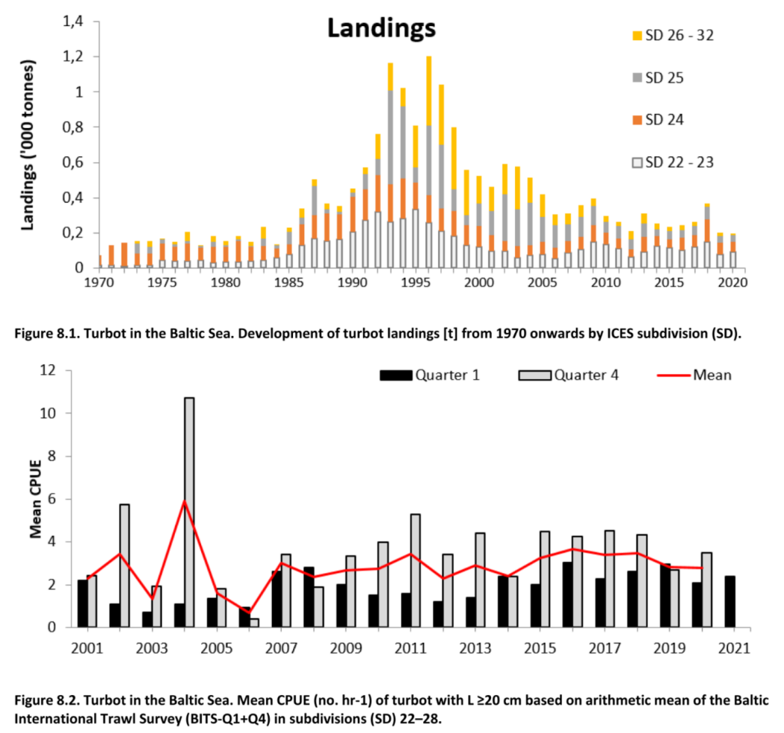(ICES 2021a)

|  |  |
| --- | --- |
| Sensitivity attributes | Information: Turbot |
| Habitat specificity | * Sandy, muddy-sandy, gravel bottoms at depth of 1-15 m (central Baltic Sea) (Aarnio et al. 1996) * Seldom caught at depths more than 70 m (Florin and Höglund 2007 and ref. therein) * High spawning site fidelity (central Baltic Sea) (Florin and Franzén 2010) * Coastal species, spawns in shallow waters (10-40 m, 10-15 m in central Baltic) (ICES 2021a), feeds in deeper waters (Florin and Franzén 2010) * Age-0: preference for 0.2 and 0.6 m over 1 m depth, overlap with flounder age-0 (central Baltic Sea) (Martinsson and Nissling 2011) * Juveniles prefer sandy substrate with low cover of filamentous algae (central Baltic Sea) (Florin et al. 2009) * Age-1: remain close to the shore during the first 2 years (Skagerrak-Kattegat) (Støttrup et al. 2002) |
| Prey specificity | * < 20 cm: mainly mysids, crangon, fish (sand goby), > 20 cm: mysids, crangon, increased share of fish (sand goby, sandeel, miscellaneous roundfish and flatfish) (Kattegat) (Sparrevohn and Støttrup 2008) * Juveniles < 30 mm: amphipods, ≥ 30mm mysids, amphipods and fish (gobies, sand eels, nine-spined sticklebacks) (central Baltic Sea) (Aarnio et al. 1996) * Juveniles < 30 mm: calanoid copepods, mysdis, chironomids, amphipods; juveniles ≥ 30 mm: mysids, fish (central Baltic Sea) (Nissling et al. 2007) |
| Adult mobility | * In a tagging study the majority individuals were recaptured less than 30 km from tagging site over a period of about three years (central Baltic Sea) (Florin and Franzén 2010) * Rather sedentary (Florin and Höglund 2007; ICES 2013) |
| Dispersal of early life stages | * Demersal eggs (central Baltic Sea) (not buoyant at salinities below 20 psu) (Aarnio et al. 1996; Nissling et al. 2006) * Eggs are pelagic in marine environment (Nissling et al. 2013) * Days until hatch: 9°C – 12 days, 12°C – 8 days, 15°C – 6 days, 18°C – 4 days, 21°C – 3 to 4 days (central Baltic Sea) (Nissling et al. 2006) * Larvae are pelagic at the start (central Baltic Sea) (Aarnio et al. 1996 and ref. therein) * Transportation of larvae to suitable nursery areas might be less critical; rather prevailing salinity conditions and upwelling situation may influence number of settlers (central Baltic Sea) (Nissling et al. 2006) |
| Early life stage survival & settlement requirements | * Year-class strength of turbot in Baltic Sea more variable, presumably due to varying abiotic conditions (Nissling et al. 2013 and ref. therein) * Larvae (yolk-sac) optimal growth efficiency: at 15°C (Jones 1972) * Metamorphosed post larvae migrate close to shore to shallow water (down to one meter depth) (Florin and Franzén 2010; ICES 2021a) * Age-0: preference for 0.2 and 0.6 m over 1 m depth (central Baltic Sea) (Martinsson and Nissling 2011) |
| Complexity of reproductive strategy | * Complex live cycle with individuals of each life history stage having different habitat requirements and inhabit spatially distinct habitats (van der Hammen et al. 2013) * Spawning site fidelity (central Baltic) (Florin and Franzén 2010; ICES 2021a) * Batch-spawning at shallow depths along the coast and offshore banks (western and central Baltic Sea) (Nissling et al. 2013) * Spawning seems to be triggered by specific temperature (13-15°C) in combination with certain daylength (15-16 h) (experimental animals presumably not from Baltic Sea, Skagerrak, Kattegat or North Sea) (Devauchelle et al. 1988) * Decreased reproductive success at salinities < 7 psu (central Baltic Sea) (Nissling et al. 2006) |
| Population Spawning Cycle | * Spawn from May-July (western and central Baltic Sea) (Nissling et al. 2013) |
| Sensitivity to increasing temperature | * Larvae (yolk-sac) optimal growth efficiency: at 15°C (Jones 1972) * Spawning seems to be triggered by specific temperature (13-15°C) in combination with certain daylength (15-16 h) (experimental animals presumably not from Baltic Sea, Skagerrak, Kattegat or North Sea) (Devauchelle et al. 1988) * 12-18°C: optimum condition for egg development and hatching; considerably lower viable hatch at 9°C and 21°C (central Baltic Sea) (Nissling et al. 2006) * Relatively eurythermal with a geographic range from Norway to the Mediterranean (Gibson and Johnston 1995) * Productivity is highest in areas where the maximum temperature is close to the optimal temperature for growth (16-18 °C) (van der Hammen et al. 2013) |
| Sensitivity to decreasing salinity | * Adapted to low salinity and spawn successfully up to the northern Baltic Sea (Florin 2005) * Range of salinity for spawning from 15-10 psu in the Belt Sea (western Baltic Sea) (Nissling et al. 2006 and ref. therein) down to 7 psu (central Baltic Sea) (Nissling et al. 2006) * Threshold for viable hatch: < 7 psu; lethal for eggs/no viable hatch at 5 psu (central Baltic Sea) (Nissling et al. 2006) * Landings drop to zero where salinity falls below ~5 psu (central Baltic Sea) (van der Hammen et al. 2013) * At low salinities higher rate of deformities is observed (experimental animals presumably not from Baltic Sea, Skagerrak, Kattegat or North Sea) (Devauchelle et al. 1988) |
| Sensitivity to Ocean Acidification | * Juvenile turbot reared at increased CO2-levels (pH 6.6, 6.4) lead to reduced condition, feeding, weight gain and growth rates compared to low treatment (pH 7.3), growth rates were reduced between 21-58 % (Stiller et al. 2015) |
| Population growth rate | * r=2\*FMSY=1\*Fpa (Froese et al. 2017)  |  |  | | --- | --- | | Maximum growth rate (rmax) | * FMSY= 0.36 (ICES 2021c) * r=0.72 (North Sea) | | Von Bertalanffy K | * K♂= 0.30, K♀=0.19 (Central Baltic Sea) (Stankus 2003) | | Age at maturity (tm) | * ♀= 3 years (Central Baltic Sea) (Nissling et al. 2013) | | Maximum age (tmax) | * 35 (North Sea) (van der Hammen et al. 2013) | | Natural mortality (M) | * 0.1-0.25 (Central Baltic Sea) (Draganik et al. 2005) | | Maximum length (Linf) | * ♀=54.7 cm (western and central Baltic Sea) (ICES 2021a) | |
| Sensitivity to other stressors | * Juvenile turbot: pH 6.8-7.8 recommended for rearing turbot; at pH 7.8-8.8 significantly reduced survival rate compared to lower pH (6.3-7.3) (Shuangyao et al. 2018) * High tolerance for O2 deficient waters (Maxime et al. 2000) |

Aarnio, K., E. Bonsdorff, and N. Rosenback. 1996. Food and feeding habits of juvenile flounder *Platichthys flesus* (L.), abd turbot *Scophthalmus maximus* L. in the Åland archipelago, northern Baltic Sea. *Journal of Sea Research* 36: 311-320.

Devauchelle, N., J.C. Alexandre, N. Le Corre, and Y. Letty. 1988. Spawning of turbot (*Scophthalmus maximus*) in captivity. *Aquaculture* 69: 159-184.

Draganik, B., Y. Maksimov, and S. Ivanov. 2005. The status of the turbot *Psetta Maxima* (L.) stock supporting Baltic fishery. *Bulletin of the Sea Fisheries Institute,* 1: 23-53.

Florin, A.-B., and F. Franzén. 2010. Spawning site fidelity in Baltic Sea turbot (*Psetta maxima*). *Fisheries Research* 102: 207-213.

Florin, A.-B., and J. Höglund. 2007. Absence of population structure of turbot (*Psetta maxima*) in the Baltic Sea. *Molecular Ecology* 16: 115-126.

Florin, A.-B., G. Sundblad, and U. Bergström. 2009. Characterisation of juvenile flatfish habitats in the Baltic Sea. *Estuarine, Coastal and Shelf Science* 82: 294-300.

Florin, A.B. 2005. Flatfishes in the Baltic Sea - a review of biology and fishery with a focus on Swedish conditions. *Institute of Coastal Research, Swedish Board of Fisheries*.

Froese, R., N. Demirel, G. Coro, K.M. Kleisner, and H. Winker. 2017. Estimating fisheries reference points from catch and resilience. *Fish and Fisheries* 18: 506-526.

Froese, R., A.C. Tsikliras, G. Scarcella, and D. Gascuel. 2021. Progress towards ending overfishing in the Northeast Atlantic. *Marine Policy* 125: 104282.

Gibson, S., and I.A. Johnston. 1995. Temperature and development in larvae of the turbot *Scophthalmus maximus*. *Marine Biology* 124: 17-25.

ICES. 2013. Report of the Working Group on Assessment of New MoU Species (WGNEW), 18 - 22 March 2013, ICES HQ, Copenhagen, Denmark. ACOM.

ICES. 2021a. Baltic Fisheries Assessment Working Group (WGBFAS). ICES Scientific Reports. 3:53. 717 pp. https://doi.org/10.17895/ices.pub.8187.

ICES. 2021b. Turbot (*Scophthalmus maximus*) in Division 3.a (Skagerrak and Kattegat). In Report of the ICES Advisory Committee, 2021. ICES Advice 2021, tur.27.3a. https://doi.org/10.17895/ices.advice.7878.

ICES. 2021c. Turbot (*Scophthalmus maximus*) in Subarea 4 (North Sea). In Report of the ICES Advisory Committee, 2021. ICES Advice 2021, tur.27.4. https://doi.org/10.17895/ices.advice.7879. .

ICES. 2021d. Turbot (*Scophthalmus maximus*) in Subdivisions 22-32 (Baltic Sea). In Report of the ICES Advisory Committee, 2021. ICES Advice 2021, tur.27.22-32. <https://doi.org/10.17895/ices.advice.7877>.

Jones, A. (1972). Studies on egg development and larval rearing of turbot, *Scophthalmus aximus* L., and Brill, *Scophthalmus rhombus* L., in the laboratory. *Journal of the Marine Biological Association of the United Kingdom*, *52*(4), 965–986. https://doi.org/10.1017/S0025315400040698

Martinsson, J., and A. Nissling. 2011. Nursery area utilization by turbot (*Psetta maxima*) and flounder (*Platichthys flesus*) at Gotland, central Baltic Sea. *Boreal Environment Research* 16: 60-70.

Maxime, V., K. Pichavant, G. Boeuf, and G. Nonnotte. 2000. Effects of hypoxia on respiratory physiology of turbot, *Scophthalmus maximus*. *Fish Physiology and Biochemistry* 22: 51-59.

Nielsen, E.E., P.H. Nielsen, D. Meldrup, and M.M. Hansen. 2004. Genetic population structure of turbot (*Scophthalmus maximus* L.) supports the presence of multiple hybrid zones for marine fishes in the transition zone between the Baltic Sea and the North Sea. 13: 585-595.

Nissling, A., A.-B. Florin, A. Thorsen, and U. Bergström. 2013. Egg production of turbot, *Scophthalmus maximus*, in the Baltic Sea. *Journal of Sea Research* 84: 77-86.

Nissling, A., M. Jacobsson, and N. Hallberg. 2007. Feeding ecology of juvenile turbot *Scophthalmus maximus* and flounder *Pleuronectes flesus* at Gotland, Central Baltic Sea. *Journal of Fish Biology* 70: 1877-1897.

Nissling, A., U. Johansson, and M. Jacobsson. 2006. Effects of salinity and temperature conditions on the reproductive success of turbot (*Scophthalmus maximus*) in the Baltic Sea. *Fisheries Research* 80: 230-238.

Shuangyao, W., J. Zhiqiang, M. Mingguang, M. Shoukang, S. Yang, and S. Youzhen. 2018. Effects of seawater pH on survival, growth, energy budgetand oxidative stress parameters of juvenile turbot *Scophthalmus maximus*. *Iranian Journal of Fisheries Sciences* 17: 675-689.

Sparrevohn, C.R., and J.G. Støttrup. 2008. Diet, Abundance, and Distribution as Indices of Turbot (*Psetta maxima* L.) Release Habitat Suitability. *Reviews in Fisheries Science* 16: 338-347.

Stankus, S. 2003. The Peculiarities of Turbot (*Psetta Maxima* L.) Biology and their Role in the Ecosystem of the Baltic Sea Coastal Zone of Lithuania. *Acta Zoologica Lituanica* 13: 217-238.

Stiller, K.T., K.H. Vanselow, D. Moran, G. Bojens, W. Voigt, S. Meyer, and C. Schulz. 2015. The effect of carbon dioxide on growth and metabolism in juvenile turbot *Scophthalmus maximus* L. *Aquaculture* 444: 143-150.

Støttrup, J.G., C.R. Sparrevohn, J. Modin, and K. Lehmann. 2002. The use of releases of reared fish to enhance natural populations: A case study on turbot *Psetta maxima* (Linné, 1758). *Fisheries Research* 59: 161-180.

van der Hammen, T., J.J. Poos, H.M.J. van Overzee, H.J.L. Heessen, A. Magnusson, and A.D. Rijnsdorp. 2013. Population ecology of turbot and brill: What can we learn from two rare flatfish species? *Journal of Sea Research* 84: 96-108.

**Glattbutt - Brill (*Scophthalmus rhombus*)**

**Additional information**

|  |  |
| --- | --- |
| **Distribution range in the Western Baltic Sea** | * Brill is distributed mainly in the western part of the Baltic Sea (Pomeranian Bay) (Więcaszek et al. 2019), the eastern border of its occurrence is not clearly described (ICES 2020a) * Cape Arkona, around Bornholm (Heessen et al. 2015) * No definition of eastern limit of its range, Gulf of Dansk (rare), single specimen mid-Polish coast and Latvian waters (citations in Więcaszek et al. 2019) * Some catches of juveniles in the Baltic Sea, not comparable with turbot (Expert information) * According to survey estimation at the edge of its distributional area in SD22-32, center of gravity in Kattegat (ICES 2021) * Located in Kattegat, catch area: Oderbank (Expert information) |
| **Stock size** | * Unclear whether it is one stock in Baltic Sea or if *S. rhombus* is a part of a larger stock complex (Więcaszek et al. 2019) * Baltic Sea: Stock size indicator: high in 2011, declined in 2012, increasing since 2016 (ICES 2020b), no reference points defined: BMSY/Bpa/MSY Btrigger (ICES 2017; ICES 2020b) * MSY B trigger proxy=B/BMSY= 0.5 (North Sea) (ICES 2019) |
| **Recruitment** | * No data/information |
| **Growth** | * Fast growing (Kerby et al. 2013) * Turbot and brill from the North Sea showed sexually dimorphic growth with females reaching a larger maximum body size than males (brill ♂ L∞ = 43.3 cm, K =0.48, t 0 = −0.27 year, ♀ L∞ = 58.0 cm, K = 0.38, t 0 = −0.27 year) * The highest somatic growth takes place in the 2nd half of the year (van der Hammen et al. 2013) |
| * Brill fishery is dominated by Denmark in SD 22 (95% of the catches in 1985–2016) (ICES 2020a) * Yearly landings within the Baltic Sea have varied between 27 and 105 t. during the last ten years (ICES 2020a) * Data limited species, stock is not regulated by TAC (ICES 2017; Kerby et al. 2013) * Mainly bycatch species in fisheries for plaice and sole (ICES 2019) | |

**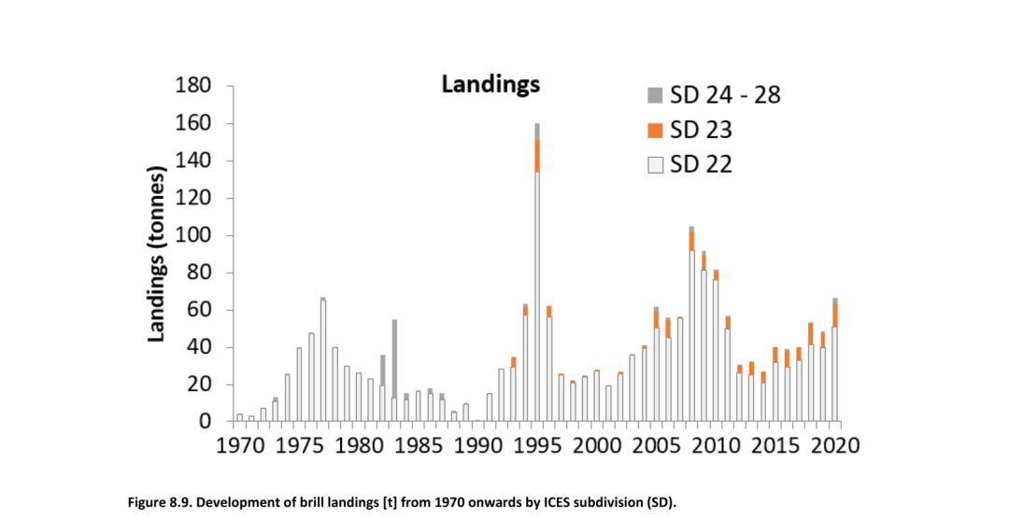**(ICES 2021)

**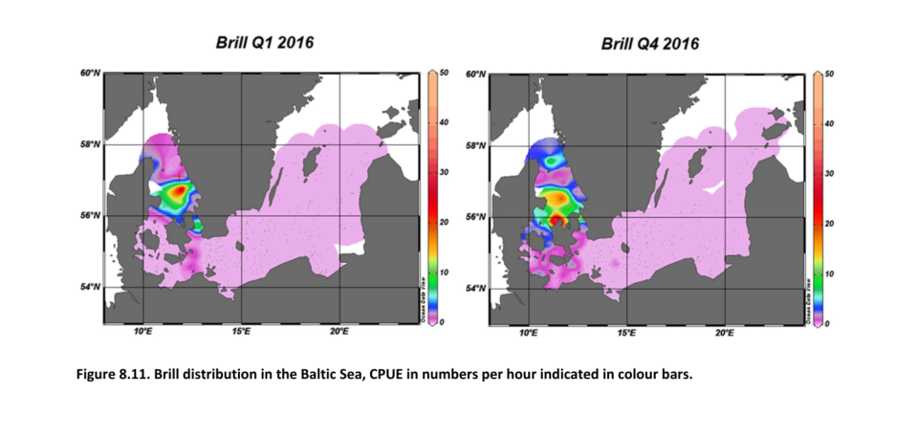**(ICES 2021)

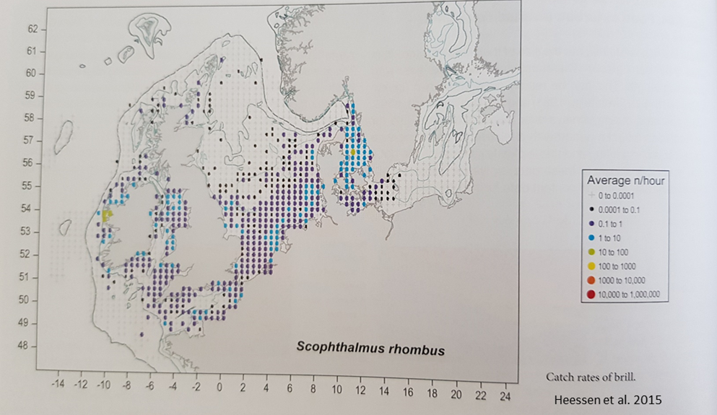

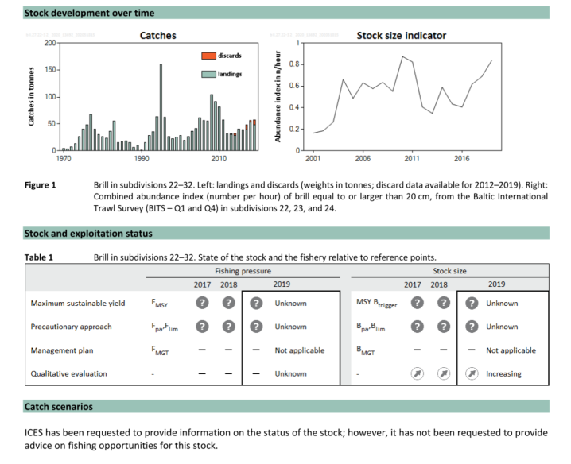(ICES 2020b)

|  |  |
| --- | --- |
| Sensitivity attributes | Information: Brill |
| Habitat specificity | * Demersal, living on sandy and muddy bottoms in shallow water (Turan et al. 2016) * Close to inshore areas on sandy bottoms, sometimes also on gravel (Kerby et al. 2013) * Juveniles reside on sandy beach nursery grounds (Haynes et al. 2011) |
| Prey specificity | * Rather narrow prey-spectrum * Juveniles feed on mysids, shrimps and juvenile gobies (Beyst et al. 1999; Haynes et al. 2011) * Adults are piscivorous (Piet et al. 1998), prey on *Neogobius melanostomus* (new food item) (Więcaszek et al. 2019) and sandeels, cephalopods, to a lesser extent crustaceans and bivalves (Froese and Pauly 2021; Turan et al. 2016) * Feed mainly on fish (stable isotope signal) (Expert information) |
| Adult mobility | * Short migrations to deeper waters during autumn/winter, spawning site fidelity is assumed (Florin 2005) |
| Dispersal of early life stages | * Kattegat: Eggs and larvae are transported to nurseries by Baltic surface current and wind-induced on-shore currents (Pihl 1989) * Larvae are transported by wind-driven currents to the surf zone of sandy beach nurseries (van der Hammen et al. 2013; Van der Land 1991) |
| Early life stage survival & settlement requirements | * Egg viability decreased at ~16°C, hatching success low, when incubation temperature >16°C (Hachero-Cruzado et al. 2007) * Some catches of juveniles in the Baltic Sea, not comparable with turbot (Expert information) |
| Complexity of reproductive strategy | * In Atlantic: Spawning is sequential, every 2-4 days (Turan et al. 2016) * Pelagic eggs are spawned offshore (van der Hammen et al. 2013) * Turbot and brill have complex life cycles, individuals of each life history stage have different habitat requirements and inhabit spatially distinct habitats * Populations can only survive in areas where these habitat requirements are fulﬁlled (van der Hammen et al. 2013) |
| Population spawning cycle | * May-August (North Sea) (Jones 1972) * Protected spawning period (turbot ad brill) assumed summer spawning in June-July (Baltic Sea) (Florin 2005) |
| Sensitivity to increasing temperature | * Egg viability decreased at ~16°C, hatching success low, when incubation temperature >16°C (Atlantic, Spain) (Hachero-Cruzado et al. 2007) * Productivity is highest in areas where the maximum temperature is close to the optimal temperature for growth (16–18 °C) (North Sea) (van der Hammen et al. 2013) |
|
| Sensitivity to decreasing salinity | * Landings decrease where salinity falls below ~15 psu (brill) (North Sea) (van der Hammen et al. 2013) * Limited to salinity (Expert information) |
| Sensitivity to Ocean Acidification | * No data/information |
| Population growth rate | * Slower in the northern parts, maturation is attained at shorter lengths (no precise data, Więcaszek et al. 2019)  |  |  | | --- | --- | | Maximum growth rate (rmax) | * No reference points (Baltic Sea) * 0.47 (Froese and Pauly 2021) | | Von Bertalanffy K | * 0.32-0.59 (Southern North Sea) | | Age at maturity (tm) | * 3 (North Sea, Western Scheldt) | | Maximum age (tmax) | * 5 (Atlantic, France) | | Natural mortality (M) | * No data | | Maximum length (Linf) | * 40.2 cm TL |  * ([www.fishbase.org](http://www.fishbase.org), (Froese and Pauly 2021)) |
| Sensitivity to other stressors | * No data/information |

Beyst, B., A. Cattrijsse, and J. Mees. 1999. Feeding ecology of juvenile flatfishes of the surf zone of a sandy beach. *Journal of Fish Biology* 55: 1171-1186.

Florin, A.B. 2005. Flatfishes in the Baltic Sea - a review of biology and fishery with a focus on Swedish conditions. *Institute of Coastal Research, Swedish Board of Fisheries*.

Froese, R., and D. Pauly. 2021. Editors. 2021. Fishbase. World Wide Web electronic publication. www.fishbase.org (06/10.2021).

Hachero-Cruzado, I., Á. García-López, M. Herrera, L. Vargas-Chacoff, G. Martínez-Rodríguez, J.M. Mancera, and J.I. Navas. 2007. Reproductive performance and seasonal plasma sex steroid and metabolite levels in a captive wild broodstock of brill *Scophthalmus rhombus* L. *Aquaculture Research* 38: 1161-1174.

Haynes, P.S., D. Brophy, F. De Raedemaecker, and D. McGrath. 2011. The feeding ecology of 0 year-group turbot *Scophthalmus maximus* and brill *Scophthalmus rhombus* on Irish west coast nursery grounds. *Journal of Fish Biology* 79: 1866-1882.

Heessen, H.J.L., N. Daan, and J. Ellis. 2015. *Fish atlas of the Celtic Sea, North Sea and Baltic Sea - Based on international research-vessel surveys*. Wageningen, Netherlands: Wageningen Academic Publishers.

ICES. 2017. Brill (*Scophthalmus rhombus*) in subdivisions 22–32 (Baltic Sea). In Report of the ICES Advisory Committee, 2017. ICES Advice 2017, bll.27.22-32. DOI: 10.17895/ices.pub.3057.

ICES. 2019. Brill (*Scophthalmus rhombus*) in Subarea 4 and divisions 3.a and 7.d-e (North Sea, Skagerrak and Kattegat, English Channel). In Report of the ICES Advisory Committee, 2019. ICES Advice 2019, bll.27.3a47de, https://doi.org/10.17895/ices.advice.4858.

ICES. 2020a. Baltic Fisheries Assessment Working Group (WGBFAS). ICES Scientific Reports. 2:45. 643 pp. http://doi.org/10.17895/ices.pub.6024

ICES. 2020b. Brill (*Scophthalmus rhombus*) in subdivisions 22–32 (Baltic Sea). In Report of the ICES Advisory Committee, 2020. ICES Advice 2020, bll.27.22-32. https://doi.org/10.17895/ices.advice.5774.

ICES. 2021. Baltic Fisheries Assessment Working Group (WGBFAS). ICES Scientific Reports. 3:53. 717 pp. https://doi.org/10.17895/ices.pub.8187.

Jones, A. 1972. Studies on egg development and larval rearing of turbot, *Scophthalmus maximus* L., and brill, *Scophthalmus rhombus* L., in the Laboratory. *J. mar. biol. Ass. U.K.* 52: 965-986.

Kerby, T.K., W.W.L. Cheung, C. van Oosterhout, and G.H. Engelhard. 2013. Entering uncharted waters: Long-term dynamics of two data limited fish species, turbot and brill, in the North Sea. *Journal of Sea Research* 84: 87-95.

Piet, G.J., A.B. Pfisterer, and A.D. Rijnsdorp. 1998. On factors structuring the flatfish assemblage in the southern North Sea. *Journal of Sea Research* 40: 143-152.

Pihl, L. 1989. Abundance, biomass and production of juvenile flatfish in southeastern Kattegat. *Netherlands Journal of Sea Research* 24: 69-81.

Turan, C., D. Yağlioğlu, D. Ergüden, M. Gürlek, A. Uyan, S. Karan, and S. Doğdu. 2016. Threatened brill species in marine waters of Turkey: *Scopthalmus rhombus* (Linnaeus, 1758) (Scopthalmidae). *Natural and Engineering Sciences* 1: 1-6.

van der Hammen, T., J.J. Poos, H.M.J. van Overzee, H.J.L. Heessen, A. Magnusson, and A.D. Rijnsdorp. 2013. Population ecology of turbot and brill: What can we learn from two rare flatfish species? *Journal of Sea Research* 84: 96-108.

Van der Land, M.A. 1991. Distribution of flatfish eggs in the 1989 egg surveys in the southeastern North Sea, and mortality of plaice and sole eggs. *Netherlands Journal of Sea Research* 27: 277-286.

Więcaszek, B., E. Sobecka, S. Keszka, R. Panicz, K. Górecka, A. Linowska, and S. Król. 2019. Three new records of fishes and their parasite fauna from Pomeranian Bay, Baltic Sea. *Acta Ichthyologica et Piscatoria* 49: 65-73.

**Kliesche - Common dab (*Limanda limanda*)**

**Additional information**

|  |  |
| --- | --- |
| **Distribution range in the Western Baltic Sea** | * Skagerrak and Kattegat, southern part Baltic Sea, Gotland (Florin 2005; Temming 1989); SD 24+25 (Nissling et al. 2002) |
| **Stock size** | * Baltic Sea: Stock size indicator increased since the early 2000s and remained stable since 2010 with some variability (ICES 2017; ICES 2020) * SD 22-32 (Baltic Sea): No reference point for defined (ICES 2017; ICES 2020) * BMSY=2\*Bpa (Froese et al. 2021) * North Sea, Skagerrak and Kattegat: MSY Btrigger proxy= B/BMSY= 0.5 (relative value) (ICES 2019) |
| **Recruitment** | * No data/information |
| **Growth** | * Differences in growth between populations: dab in Icelandic waters grow slower than Baltic (Henderson 1998), Comparison Irish Sea and Central North Sea (citations in Henderson 1998): Females: west coast: W∞=398 g, K= 0.31, east coast W∞=328.5 g, K= 0.21; males: west coast W∞=110 g, K=0.06, east coast W∞=95.9 g, K= 0.44 |
| * Three dab populations: Belt Sea (SD 22 and 24), Sound (SD 23) and Arkona and Bornholm basins (SD24 and 25) (ICES 2018) * Morphological differences between Bornholm dab and western dab (Temming 1989) * Two stocks are discussed, comparison of dab eggs from Kiel Bay and North Sea showed a reduced chorion in Kiel Bay eggs, indicating genetic adaption to float in low salinities (Lønning and Solemdal 1972; Temming 1989) | |

**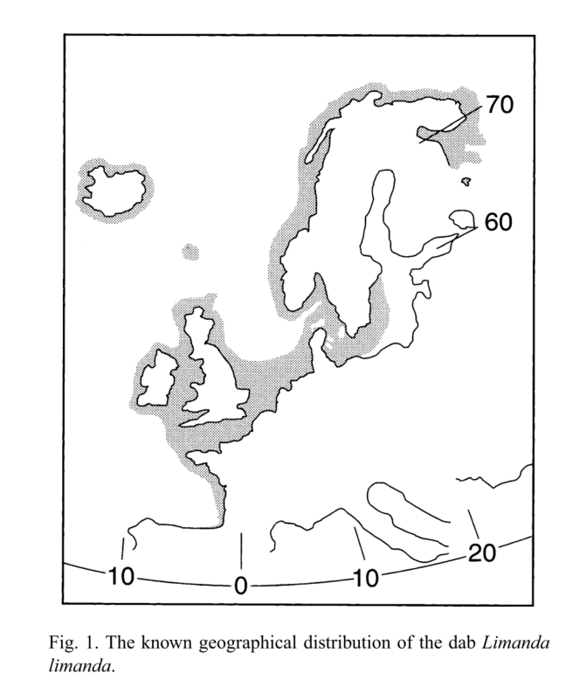** (Henderson 1998)**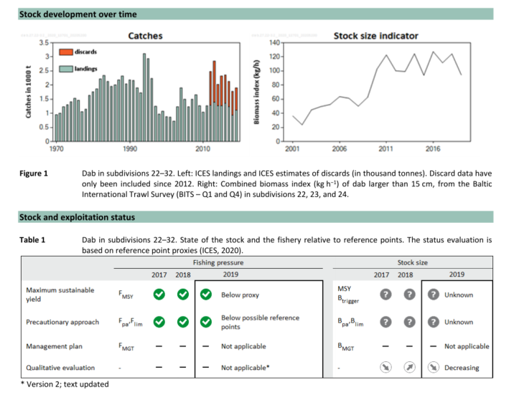**

(ICES 2020)

|  |  |
| --- | --- |
| Sensitivity attributes | Information: Dab |
| Habitat specificity | * Spawning: offshore (North Sea), eggs and larvae in coastal areas (Henderson 1998), settlement in coastal areas (Bolle et al. 1994) * Occurrence water depth: Juveniles: 5-11m (Pihl 1989), 20-40 m, areas of highest abundance within 50 m (North Sea) (Bohl 1957, in Henderson 1998) |
| Prey specificity | * Juveniles: Broader prey spectrum opportunistic: Benthic prey (polychaetes), cyprid larvae, hydrozoans, postlarval shrimps, amphipods (Amara et al. 2001; Beyst et al. 1999; Malzahn and Boersma 2009) * Adults: Crustaceans, polychaetes most important, also fish eggs and fish and mollusks, bryozoans and hydroids (Braber and de Groot 1973) * highly opportunistic (Hinz et al. 2005) |
| Adult mobility | * Adult spawn offshore, in autumn juveniles migrate inshore to shallow waters, January migration to deeper waters after arrival of colder weather (Henderson 1998), dab is found in coastal waters until age 2+, then moving offshore to join adults |
| Dispersal of early life stages | * Pelagic eggs: Egg duration:33 days at 2°C to 4.5 days at 14°C (North Sea) (Henderson 1998) * D (days)=22 exp(-0.12T (temp.)) (North Sea) (stated in Henderson 1998) * Kattegat: Eggs and larvae are transported to nurseries by Baltic surface current and wind-induced on-shore currents (Pihl 1989) |
| Early life stage survival & settlement requirements | * Settlement (North Sea): Both in coastal and offshore waters (Bolle et al. 1994) * Larvae: Dino-flagellates, followed by tintinnids and copepod nauplii (Last 1978) |
| Complexity of reproductive strategy | * Spawning in Öresund strait, Arkona and Bornholm basin (Nissling et al. 2002) * Spawning grounds offshore: 30-50 m (Henderson 1998) * Age first reproduction (North Sea): 1-2 years, batch spawner (citations in Henderson 1998) |
| Population Spawning Cycle | * Spawning period: Feb-May (Kattegat), March-June in SD 22 (Florin 2005) * Jan-May (North Sea) (Van der Land 1991) |
| Sensitivity to increasing temperature | * Optimal growth young dab: 15-18°C, >18°C decline in feeding and growth (Bolle et al. 1994) * Sensitivity to phenological changes: Correlation with preceding winter t (North Sea) (Greve et al. 2005) |
| Sensitivity to decreasing salinity | * Eggs do not tolerate low salinity (Florin 2005) * Eggs do not float below 12 psu (Temming 1989) * Salinity at which 1% of the egg batches in the population will obtain neutral egg buoyancy is 17.8 psu (Nissling et al. 2002) |
| Sensitivity to Ocean Acidification | * No data/information |
| Population growth rate | |  |  | | --- | --- | | Maximum growth rate (rmax) | * No data /information | | Von Bertalanffy K | * 0.19 (Western Baltic Sea), 0.25 (Baltic Sea) | | Age at maturity (tm) | * 2.3 years (North Sea) | | Maximum age (tmax) | * 12 years (North Sea) | | Natural mortality (M) | * 0.37 (North Sea) | | Maximum length (Linf) | * 33.4 cm TL |  * ([www.fishbase.org](http://www.fishbase.org)) (Froese and Pauly 2021) |
| Sensitivity to other stressors | * Pathogens, predation, parasites (Henderson 1998) * Juvenile dab showed reduced growth at 50% O2-saturation (during 20 days period) (Kattegat) (Petersen and Pihl 1995) * Dab were present in the Kattegat area down to 10-20% saturation level, assuming higher physiological tolerance to low oxygen, frequency of eating decreased during hypoxic (<30% O2-saturation) (Kattegat) (Petersen and Pihl 1995) * Toxic explosive compounds from dumpsite in Baltic Sea are accumulated in biles and pose a risk to fish health (Western Baltic Sea) (Koske et al. 2020) |

Amara, R., P. Laffargue, J.M. Dewarumez, C. Maryniak, F. Lagardére, and C. Luzac. 2001. Feeding ecology and growth of O-group flatfish (sole, dab and plaice) on a nursery ground (Southern Bight of the North Sea). *Journal of Fish Biology* 58: 788-803.

Beyst, B., A. Cattrijsse, and J. Mees. 1999. Feeding ecology of juvenile flatfishes of the surf zone of a sandy beach. *Journal of Fish Biology* 55: 1171-1186.

Bohl, H. 1957. Die Biologie der Kliesche (*Limanda limanda* L.) in der Nordsee. *Berichte der Deutschen Wissenschaftlichen Kommission für Meeresforschung* 15: 1-57.

Bolle, L.J., R. Dapper, J.I.J. Witte, and H.W. Van Der Veer. 1994. Nursery grounds of dab (*Limanda limanda* L.) in the southern North Sea. *Netherlands Journal of Sea Research* 32: 299-307.

Braber, L., and S.J. de Groot. 1973. The food of five flatfish species (Pleuronectiformes) in the southern North Sea. *Netherlands Journal of Sea Research* 6: 163-172.

Florin, A.B. 2005. Flatfishes in the Baltic Sea - a review of biology and fishery with a focus on Swedish conditions. *Institute of Coastal Research, Swedish Board of Fisheries*.

Froese, R., and D. Pauly. 2021. Editors. 2021. Fishbase. World Wide Web electronic publication. www.fishbase.org (06/10.2021).

Froese, R., A.C. Tsikliras, G. Scarcella, and D. Gascuel. 2021. Progress towards ending overfishing in the Northeast Atlantic. *Marine Policy* 125: 104282.

Henderson, P.A. 1998. On the variation in dab *Limanda limanda* recruitment: a zoogeographic study. *Journal of Sea Research* 40: 131-142.

Hinz, H., I. Kröncke, and S. Ehrich. 2005. The feeding strategy of dab *Limanda limanda* in the southern North Sea: linking stomach contents to prey availability in the environment. *Journal of Fish Biology* 67: 125-145.

ICES. 2017. Dab (*Limanda limanda*) in subdivisions 22–32 (Baltic Sea). In Report of the ICES Advisory Committee, 2017. ICES Advice 2017, dab.27.22-32. https://doi.org/10.17895/ices.pub.3105.

ICES. 2018. Baltic Fisheries Assessment Working Group (WGBFAS), 6–13 April 2018, ICES HQ, Copenhagen, Denmark. 748 pp. .

ICES. 2019. Dab (*Limanda limanda*) in Subarea 4 and Division 3.a (North Sea, Skagerrak and Kattegat). In Report of the ICES Advisory Committee, 2019. ICES Advice 2019, dab.27.3a4, https://doi.org/ 10.17895/ices.advice.5641.

ICES. 2020. Dab (*Limanda limanda*) in subdivisions 22–32 (Baltic Sea). In Report of the ICES Advisory Committee, 2020. ICES Advice 2020, dab.27.22-32. https://doi.org/10.17895/ices.advice.5776.

Koske, D., K. Straumer, N.I. Goldenstein, R. Hanel, T. Lang, and U. Kammann. 2020. First evidence of explosives and their degradation products in dab (*Limanda limanda* L.) from a munition dumpsite in the Baltic Sea. *Marine Pollution Bulletin* 155: 111131.

Last, J.M. 1978. The food of four species of pleuronectiform larvae in the eastern English Channel and southern North Sea. *Marine Biology* 45: 359-368.

Lønning, S., and P. Solemdal. 1972. The relation between thickness of chorion and specific gravity of eggs from Norwegian and Baltic flatfish populations. *FiskDir. Skr. Ser. HavUnders.* 16: 77-87.

Malzahn, A.M., and M. Boersma. 2009. Trophic flexibility in larvae of two fish species (lesser sandeel, *Ammodytes marinus* and dab, *Limanda limanda*). *Scientia Marina* 73: 131-139.

Nissling, A., L. Westin, and O. Hjerne. 2002. Reproductive success in relation to salinity for three flatfish species, dab (*Limanda limanda*), plaice (*Pleuronectes platessa*), and flounder (*Pleuronectes flesus*), in the brackish water Baltic Sea. *ICES Journal of Marine Science* 59: 93-108.

Petersen, J.K., and L. Pihl. 1995. Responses to hypoxia of place, Pleuronectes platessa, and dab, *Limanda limanda,* in the south-east Kattegat: distribution and growth. *Environmental Biology of Fishes* 43: 311-321.

Pihl, L. 1989. Abundance, biomass and production of juvenile flatfish in southeastern Kattegat. *Netherlands Journal of Sea Research* 24: 69-81.

Temming, A. 1989. Migration and mixing of dab (*Limanda limanda*) in the Baltic. *Rapports et procès-verbaux des Réunions. Conseil International pour l’Éxploration de la Mer* 190: 25-38.

Van der Land, M.A. 1991. Distribution of flatfish eggs in the 1989 egg surveys in the southeastern North Sea, and mortality of plaice and sole eggs. *Netherlands Journal of Sea Research* 27: 277-286.

**Flunder - European flounder (*Platichthys flesus*)**

**Additional information**

|  |  |
| --- | --- |
| **Distribution range in the Western Baltic Sea** | * In the Baltic Sea, *Platichthys* spp. distributed in all subdivisions, except SD 31+32 (Bagge and Steffensen 1989; Momigliano et al. 2018; Nissling et al. 2002) * Share of pelagic spawners (*P. flesus*) decreases from west to east (except in SD26) and share of demersal spawners (*P. solemdali*) increases (ICES 2021a):   + Share of pelagic spawners:   SD24 – 97%, SD25 – 76%, SD26 – 98%, SD28 – 24%, SD32 – 8% |
| **Stock size** | * Trend-based assessments (length-based indicator) for all Baltic flounder stocks (ICES 2021a) * No advice requested and given for stock SD22-23 (Western Baltic Sea): Stock size indicator peaked in 2015, has been decreasing since then (ICES 2019; ICES 2021a) * SD 24-25 (part western, part southern central Baltic Sea): stock size indicator peaked in 2016, then decreased with a slightly positive trend since 2018 (ICES 2021c) * No reference points (BMSY, Bpa, MSY Btrigger proxy) defined for SD26+28 (*Platichthys* spp., central Baltic Sea) (ICES 2021d), SD24-25 (*Platichthys* spp., part western, part southern central Baltic Sea) (ICES 2021c), SD22-23 (*P. flesus*, western Baltic Sea) (ICES 2019) and North Sea, Skagerrak, Kattegat (*P. flesus*) (ICES 2021b) |
| **Recruitment** | * Recruitment success variability depends on fluctuations of hydrological conditions on spawning ground (Florin and Höglund 2008) |
| **Growth** | Growth faster at higher temperatures >14°C   * Max. growth rate: ~18-20°C, (Fonds et al. 1992), >22°C feeding and growth decline (North Sea) |
| * Two sympatric flounder populations in the Baltic Sea, differing in spawning habitat and egg characteristics (Florin and Höglund 2008; Ustups et al. 2013) * Just recently (2018) distinguished into two different species ([*P.*](http://researcharchive.calacademy.org/research/ichthyology/catalog/fishcatget.asp?genid=2188) *flesus* – pelagic-spawning lineage, [*P.*](http://researcharchive.calacademy.org/research/ichthyology/catalog/fishcatget.asp?genid=2188)[*solemdali*](http://researcharchive.calacademy.org/research/ichthyology/catalog/fishcatget.asp?spid=75381) – demersal-spawning lineage) (Momigliano et al. 2018) * Flounder split up (currently) into four different stocks by ICES (ICES 2021a):   + SD22-23: western Baltic Sea (mainly *P. flesus*)   + SD24-25: part western, part southern central Baltic Sea (~80 % [*P.*](http://researcharchive.calacademy.org/research/ichthyology/catalog/fishcatget.asp?genid=2188) *flesus*, ~20 % [*P.*](http://researcharchive.calacademy.org/research/ichthyology/catalog/fishcatget.asp?genid=2188)[*solemdali*](http://researcharchive.calacademy.org/research/ichthyology/catalog/fishcatget.asp?spid=75381))   + SD26+28: east of Gotland and Gulf of Gdansk (central Baltic Sea; ~45 % [*P.*](http://researcharchive.calacademy.org/research/ichthyology/catalog/fishcatget.asp?genid=2188) *flesus*, ~55 % [*P.*](http://researcharchive.calacademy.org/research/ichthyology/catalog/fishcatget.asp?genid=2188)[*solemdali*](http://researcharchive.calacademy.org/research/ichthyology/catalog/fishcatget.asp?spid=75381))   + SD27+29-32: northern central and northern Baltic Sea (mixture of both species, mainly [*P.*](http://researcharchive.calacademy.org/research/ichthyology/catalog/fishcatget.asp?genid=2188)[*solemdali*](http://researcharchive.calacademy.org/research/ichthyology/catalog/fishcatget.asp?spid=75381) (Momigliano et al. 2018) * Caught offshore as well as in coastal fisheries and with active as well as with passive fishing gear (Baltic Sea) (ICES 2021a) | |

C:\Users\moll\Desktop\balt_ADAPT\WP1_CVA\Species PROFILES\Species Profiles\Literatur Arten\Platichthys flesus_Flunder\flounder stock info.tif

|  |  |
| --- | --- |
| Sensitivity attributes | Information: Flounder |
| Habitat specificity | * Sandy substrate (western Baltic Sea) (Rau et al. 2019) * Feed in shallow waters and migrate to spawn in deeper waters with higher salinities or feed and spawn in shallow coastal areas or banks with lower salinities (Florin and Höglund 2008; Momigliano et al. 2018; Nissling and Dahlman 2010) * Low salinity habitats are nursery grounds for juvenile flounder (North Sea) (Kafemann et al. 1996) * Sand and gravel preferred over soft and stony substrate as nursery grounds (central Baltic Sea) (Florin et al. 2009) * Age-0: preference for 0.2 and 0.6 m over 1 m depth, overlap with turbot age-0 (central Baltic Sea) (Martinsson and Nissling 2011) * Juveniles occurred mainly at 1.5-5 m (Kattegat) (Pihl 1989) |
| Prey specificity | * < 40 mm: mainly copepods, followed by oligochatea and chironomidae; > 40 mm: oligochatea and chironomidae dominate diet, followed by amphipods (central Baltic Sea) (Nissling et al. 2007) * Individuals ≤ 20 cm mainly feed on crustaceans (cumaceans) and polychates; with increasing size (> 20 cm), the share of molluscs and priapulida (worm-like animal) increases and that of crustaceans decreases (western Baltic Sea) (Arntz 1977) * Bivalves dominate diet in spring and summer (western and southern central Baltic Sea) (Reßing 2020) * < 30 cm also feed on isopods (central Baltic Sea) (Haase 2018) |
| Adult mobility | * Flounder in the Baltic Sea represent a mixture of resident and very local species and migratory species (Bagge and Steffensen 1989; Florin 2005) |
| Dispersal of early life stages | * Pelagic eggs (Western Baltic Sea) * Days until hatch (pelagic eggs): 4°C & 15-33 psu: ~11-13 days; 6°C & 15-33 psu: ~8-10 days; 8°C & 15-33 psu: ~6-7 days; 10°C & 15-33 psu: ~4-5 days (western Baltic Sea) (von Westernhagen 1970) * Pelagic larvae originating from the Baltic Sea deep basins drift to shallow, coastal areas, where they then settle and migrate to the close-by nursery grounds (central Baltic Sea) (Hinrichsen et al. 2018) |
| Early life stage survival & settlement requirements | * Pelagic larvae originating from the Baltic Sea deep basins drift to shallow, coastal areas, where they then settle and migrate to the close-by nursery grounds (central Baltic Sea) (Hinrichsen et al. 2018) * ~56 days from hatching to settling (central Baltic Sea) (Hinrichsen et al. 2018) * Age-0: salinity < 5.8 psu negative effect on presence of flounder in nurseries (central Baltic Sea) (Florin et al. 2009) * Settling age-0: April-July, shallow water, sandy bottom (Kattegat) (Pihl 1989) |
| Complexity of reproductive strategy | * Batch spawner (Nissling and Dahlman 2010) * Migrations between shallow waters (feeding) to deep waters (spawning), in Central/north Baltic: flounder spawn and feed in shallow waters, substantial movements (hundreds of km are reported) (Florin 2005; Florin and Höglund 2008) * Specific spawning areas in SD22+23 (western Baltic Sea) are unknown; assumed to be deeper 20 m (Petereit et al. 2014) * Two separate reproduction patterns: * pelagic eggs associated with *P. flesus* (Momigliano et al. 2018), spawned offshore in deep basins (Nissling and Dahlman, 2010) * demersal eggs associated with *P. solemdali* (Momigliano et al. 2018), spawned in shallow waters on banks or of coastal areas (Nissling and Dahlman 2010 and ref. therein), eggs have a thicker chorion (Lønning and Solemdal 1972) and are denser and smaller (Momigliano et al. 2018 and ref. therein) than the pelagic eggs * Minimum salinity for pelagic eggs to be neutrally buoyant: 10-12 psu (Nissling et al. 2002) |
| Population Spawning Cycle | * Spawning in Feb. –April (western Baltic Sea) (Arntz and Finger 1981) |
| Sensitivity to increasing temperature | * 4-6°C: Highest hatch rate (western Baltic Sea) (von Westernhagen 1970) * Eat more and grow faster at higher temperatures: >14°C, maximum growth rate at 18-20°C (Fonds et al. 1992) * Temperature threshold: >22°C, strong reduction in feeding and growth (Fonds et al. 1992) * Lethal limit: 26-27°C (in Fonds et al. 1992) * Sensitvity to phenological changes: Seasonal timing strongly negatively correlated with preceding winter temperature: colder winter postpone season, warmer winter cause season to start earlier (North Sea) (Greve et al. 2005) |
| Sensitivity to decreasing salinity | * Euryhaline species (Solemdal 1970) * At 33 psu during egg development: highest mean survival rate of hatched larvae; 15 psu threshold for successful egg development (western Baltic Sea) (von Westernhagen 1970) * Egg development takes longer and hatch is delayed with decreasing salinity (western Baltic Sea) (von Westernhagen 1970) * Threshold: successful development of pelagic eggs at ≥ 11 psu (Solemdal 1967); spermatozoa activity from flounder with pelagic eggs ≥ 10 psu; spermatozoa activity from flounder with demersal eggs ≥ 3 psu (Nissling et al. 2002) * Minimum salinity for pelagic eggs to be neutrally buoyant: 10-12 psu (Nissling et al. 2002) * Effect of variability in salinity on variability of year-classes of demersal spawners (central Baltic Sea) (Nissling and Wallin 2020) * Age-0: salinity < 5.8 psu negative effect on presence in nursery areas (central Baltic Sea) (Florin et al. 2009) * Preference of low salinity (0.5 psu) in postlarval flounder and early juveniles when finished metamorphosis (mouth of river Elbe, North Sea) (Bos and Thiel 2006) |
| Sensitivity to Ocean Acidification | * No data/information |
| Population growth rate | * (Froese and Pauly 2021)  |  |  | | --- | --- | | Maximum growth rate (rmax) | * Prior r= 0.56 (based on 5 stock assessments (Froese et al. 2017) | | Von Bertalanffy K | * 0.23 & 0.38 (Kiel Bight, western Baltic Sea) | | Age at maturity (tm) | * 2 (Western Baltic Sea) (ICES 2014) | | Maximum age (tmax) | * 15 (Western Baltic Sea) | | Natural mortality (M) | * 0.2 (Western Baltic Sea) (ICES 2014) | | Maximum length (Linf) | * Linf = 44 cm (♂ and ♀), SD22-23, western Baltic Sea) (ICES 2021a) * Linf = 33 cm (♂ and ♀), SD24-25, part western, part southern central Baltic Sea) (ICES 2021a) | |
| Sensitivity to other stressors | * Climate change might have a negative impact on flounder recruitment in the BS, combined effects of temperature changes, precipitation and bottom water oxygen will decrease reproductive volume (Ustups et al. 2013) * Presence of algae negatively affected predation efficiency and consumption of prey was much reduced in algal treatment compared to bare sand (central Baltic Sea) (Aarnio and Mattila 2000) * Competition with invasive round goby: Goby abundance restricts flounder habitat utilization and food availability (central Baltic Sea) (Karlson et al. 2007) * Sublethal oxygen saturations (30-40%) cause changes in physiology and predation behaviour of juvenile flounder (central Baltic Sea) (Tallqvist et al. 1999) * Reproductive volume (dissolved oxygen > 1 ml/l and salinity of 10.6-12 psu) significantly affects abundance of eggs and larvae from pelagic spawning flounder in the water column and climate change might have negative impact on flounder recruitment if it causes the reproductive volume to decrease (central Baltic Sea) (Ustups et al. 2013) |

Aarnio, K., and J. Mattila. 2000. Predation by juvenile *Platichthys flesus* (L.) on shelled prey species in a bare sand and a drift algae habitat. *In M. B. Jones, J. M. N. Azevedo, A. I. Neto, A. C. Costa, & A. M. F. Martins (Eds.), Island, Ocean and Deep-Sea Biology (pp. 347–355). Springer Netherlands.* .

Arntz, W.E. 1977. Seasonal predation by flounder (*Platichthys flesus* (L.)) in the deeper parts of Kiel Bay. *ICES CM 1977/P:8*: 1-15.

Arntz, W.E., and I. Finger. 1981. Demersal fish in the western Baltic: Their feeding relations, food coincidence and food selection. *ICES CM 1981/J:6*: 1-30.

Bagge, O., and E. Steffensen. 1989. Stock indentification of demersal fish in the Baltic. *Rapports et procès-verbaux des Réunions. Conseil International pour l’Éxploration de la Mer* 190: 3-16.

Bos, A.R., and R. Thiel. 2006. Influence of salinity on the migration of postlarval and juvenile flounder *Pleuronectes flesus* L. in a gradient experiment. *Journal of Fish Biology* 68: 1411-1420.

Florin, A.-B., G. Sundblad, and U. Bergström. 2009. Characterisation of juvenile flatfish habitats in the Baltic Sea. *Estuarine, Coastal and Shelf Science* 82: 294-300.

Florin, A.B. 2005. Flatfishes in the Baltic Sea - a review of biology and fishery with a focus on Swedish conditions. *Institute of Coastal Research, Swedish Board of Fisheries*.

Florin, A.B., and J. Höglund. 2008. Population structure of flounder (*Platichthys flesus*) in the Baltic Sea: differences among demersal and pelagic spawners. *Heredity* 101: 27-38.

Fonds, M., R. Cronie, A.D. Vethaak, and P. Van Der Puyl. 1992. Metabolism, food consumption and growth of plaice (*Pleuronectes platessa*) and flounder (*Platichthys flesus*) in relation to fish size and temperature. *Netherlands Journal of Sea Research* 29: 127-143.

Froese, R., N. Demirel, G. Coro, K.M. Kleisner, and H. Winker. 2017. Estimating fisheries reference points from catch and resilience. *Fish and Fisheries* 18: 506-526.

Froese, R., and D. Pauly. 2021. Editors. 2021. Fishbase. World Wide Web electronic publication. www.fishbase.org (06.2021).

Greve, W., S. Prinage, H. Zidowitz, J. Nast, and F. Reiners. 2005. On the phenology of North Sea ichthyoplankton. *ICES Journal of Marine Science* 62: 1216-1223.

Haase, K. 2018. Diet overlap between Cod (*Gadus morhua*) and European Flounder (*Platichthys flesus*) in the central Baltic Sea. *[Master Thesis]. Sveriges lantbruksuniversitet.*

Hinrichsen, H.H., C. Petereit, B. von Dewitz, H. Haslob, D. Ustups, A.B. Florin, and A. Nissling. 2018. Biophysical modeling of survival and dispersal of Central and Eastern Baltic Sea flounder (*Platichthys flesus*) larvae. *Journal of Sea Research* 142: 11-20.

ICES. 2014. Report of the Benchmark Workshop on Baltic Flatfish Stocks (WKBALFLAT), 27–31 January 2014, Copenhagen, Denmark. ICES CM 2014/ACOM:39. 320 pp. .

ICES. 2019. Flounder (*Platichthys flesus*) in subdivisions 22 and 23 (Belt Seas and the Sound). In Report of the ICES Advisory Committee, 2019. ICES Advice 2019, le.27.2223, https://doi.org/10.17895/ices.advice.5273.

ICES. 2021a. Baltic Fisheries Assessment Working Group (WGBFAS). ICES Scientific Reports. 3:53. 717 pp. https://doi.org/10.17895/ices.pub.8187.

ICES. 2021b. Flounder (*Platichthys flesus*) in Subarea 4 and Division 3.a (North Sea, Skagerrak and Kattegat). In Report of the ICES Advisory Committee, 2021. ICES Advice 2021, fle.27.3a4. https://doi.org/10.17895/ices.advice.7753.

ICES. 2021c. Flounder (*Platichthys* spp.) in subdivisions 24 and 25 (west of Bornholm and southwestern central Baltic). In Report of the ICES Advisory Committee, 2021. ICES Advice 2021, bzq.27.2425. https://doi.org/10.17895/ices.advice.7928. .

ICES. 2021d. Flounder (*Platichthys* spp.) in subdivisions 26 and 28 (east of Gotland and Gulf of Gdansk). In Report of the ICES Advisory Committee, 2021. ICES Advice 2021, bzq.27.2628. https://doi.org/10.17895/ices.advice.7929. .

Kafemann, R., R. Thiel, and A. Sepúlveda. 1996. Die fischökologische Bedeutung der Nebenstromgewässer der Unterelbe. *Archiv für Hydrobiologie* 110: 199-214.

Karlson, A.M.L., G. Almquist, K.E. Skora, and M. Appelberg. 2007. Indications of competition between non-indigenous round goby and native flounder in the Baltic Sea. *ICES Journal of Marine Science* 64: 479-486.

Lønning, S., and P. Solemdal. 1972. The relation between thickness of chorion and specific gravity of eggs from Norwegian and Baltic flatfish populations. *FiskDir. Skr. Ser. HavUnders.* 16: 77-87.

Martinsson, J., and A. Nissling. 2011. Nursery area utilization by turbot (*Psetta maxima*) and flounder (*Platichthys flesus*) at Gotland, central Baltic Sea. *Boreal Environment Research* 16: 60-70.

Momigliano, P., G.P.J. Denys, H. Jokinen, and J. Merilä. 2018. *Platichthys solemdali* sp. nov. (Actinopterygii, Pleuronectiformes): A New Flounder Species From the Baltic Sea. *Frontiers in Marine Science* 5.

Nissling, A., and G. Dahlman. 2010. Fecundity of flounder, Pleuronectes flesus, in the Baltic Sea — Reproductive strategies in two sympatric populations. *Journal of Sea Research* 64: 190-198.

Nissling, A., M. Jacobsson, and N. Hallberg. 2007. Feeding ecology of juvenile turbot *Scophthalmus maximus* and flounder *Pleuronectes flesus* at Gotland, Central Baltic Sea. *Journal of Fish Biology* 70: 1877-1897.

Nissling, A., and I. Wallin. 2020. Recruitment variability in Baltic flounder (*Platichthys solemdali*) – effects of salinity with implications for stock development facing climate change. *Journal of Sea Research* 162: 101913.

Nissling, A., L. Westin, and O. Hjerne. 2002. Reproductive success in relation to salinity for three flatfish species, dab (*Limanda limanda*), plaice (*Pleuronectes platessa*), and flounder (*Pleuronectes flesus*), in the brackish water Baltic Sea. *ICES Journal of Marine Science* 59: 93-108.

Petereit, C., H.-H. Hinrichsen, A. Franke, and F.W. Köster. 2014. Floating along buoyancy levels: Dispersal and survival of western Baltic fish eggs. *Progress in Oceanography* 122: 131-152.

Pihl, L. 1989. Abundance, biomass and production of juvenile flatfish in southeastern Kattegat. *Netherlands Journal of Sea Research* 24: 69-81.

Rau, A., W.-C. Lewin, M.L. Zettler, M. Gogina, and C. von Dorrien. 2019. Abiotic and biotic drivers of flatfish abundance within distinct demersal fish assemblages in a brackish ecosystem (western Baltic Sea). *Estuarine, Coastal and Shelf Science* 220: 38-47.

Reßing, T. 2020. Spatio-temporal distribution and food intake of flounder (*Platichthys flesus*) along a depth gradient in the western Bornholm basin [Master Thesis]. Universität Hamburg.

Solemdal, P. 1967. The effect of salinity on buoyancy, size and development of flounder eggs. *Sarsia* 29: 431-442.

Solemdal, P. 1970. The reproductive adaptation of marine teleosts to water of low salinity. *ICES CM 1970/F:30, 1–3.*

Tallqvist, M., E. Sandberg-Kilpi, and E. Bonsdorff. 1999. Juvenile flounder, *Platichthys flesus* (L.), under hypoxia: effects on tolerance, ventilation rate and predation efficiency. *Journal of Experimental Marine Biology and Ecology* 242: 75-93.

Ustups, D., B. Müller-Karulis, U. Bergstrom, A. Makarchouk, and I. Sics. 2013. The influence of environmental conditions on early life stages of flounder (*Platichthys flesus*) in the central Baltic Sea. *Journal of Sea Research* 75: 77-84.

Westernhagen, H.V. 1970. Erbrütung der Eier von Dorsch (*Gadus morhua*), Flunder (*Pleuronectes ﬂesus*) und Scholle (*Pleuronectes platessa*) unter kombinierten Temperatur- und Salzgehaltsbedingungen. *Helgoländer Wissenschaftliche Meeresuntersuchungen, 21, 21–102.*

**Scholle - European plaice (*Pleuronectes platessa*)**

**Additional information**

|  |  |
| --- | --- |
| **Distribution range in the Western Baltic Sea** | * Baltic Sea eastwards to Gdansk Bay and northwards to Gotland area (Bagge and Steffensen 1989) |
| **Stock size** | * BMSY=2\*Bpa (Froese et al. 2021) * SD 21-23: Spawning stock size is above MSY Btrigger, Bpa, Blim (ICES 2021b) * SD 21-23 (Kattegat, Belt Seas and the Sound): Bpa= 4,730 t, SSB(2022)=22,837 t: B/BMSY=2.41 (ICES 2021b) * SD 24-32 (Baltic Sea): Relative value MSY Btrigger proxy: B/BMSY= 0.5, relative spawning-stock size is above MSY Btrigger proxy (ICES 2021c) |
| **Recruitment** | * Recruitment estimates age-1 high for 2020 (~147 million) (ICES 2021a) |
| **Growth** | * Max. growth rates in lengths of 0.5-0.6 mm/d at 12-14°C (Fonds et al. 1992) * Max growth rates about 18-20°C (Fonds et al. 1992), >22°C feeding and growth decreased |
| * Assumption of two stocks, Baltic stock in SD 24-25 and a Belt Sea stock in SD 22 (Bagge and Steffensen 1989) * Plaice is mainly caught in the area of Arkona and Bornholm basin (SD 24-25) (ICES 2021a) | |

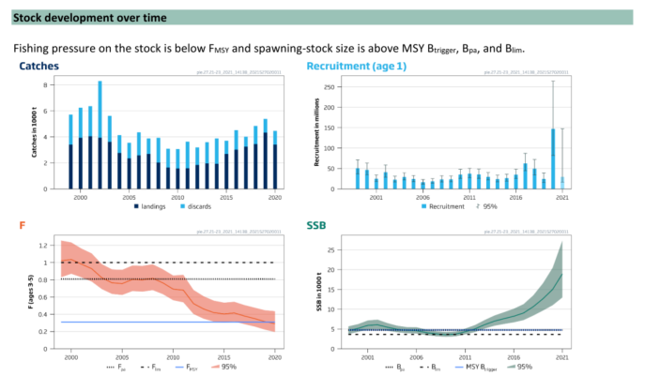(ICES 2021b)

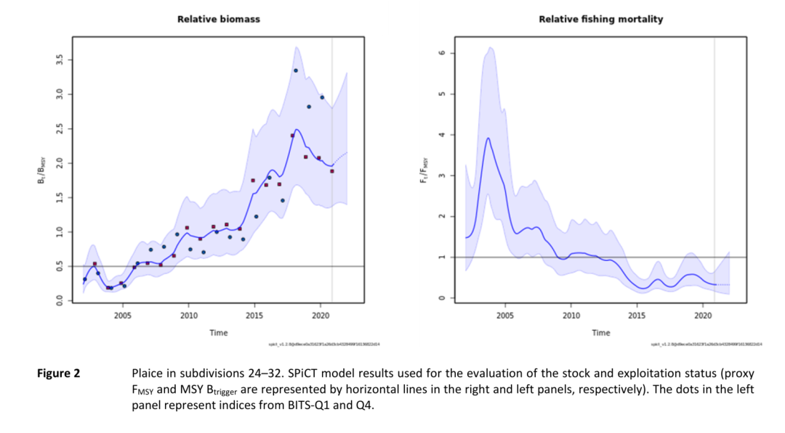

(ICES 2021c)

|  |  |
| --- | --- |
| Sensitivity attributes | Information: Plaice |
| Habitat specificity | * Sediment characteristics important, positive relationship between grain size and densities (ICES 2006; Zijlstra et al. 1982) * Nursery grounds: Shallow (0-3 m) sediment substratum during their early juvenile stage (citation in Ulrich et al. 2013) * Recently metamorphosed (11–15 mm) and post-settlement (16–26 mm) juveniles showed a significant preference for bare sediment (Wennhage and Pihl 1994) * Juveniles: 1.5-5 m, as 1-group also deeper water (Pihl 1989) |
| Prey specificity | * Juveniles prey mainly polychaetes, postlarval *Crangon* and siphons of bivalves (North Sea) (Beyst et al. 1999) * Brown shrimp (*Crangon crangon*) shows to be the most predominant prey items in 0-group plaice (North Sea) (Heindler et al. 2019) * North Sea: Stomach content dominated by polychaetes (*Pectinaria, Nereis, Lanice, Magelona*) (Rijnsdorp and Vingerhoed 2001) |
| Adult mobility | * Spawning site fidelity (Hunter et al. 2003) * Directed seasonal migrations from he winter spawning area (Dogger Bank Tail End) to summer feeding grounds 250 km to the north in deep, cold, thermally stratified water (North Sea) (Hunter et al. 2003) * Usage of tidal streams to assist with navigation and transport (citation in Hunter et al. 2003; ICES 2006) |
| Dispersal of early life stages | * Eggs and larvae are transported to nurseries by Baltic surface current and wind-induced on-shore currents (Kattegat) (Pihl, 1989) * Egg and larval stages duration: 3-4 months, young plaice settle in areas far away from spawning area (North Sea) (ICES 2006) * Dispersal characteristics of the survival yolk sac larvae reflected retention within the Belt Sea or northwards transport through the Great Belt into Kattegat and partly into Skagerrak (Petereit et al. 2014) |
| Early life stage survival & settlement requirements | * Ontogenetic shift: Spawning in southern North Sea, eggs drift to coastal areas, juveniles are found in along the coast, as sizes increases plaice shift offshore (Rijnsdorp and Van Beek 1991) * Long pelagic phase (3-4 months), settlement far away from spawning area, settling after metamorphosis (13-14 mm) (ICES 2006; Russell 1976) * Sediment characteristics important during settlement (ICES 2006) * Larvae settle on soft sediments in puddles on tidal flats during first weeks after metamorphosis (Berghahn 1983) * Ontogenetic shift: Spawning in southern North Sea, eggs drift to coastal areas, juveniles are found in along the coast, as sizes increases plaice shift offshore (Rijnsdorp and Van Beek 1991) |
| Complexity of reproductive strategy | * North Sea: Spawning offshore in restricted areas, eggs and larvae are transported to coastal nurseries (ICES 2006) * Males become sexually mature at age 2-3, females mature later (4-5 year) (ICES 2006) * Spawning site fidelity (Hunter et al. 2003) |
| Population Spawning Cycle | * Peak spawning: Jan-Feb (German Bight) (ICES 2006; Rijnsdorp 1989) * Spawning season November to March (Muus and Nielsen 1999) |
| Sensitivity to increasing temperature | * Different temperature ranges for different life stages: potential avoidance of warmer coastal waters (North Sea) (Teal et al. 2012) * Plaice have lower optimal growth temperature and lower thermal tolerance (Teal et al. 2012) * Max. growth at 18-20°C, lethal limit: 26-27°C (in Fonds et al. 1992) * Optimum temperature (Baltic Sea): 6°C (von Westernhagen 1970) * Juveniles grow faster at higher temperatures, adult plaice grow faster at low temperature: Habitat differentiation (Fonds et al. 1992; van der Sleen et al. 2018) * Sensitivity to phenological changes: Corr. with preceding winter-T (North Sea) (Greve et al. 2005) |
| Sensitivity to decreasing salinity | * High egg mortality: Below 17.5 psu, yolk-sac larvae tolerated salinities between 15 and 60 psu over one week (Holliday and Jones 1967) * Optimum salinity (Baltic Sea): 20 psu (von Westernhagen 1970) * Rearing of eggs at low salinity decreases speed of development (von Westernhagen 1970) * Fertilization experiment performed at salinities between 8 and 15 psu showed a low percentage of fertilized eggs at low salinities, successful fertilization was low and variable at 9–12 psu and increased with salinity up to 15 psu (Baltic Sea) (Nissling et al. 2002) |
| Sensitivity to Ocean Acidification | * No data/information |
| Population growth rate | * r=2\*FMSY=1\*Fpa  (Froese et al. 2017)  |  |  | | --- | --- | | Maximum growth rate (rmax) | * FMSY=0.31 (Kattegat, Belt Seas and Sound) (ICES 2021b) * r=0.62 (SD 21-23) | | Von Bertalanffy K | * 0.15 (Baltic Sea) -0.17 (Kattegat, Belt Sounds) | | Age at maturity (tm) | * 2-3 years (North Sea) (Rijnsdorp 1993) | | Maximum age (tmax) | * 10 (Baltic Sea) | | Natural mortality (M) | * 0.1-0.2 (age-1) (Baltic Sea) (ICES 2021a) | | Maximum length (Linf) | * 54 cm TL |  * (Froese and Pauly 2021) |
| Sensitivity to other stressors | * Juvenile plaice showed reduced growth at 30% O2-saturation (during 20 days period), few individuals were found in the Kattegat area down to 10-20% saturation level * Frequency of eating decreased during hypoxic (<30% O2-saturation) (Petersen and Pihl 1995) * Growth changes of the smaller size classes were significantly correlated with indices of plaice density, eutrophication, and seabed disturbance by beam trawling, they could be related to spatial and temporal patterns in variations in eutrophication and beam trawling (North Sea) (Rijnsdorp and van Leeuwen 1996) * No correlation was observed with temperature (North Sea) (Rijnsdorp and van Leeuwen 1996) |

Bagge, O., and E. Steffensen. 1989. Stock indentification of demersal fish in the Baltic. *Rapports et procès-verbaux des Réunions. Conseil International pour l’Éxploration de la Mer* 190: 3-16.

Berghahn, R. 1983. Untersuchungen an Plattfischen und Nordseegarnelen (*Crangon crangon*) im Eulitoral des Wattenmeeres nach dem Übergang zum Bodenleben. *Helgoländer Meeresuntersuchungen* 36: 163-181.

Beyst, B., A. Cattrijsse, and J. Mees. 1999. Feeding ecology of juvenile flatfishes of the surf zone of a sandy beach. *Journal of Fish Biology* 55: 1171-1186.

Fonds, M., R. Cronie, A.D. Vethaak, and P. Van Der Puyl. 1992. Metabolism, food consumption and growth of plaice (*Pleuronectes platessa*) and flounder (*Platichthys flesus*) in relation to fish size and temperature. *Netherlands Journal of Sea Research* 29: 127-143.

Froese, R., N. Demirel, G. Coro, K.M. Kleisner, and H. Winker. 2017. Estimating fisheries reference points from catch and resilience. *Fish and Fisheries* 18: 506-526.

Froese, R., and D. Pauly. 2021. Editors. 2021. Fishbase. World Wide Web electronic publication. www.fishbase.org (06/10.2021).

Froese, R., A.C. Tsikliras, G. Scarcella, and D. Gascuel. 2021. Progress towards ending overfishing in the Northeast Atlantic. *Marine Policy* 125: 104282.

Greve, W., S. Prinage, H. Zidowitz, J. Nast, and F. Reiners. 2005. On the phenology of North Sea ichthyoplankton. *ICES Journal of Marine Science* 62: 1216-1223.

Heindler, F.M., G.E. Maes, S. Delerue-Ricard, A. Vanden Bavière, K. Hostens, and F.A.M. Volckaert. 2019. Diet composition and gut microbiome of 0-group European plaice *Pleuronectes platessa* L. - Strong homogeneity and subtle spatial and temporal differences. *Journal of Sea Research* 144: 67-77.

Holliday, F.G.T., and M.P. Jones. 1967. Some effects of salinity on the developing eggs and larvae of the plaice (*Pleuronectes platessa*). *Journal of the Marine Biological Association of the United Kingdom* 47: 39-48.

Hunter, E., J.D. Metcalfe, and J.D. Reynolds. 2003. Migration route and spawning area fidelity by North Sea plaice. *Proceedings of the Royal Society of London B.* 270: 2097-2103.

ICES. 2006. North Sea fish species fact sheets. *Pleuronectes platessa*. *Available at ICES website https://www.ices.dk/data/maps/Pages/ICES-FishMap.aspx*.

ICES. 2021a. Baltic Fisheries Assessment Working Group (WGBFAS). ICES Scientific Reports. 3:53. 717 pp. https://doi.org/10.17895/ices.pub.8187.

ICES. 2021b. Plaice (*Pleuronectes platessa*) in subdivisions 21-23 (Kattegat, Belt Seas, and the Sound). In Report of the ICES Advisory Committee, 2021. ICES Advice 2021, ple.27.21-23, https://doi.org/10.17895/ices.advice.7817.

ICES. 2021c. Plaice (*Pleuronectes platessa*) in subdivisions 24-32 (Baltic Sea, excluding the Sound and Belt Seas). In Report of the ICES Advisory Committee, 2021. ICES Advice 2021, ple.27.24-32, https://doi.org/10.17895/ices.advice.7818.

Muus, B.J., and J.G. Nielsen. 1999. *Die Meeresfische Europas: in Nordsee, Ostsee und Atlantik*: Kosmos Naturführer, Franckh-Kosmos Verlag.

Nissling, A., L. Westin, and O. Hjerne. 2002. Reproductive success in relation to salinity for three flatfish species, dab (*Limanda limanda*), plaice (*Pleuronectes platessa*), and flounder (*Pleuronectes flesus*), in the brackish water Baltic Sea. *ICES Journal of Marine Science* 59: 93-108.

Petereit, C., H.-H. Hinrichsen, A. Franke, and F.W. Köster. 2014. Floating along buoyancy levels: Dispersal and survival of western Baltic fish eggs. *Progress in Oceanography* 122: 131-152.

Petersen, J.K., and L. Pihl. 1995. Responses to hypoxia of place, *Pleuronectes platessa*, and dab, *Limanda limanda*, in the south-east Kattegat: distribution and growth. *Environmental Biology of Fishes* 43: 311-321.

Pihl, L. 1989. Abundance, biomass and production of juvenile flatfish in southeastern Kattegat. *Netherlands Journal of Sea Research* 24: 69-81.

Rijnsdorp, A.D. 1989. Maturation of male and female North Sea plaice (*Pleuronectes platessa* L.). *ICES Journal of Marine Science* 46: 35-51.

Rijnsdorp, A.D. 1993. Relationship between Juvenile Growth and the Onset of Sexual Maturity of Female North Sea Plaice, *Pleuronectes platessa*. *Canadian Journal of Fisheries and Aquatic Sciences* 50: 1617-1631.

Rijnsdorp, A.D., and F.A. Van Beek. 1991. Changes in growth of plaice *Pleuronectes platessa* L. and sole *Solea solea* (L.) in the North Sea. *Netherlands Journal of Sea Research* 27: 441-457.

Rijnsdorp, A.D., and P.I. van Leeuwen. 1996. Changes in growth of North Sea plaice since 1950 in relation to density, eutrophication, beam-trawl effort, and temperature. *ICES Journal of Marine Science* 53: 1199-1213.

Rijnsdorp, A.D., and B. Vingerhoed. 2001. Feeding of plaice *Pleuronectes platessa* L. and sole *Solea solea* (L.) in relation to the effects of bottom trawling. *Journal of Sea Research* 45: 219-229.

Russell, F.S. 1976. *The Eggs and Planktonic Stages of British Marine Fishes*. London: Academic Press.

Teal, L.R., R. van Hal, T. van Kooten, P. Ruardij, and A.D. Rijnsdorp. 2012. Bio-energetics underpins the spatial response of North Sea plaice (*Pleuronectes platessa* L.) and sole (*Solea solea* L.) to climate change. *Global Change Biology* 18: 3291-3305.

Ulrich, C., J. Boje, M. Cardinale, P. Gatti, Q. LeBras, M. Andersen, J. Hemmer-Hansen, N.T. Hintzen, J.B. Jacobsen, P. Jonsson, D.C.M. Miller, E.E. Nielsen, A.D. Rijnsdorp, M. Sköld, H. Svedäng, and H. Wennhage. 2013. Variability and connectivity of plaice populations from the Eastern North Sea to the Western Baltic Sea, and implications for assessment and management. *Journal of Sea Research* 84: 40-48.

van der Sleen, P., C. Stransky, J.R. Morrongiello, H. Haslob, M. Peharda, and B.A. Black. 2018. Otolith increments in European plaice (*Pleuronectes platessa*) reveal temperature and density-dependent effects on growth. *ICES Journal of Marine Science* 75: 1655-1663.

von Westernhagen, H. 1970. Erbrütung der Eier von Dorsch (*Gadus morhua*), Flunder (*Pleuronectes ﬂesus*) und Scholle (*Pleuronectes platessa*) unter kombinierten Temperatur- und Salzgehaltsbedingungen. *Helgoländer Wissenschaftliche Meeresuntersuchungen, 21, 21–102.*

Wennhage, H., and L. Pihl. 1994. Substratum selection by juvenile plaice (*Pleuronectes platessa* L.): Impact of benthic microalgae and filamentous macroalgae. *Netherlands Journal of Sea Research* 32: 343-351.

Zijlstra, J.J., R. Dapper, and J.I. Witte. 1982. Settlement, growth and mortality of post-larval plaice (*Pleuronectes platessa*) in the western Wadden Sea. *Netherlands Journal of Sea Research* 15: 250-272.

**Seezunge - Common sole (*Solea solea*)**

**Additional information**

|  |  |
| --- | --- |
| **Distribution range in the Western Baltic Sea** | * Occurs regularly in Skagerrak and Kattegat and occasionally in the western Baltic Sea (Florin 2005; Muus and Nielsen 1999) |
| **Stock size** | * Analytical assessment (Skagerrak, Kattegat, western Baltic Sea) (ICES 2021a) * Low productivity since 2004 (Skagerrak, Kattegat, western Baltic Sea) (ICES 2021a) * Spawning stock biomass increased to above Btrigger in recent years (Skagerrak, Kattegat, western Baltic Sea) (ICES 2021a) * Fishing mortality decreased continuously since mid-1990s and is below FMSY since 2017; could be the reason why spawning stock biomass increased in recent years (Skagerrak, Kattegat, western Baltic Sea) (ICES 2021a) * Skagerrak, Kattegat, western Baltic Sea: MSY Btrigger = Bpa= 2,600 t; SSB(2022) = 3,756 t (ICES 2021c) * BMSY = 2 x MSYBtrigger (Froese et al. 2021) * B/BMSY = 0.72 * North Sea: MSY B trigger = Bpa= 42,838 t; SSB(2022) = 58,617 t (ICES 2021b) * B/BMSY = 0.68 (North Sea) |
| **Recruitment** | * Low recruitment since 2004 with an increase recent years (Skagerrak, Kattegat, western Baltic Sea) (ICES 2021a; ICES 2021c) |
| **Growth** | * Growth rates not stable over time (for North Sea), after increase in size at age during 1960s, reaching a peak in 1970s, growth rate has decreased steadily (possible explanation: declining inputs of nutrients, reduced food) (Rijnsdorp et al. 2004; Van Beek et al. 1989) |
| * Mainly caught in mixed fishery as valuable bycatch (in plaice and cod gillnet fishery and in nephrops trawl fishery) (Skagerrak, Kattegat) (ICES 2021a) * economically important for Danish fishery (ICES 2021a) * SD20-SD24 considered as one stock (ICES 2021a) * Validation needed on stock structure (Skagerrak, Kattegat, western Baltic Sea) and on connectivity to adjacent stocks (North Sea) (ICES 2021a) | |

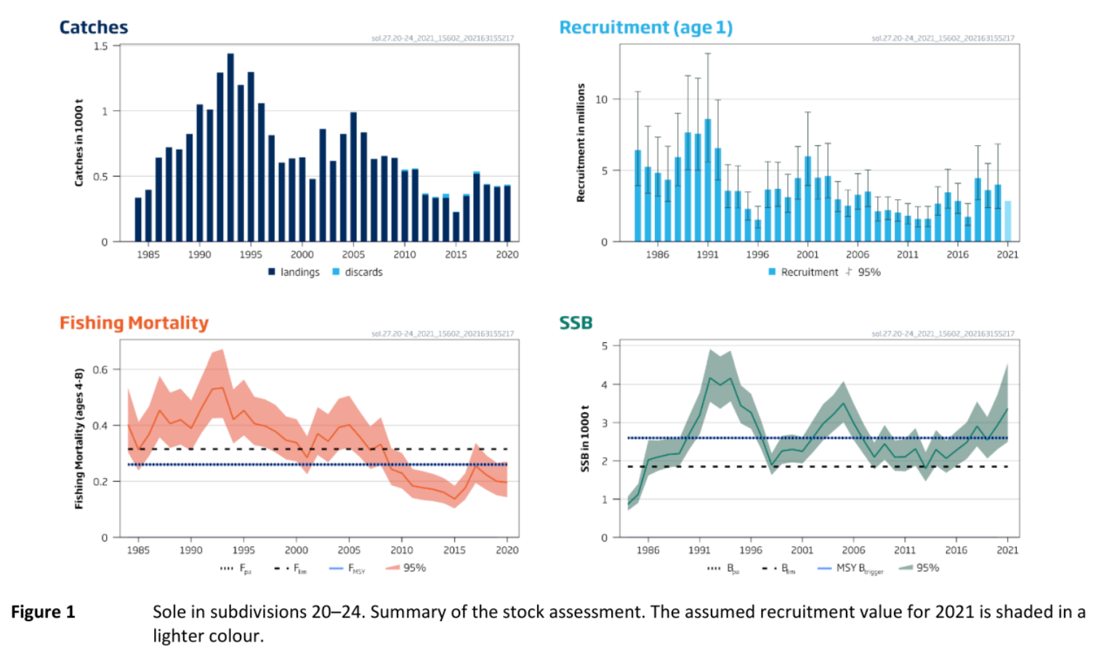(ICES 2021c)

|  |  |
| --- | --- |
| Sensitivity attributes | Information: Sole |
| Habitat specificity | * Adults most abundant in waters down to 40 m with seabed characterized by fine sediment (North Sea) (Rijnsdorp et al. 1992) * Age-0: at 1.5-5 m, age-1 also in deeper water down to about 11 m (Kattegat) (Pihl 1989) * Nurseries: sandy or muddy coastal areas down to 20 m but mainly at depths less than 10 m (North Sea) (Rijnsdorp et al. 1992) * Spawn in shallow waters and during non-spawning prefer deeper waters (North Sea) (ICES 1965) * Spawn in inshore waters within 30 m depth (North Sea) (Borremans 1987 and ref. therein) |
| Prey specificity | * Sole are nocturnal and feed during the night (North Sea) (Kruuk 1963) * Lab-reared pelagic larvae fed on copepods, polychaete larvae (Fonds 1979) * Juveniles < 50 mm: mainly copepods and cumacea; juveniles ≥ 50 mm: polychaetes and amphipods (North Sea) (Amara et al. 2001) * Juveniles also feed on caridean shrimp (North Sea) (Beyst et al. 1999) * Adults mainly feed on polychaetes; on a few occasions also on echinoderms and molluscs (North Sea) (Braber and de Groot 1973) |
| Adult mobility | * Sole is assumed to be rather stationary (despite during spawning) (North Sea) (ICES 1965) |
| Dispersal of early life stages | * Pelagic eggs and larvae transported by residual currents along the coast (North Sea) (Fonds 1979 and ref. therein) * At 10°C hatching after 7-8 days (size 2.5-4 mm) (North Sea) (ICES 2006) and ref. therein) * At 10°C hatching after ~ 6.5 days (North Sea) (Fonds 1979) * ~3 weeks after hatching post-larvae settle (Fonds 1979; ICES 2006) * After yolk-sac absorption: active swimming first-feeding larvae (4-4.5 mm) (Fonds 1979) |
| Early life stage survival & settlement requirements | * Ambient temperature is between 10-15°C during larval stage (North Sea) (ICES 2006 and ref. therein) * After metamorphosis: post-larvae settle on bottom at length of 7-10 mm (~3 weeks after hatching) (North Sea) (Fonds 1979; ICES 2006) * Settlement of post-larvae close to spawning area (North Sea) (Rijnsdorp et al. 1992) * Settling age-0: April-July in shallow water (Kattegat) (Pihl 1989) * Age-0: Mainly at 1.5-5 m, age-1 also in deeper water down to about 11 m (Kattegat) (Pihl 1989) * Juveniles spend their first year in shallow coastal waters and estuaries; when older dispersal to deeper waters (North Sea) (ICES 2006) |
| Complexity of reproductive strategy | * High migratory, assuming to return to the same spawning areas, indications of spawning site fidelity (North Sea) (ICES 1965; ICES 2006) * Long-distance migrations from deeper waters to shallow spawning sites along the coasts (central North Sea) (ICES 1965) * Water temperature assumed to trigger spawning migration (North Sea) (ICES 1965) * Migration to spawning site and start of reproduction at ~ 7°C (North Sea) (Fonds 1979 and ref. therein; ICES 1965) * Spawn in inshore waters within 30 m depth (North Sea) (Borremans 1987) and ref. therein) |
| Population Spawning Cycle | * April – June at the west coast of Denmark (North Sea) (ICES 1965) * April – August, with a main period in May (North Sea) (Borremans 1987 and ref. therein) |
| Sensitivity to increasing temperature | * Water temperature assumed to trigger spawning migration (North Sea) (ICES 1965) * Migration to spawning site and start of reproduction at ~ 7°C (North Sea) (Fonds 1979 and ref. therein; ICES 1965) * Temperature tolerance increases during ontogenesis (Irvin 1974) * Temperature thresholds: at 19°C little viable hatch and many embryos were deformed, at 22°C no viable hatch, lower limit at 7°C eggs (Fonds 1979) * Egg survival: 7-19°C; growth larvae: 10-21°C (Fonds 1979) * Successful egg development: 7-16°C (Irvin 1974) * Strong positive correlation between growth rate of larvae and temperature at 10-16°C (Fonds 1979) * Upper lethal limits for yolk-sac larvae (23°C), first-feeding larvae (24°C) and metamorphosing larvae (28°C) (Irvin 1974) * Age-0: positive correlation between length and mean temperature during 2nd and 3rd quarter (North Sea) (Rijnsdorp et al. 2004) * Sensitivity to phenological changes – seasonal timing strongly negatively correlated with preceding winter temperature: colder winter postpone season, warmer winter cause season to start earlier (North Sea) (Greve et al. 2005) * Phenology changes– in recent decades, shift of mean peak spawning week towards earlier in the year; accompanied by an increase of winter sea surface temperature preceding the spawning (partially in North Sea) (Fincham et al. 2013) * Sole are assumed to stay in deeper waters during winter in order to avoid cold water along the coasts (ICES 1965; Woodhead 1964) |
| Sensitivity to decreasing salinity | * 20-40 psu: high egg survival and normal development (Fonds 1979) * > 30 psu: eggs and larvae float (Fonds 1979) * < 30 psu: eggs and larvae sank to bottom and showed mortality due to crowding and probably respiratory stress (Fonds 1979) * At 10 psu: survival was reduced; if larvae hatched they were deformed; larvae failed to swim (Fonds 1979) * At > 50 psu: survival was reduced; many larvae failed to hatch; if larvae hatched they were deformed (Fonds 1979) |
| Sensitivity to Ocean Acidification | * No data/information |
| Population growth rate | * r=2\*FMSY=1\*Fpa (Froese et al. 2017)  |  |  | | --- | --- | | Maximum growth rate (rmax) | * Skagerrak, Kattegat and western Baltic Sea: FMSY = 0.26 (ICES 2021c), r ≈ 0.52 * North Sea: FMSY = 0.21 (ICES 2021b), r ≈ 0.42 (North Sea) | | Von Bertalanffy K | * 0.3 (North Sea) (de Veen 1976) | | Age at maturity (tm) | * ♀: 3 years (North Sea) (Mollet et al. 2007) | | Maximum age (tmax) | * 8 (North Sea) | | Natural mortality (M) | * unknown, assumed to be 0.1 (Skagerrak, Kattegat, western Baltic Sea) (ICES 2021a) | | Maximum length (Linf) | * 35 cm (♂ and ♀) (North Sea) (de Veen 1976) |  * (Froese and Pauly 2021) |
| Sensitivity to other stressors | * Hypoxic conditions: significant decrease of max. metabolic rate: below 75% air saturation, sig. decrease in max. heart rate was recorded below 50% (Lefrançois and Claireaux 2003) * Growth rates not stable over time: increase in length at age since mid 1960s, peak in 1970s, steady decrease in length at age since mid 1980s; possible explanation: declining input of nutrients, change in benthic productivity, reduced prey availability (North Sea) (Rijnsdorp et al. 2004) |

Amara, R., P. Laffargue, J.M. Dewarumez, C. Maryniak, F. Lagardére, and C. Luzac. 2001. Feeding ecology and growth of O-group flatfish (sole, dab and plaice) on a nursery ground (Southern Bight of the North Sea). 58: 788-803.

Beyst, B., A. Cattrijsse, and J. Mees. 1999. Feeding ecology of juvenile flatfishes of the surf zone of a sandy beach. *Journal of Fish Biology* 55: 1171-1186.

Borremans, C. 1987. North Sea spawning grounds of the sole (*Solea solea)* located from the 1984 Belgian plankton survey, in: Kullander, S.O. et al. (Ed.) Proceedings of the V Congress of European Ichthyologists, Stockholm, Sweden 1985. pp. 187-191.

Braber, L., and S.J. de Groot. 1973. The food of five flatfish species (Pleuronectiformes) in the southern north sea. *Netherlands Journal of Sea Research* 6: 163-172.

de Veen, J.F. 1976. On changes in some biological parameters in the North Sea sole (*Solea solea* L.). *ICES Journal of Marine Science* 37: 60-90.

Fincham, J.I., A.D. Rijnsdorp, and G.H. Engelhard. 2013. Shifts in the timing of spawning in sole linked to warming sea temperatures. *Journal of Sea Research* 75: 69-76.

Florin, A.B. 2005. Flatfishes in the Baltic Sea - a review of biology and fishery with a focus on Swedish conditions. *Institute of Coastal Research, Swedish Board of Fisheries*.

Fonds, M. 1979. Laboratory Observations on the Influence of Temperature and Salinity on Development of the Eggs and Growth of the Larvae of *Solea solea* (Pisces). *Marine Ecology Progress Series* 1: 91-99.

Froese, R., N. Demirel, G. Coro, K.M. Kleisner, and H. Winker. 2017. Estimating fisheries reference points from catch and resilience. *Fish and Fisheries* 18: 506-526.

Froese, R., and D. Pauly. 2021. Editors. 2021. Fishbase. World Wide Web electronic publication. www.fishbase.org (06.2021).

Froese, R., A.C. Tsikliras, G. Scarcella, and D. Gascuel. 2021. Progress towards ending overfishing in the Northeast Atlantic. *Marine Policy* 125: 104282.

Greve, W., S. Prinage, H. Zidowitz, J. Nast, and F. Reiners. 2005. On the phenology of North Sea ichthyoplankton. *ICES Journal of Marine Science* 62: 1216-1223.

ICES. 1965. Cooperative Research Report 5. Report of the working group on sole. https://doi.org/10.17895/ICES.PUB.8127.

ICES. 2006. North Sea fish species fact sheets. *Solea solea*. *Available at ICES website https://www.ices.dk/data/maps/Pages/ICES-FishMap.aspx*.

ICES. 2021a. Baltic Fisheries Assessment Working Group (WGBFAS). ICES Scientific Reports. 3:53. 717 pp. https://doi.org/10.17895/ices.pub.8187.

ICES. 2021b. Sole (*Solea solea*) in Subarea 4 (North Sea). In Report of the ICES Advisory Committee, 2021. ICES Advice 2021, sol.27.4. https://doi.org/10.17895/ices.advice.7859.

ICES. 2021c. Sole (*Solea solea*) in subdivisions 20-24 (Skagerrak and Kattegat, western Baltic Sea). In Report of the ICES Advisory Committee, 2021. ICES Advice 2021, sol.27.20-24. https://doi.org/10.17895/ices.advice.7858.

Irvin, D.N. 1974. Temperature tolerance of developmental stages of Dover sole (*Solea solea* L.). In J. H. S. Blaxter (Ed.), The Early Life History of Fish. Springer, Heidelberg. pp. 449464.

Kruuk, H. 1963. Diurnal periodicity in the activity of the common sole, *Solea vulgaris* Quensel. *Netherlands Journal of Sea Research* 2: 1-16.

Lefrançois, C., and G. Claireaux. 2003. Influence of ambient oxygenation and temperature on metabolic scope and scope for heart rate in the common sole *Solea solea*. *Marine Ecology Progress Series* 259: 273-284.

Mollet, F.M., S.B.M. Kraak, and A.D. Rijnsdorp. 2007. Fisheries-induced evolutionary changes in maturation reaction norms in North Sea sole *Solea solea*. *Marine Ecology Progress Series* 351: 189-199.

Muus, B.J., and J.G. Nielsen. 1999. *Die Meeresfische Europas: in Nordsee, Ostsee und Atlantik*: Kosmos Naturführer, Franckh-Kosmos Verlag.

Pihl, L. 1989. Abundance, biomass and production of juvenile flatfish in southeastern Kattegat. *Netherlands Journal of Sea Research* 24: 69-81.

Rijnsdorp, A.D., F.A. Van Beek, S. Flatman, R.M. Millner, J.D. Riley, M. Giret, and R. De Clerck. 1992. Recruitment of sole stocks, *Solea solea* (L.), in the Northeast Atlantic. *Netherlands Journal of Sea Research* 29: 173-192.

Rijnsdorp, A.D., O.A. Van Keeken, and L.J. Bolle. 2004. Changes in the productivity of the southeastern North Sea as reflected in the growth of plaice and sole *ICES Document CM 2004/K:13*.

Van Beek, F.A., A.D. Rijnsdorp, and R. de Clerck. 1989. Monitoring juvenile stocks of flatfish in the Wadden Sea and the coastal areas of the southeastern North Sea. *Helgoland Marine Research* 43: 461-477.

Woodhead, P.M.J. 1964. Changes in the behaviour of the sole, *Solea vulgaris*, during cold winters, and the relation between the winter catch and sea temperatures. *Helgoländer Wissenschaftliche Meeresuntersuchungen* 10: 328-342.

**Doggerscharbe - Long rough dab (American plaice) (*Hippoglossoides platessoides*)**

**Additional information**

|  |  |
| --- | --- |
| **Distribution range in the Western Baltic Sea** | * Continental shelves of northeastern North America and northwestern Europe (Scott and Scott 1988), Kiel Bay: western Baltic Sea (Walsh 1994) * Most southern part of the population is located in the Kattegat (Expert information) |
| **Stock size** | * No data/information |
| **Recruitment** | * No data/information |
| **Growth** | * Growth rates are the highest in North Sea (Walsh 1994), Western Atlantic: Scotian Shelf (k=0.06), southern Gulf of Lawrence (k=0.09), Eastern Atlantic: North Sea (k=0.28), Barents Sea (k=0.10) (citations within Walsh 1994) |
| * North Atlantic from the Dogger Bank in North Sea, along the Norwegian coast to Spitzbergen and the Barents Sea (populations around Faroe Bank, Clyde Sea, Celtic and Irish Sea), westward to East Greenland and Iceland and eastward into Kiel Bay (Walsh 1994) * Two patters in life histories: southern populations are characterized by faster growth, early maturation, whereas northern populations are characterized as slow growing, late maturing, spring-summer spawning (Walsh 1994) * Rare species, however catches during surveys: Positive trend in BITS data (Expert information) | |

|  |  |
| --- | --- |
| Sensitivity attributes | Information: Long rough dab |
| Habitat specificity | * Arctic-boreal origin (Stratoudakis et al. 1997; Walsh 1996) * Offshore banks: settlements of juveniles (Walsh 1994) * Fine sand and gravel bottoms (Bowering and Brodie 1991) * Broad tolerance of substrates, preferring fine sand (Morgan 2000) * Occurrence in water depth: In North Atlantic (Canada region): 20-700 m, average depth preference 100-300m (Bowering and Brodie 1991), In North Sea: 60-90m (Bagenal 1957) * No reproduction observed in the Baltic Sea (Expert information) |
| Prey specificity | * Opportunistic: high capacity to change niche according to prey availability (Klemetsen 1993) * North Atlantic: juveniles feed on polychaetes, crustaceans, shifting to echinoderms, mollusks and fish when older (citations within Walsh 1994) * 0-group whiting and gobies, cannibalism (Ntiba and Harding 1993) * Small (15-19 cm): Crustaceans, echinoderms, fish * Medium: (20-24 cm): Echinoderms most dominant, also crustaceans, fish * Large (25-29 cm): Echinoderms most important, fish, molluscs, polychaetes (Pihl 1994) |
| Adult mobility | * In Canadian waters: Sedentary, limited migration, associated with spawning, feeding and changes in temperatures (Powles 1965; Walsh 1994) * Spawning adults migrate from greater depths into shallow grounds before spawning (< 90 m) (Bigelow and Schroeder 1953; Johnson et al. 1999) |
| Dispersal of early life stages | * Pelagic eggs: 11-14 days at 4 °C (Wheeler 1969), 16-35 days at 6°C (Nagler et al. 1999) (North Sea) * Eggs drift into upper water column after release (Colton and Temple 1961) * All early life stages could retain in the spawning area, due to low current velocities (citations within Walsh 1994), depending on specific currents within the areas * Eggs of long rough dab were quite widespread, and enhanced abundances were seen in the vicinity of the Fisher Banks, peaked in the vicinity of the frontal areas (North Sea) (Munk et al. 2009) |
| Early life stage survival & settlement requirements | * North Sea: yolk is absorbed 5 d after hatching (size larvae 6.2-7.5 mm) (Johnson et al. 1999; Walsh 1994) * Size at metamorphosis 15-25 mm (Bagenal 1957) * Larvae settle in oceanic nursery areas almost exclusively on offshore banks (citations within Walsh 1994) * Larvae feed on plankton, diatoms and copepods |
| Complexity of reproductive strategy | * Batch-spawning, pelagic eggs (Bagenal 1957), floating in the upper mixed layers (Walsh 1994) * North Sea: Age at maturity: 2-3 years (size: ~ 14.4 cm) (Ntiba 1989) * Bottom spawner (Johnson et al. 1999) * Spawning is triggered by Water temperature * Spawning time and duration dependent on age (Morgan 2003) * No reproduction observed in the Baltic Sea (Expert information) |
| Population Spawning Cycle | * North Sea: spawning duration: Jan-May with peak in March-April (Ntiba 1989, in Walsh 1994) * Spawning time in Clyde Sea (North Sea): March-April (Bagenal 1957) * Northwest Atlantic: Eggs have been collected during all month of the year (Berrien and Sibunka 1999) |
| Sensitivity to increasing temperature | * Temperature range tolerance: -1.5°C- 13°C (North Atlantic, Canada) (Bowering and Brodie 1991) * Cryophilic (Expert information) * Broad tolerances of temperature (Morgan 2000) * Temperature range 5-11°C (North Sea) (Ntiba 1989) * Bottom spawning temp: 5-8.5 °C (Bigelow and Schroeder 1953) * Optimum: 1.7-7.7°C (Johnson et al. 1999) * Upper thermal threshold for reproduction: >14°C (Howell and Caldwell 1984) * Sensitivity to phenological changes: Time of spawning is related to increasing water temperature (citations within Walsh 1994)) |
| Sensitivity to decreasing salinity | * North Atlantic (Labrador): 20-22 psu in Hamilton Inlet (Johnson et al. 1999) * Salinity preferences: 31-34 psu (Scott 1982) * < 30 psu in Baltic Sea (Johnson et al. 1999) |
| Sensitivity to Ocean Acidification | * No data/information |
| Population growth rate | |  |  | | --- | --- | | Maximum growth rate (r max) | * No data/information | | Von Bertalanffy K | * 0.34 (North Sea) | | Age at maturity (tm) | * 2.6 (North Sea) | | Maximum age (tmax) | * 14-21 (Atlantic, Canada) | | Natural mortality (M) | * 0.23-0.4 (Atlantic, Canada) | | Maximum length (Linf) | * 66 cm TL |  * ([www.fishbase.org](http://www.fishbase.org), (Froese and Pauly 2021)) |
| Sensitivity to other stressors | * Feeding competition exists between young American plaice and cod (Johnson et al. 1999; Powles 1965) |

Bagenal, T.B. 1957. The breeding and fecundity of the long rough dab *Hippoglossoides platessoides* (Fabr.) and the associated cycle in condition. *J. mar. biol. Ass. U.K.* 36: 339-375.

Berrien, P.L., and J.D. Sibunka. 1999. Distribution patterns of fish eggs in the U.S. northeast continental shelf ecosystem, 1977-1987. *United States, National Marine Fisheries Service. NOAA technical report NMFS; 145*.

Bigelow, H.B., and W.C. Schroeder. 1953. Fishes of the Gulf of Maine. *U.S. Fish Wildl. Serv. Fish. Bull.* 53: 577p.

Bowering, W.R., and W.B. Brodie. 1991. Distribution of commercial flatfishes in the Newfoundland-Labrador region of the Canadian Northwest Atlantic and changes in certain biological parameters since exploitation. *Netherlands Journal of Sea Research* 27: 407-422.

Colton, J.B.J., and R.F. Temple. 1961. The enigma of Georges Bank spawning. *Limnology and Oceanography* 6: 280-291.

Froese, R., and D. Pauly. 2021. Editors. 2021. Fishbase. World Wide Web electronic publication. www.fishbase.org (06/10.2021).

Howell, W.H., and M.A. Caldwell. 1984. Influence of temperature on energy utilization and growth of embryonic and prolarval American plaice, *Hippoglossoides platessoides* (Fabricius). *Journal of Experimental Marine Biology and Ecology* 79: 173-189.

Johnson, D.L., P.L. Berrien, W.W. Morse, and J.J. Vitaliano. 1999. Essential Fish Habitat Source Document: American Plaice, *Hippoglossoides platessoides*, Life History and Habitat Characteristics. *NOAA Technical Memorandum NMFS-NE-123*.

Klemetsen, A. 1993. The food of the long-rough dab (*Hippoglossoides platessoides limandoides* Bloch) in Balsfjorden, North Norway. *Sarsia* 78: 17-24.

Morgan, M.J. 2000. Interactions between substrate and temperature preference in adult American plaice (*Hippoglossoides platessoides*). *Marine and Freshwater Behaviour and Physiology* 33: 249-259.

Morgan, M.J. 2003. Variation with age in the timing and duration of spawning in American plaice. *Journal of Fish Biology* 62: 464-473.

Munk, P., C.J. Fox, L.J. Bolle, C.J.G. Van Damme, P. Fossum, and G. Kraus. 2009. Spawning of North Sea fishes linked to hydrographic features. *Fisheries Oceanography* 18: 458-469.

Nagler, J.J., B.A. Adams, and D.G. Cyr. 1999. Egg Production, Fertility, and Hatch Success of American Plaice Held in Captivity. *Transactions of the American Fisheries Society* 128: 727-736.

Ntiba, M.J. 1989. The biology and ecology of the long rough dab, *Hippoglossoides platessoides* (Fabricius 1780) in the North Sea, University of East Anglia (United Kingdom)

Ntiba, M.J., and D. Harding. 1993. The food and the feeding habits of the long rough dab, *Hippoglossoides platessoides* (fabricius 1780) in the North Sea. *Netherlands Journal of Sea Research* 31: 189-199.

Pihl, L. 1994. Changes in the Diet of Demersal Fish due to Eutrophication-Induced Hypoxia in the Kattegat, Sweden. *Canadian Journal of Fisheries and Aquatic Sciences* 51: 321-336.

Powles, P.M. 1965. Life history and ecology of American plaice (Hippoglossoides platessoides F.) in the Magdalen shallows. *Journal of the Fisheries Research Board of Canada* 22: 565-598.

Scott, J. 1982. Depth, Temperature and Salinity Preferences of Common Fishes of the Scotian Shelf. *Journal of Northwest Atlantic Fishery Science* 3: 29-39.

Scott, W.B., and M.G. Scott. 1988. Atlantic Fishes of Canada. *Canadian Bulletin of Fisheries and Aquatic Sciences* 219: 1-731.

Stratoudakis, Y., R.J. Fryer, G.J. Pierce, and R.M. Cook. 1997. Differences in life history features of long rough dab *Hippoglossoides platessoides* within Scottish waters. *Marine Ecology Progress Series* 158: 303-306.

Walsh, S.J. 1994. Life history traits and spawning characteristics in populations of long rough dab (American plaice) *Hippoglossoides platessoides* (Fabricius) in the North Atlantic. *Netherlands Journal of Sea Research* 32: 241-254.

Walsh, S.J. 1996. Life history and ecology of long rough dab *Hippoglossoides platessoides* (F) in the Barents Sea. *Journal of Sea Research* 36: 285-310.

Wheeler, A. 1969. The fishes of the British Isles and Northwest Europe. MacMillan, London: 1-529.

**Dicklippige Meeräsche - Thicklip grey mullet (*Chelon labrosus*)**

**Additional information**

|  |  |
| --- | --- |
| **Distribution range in the Western Baltic Sea** | * Atlantic coastal waters, Norway, Mediterranean Sea, sometimes migrating into lower course of rivers (Maitland and Linsell 2007) * Expansion of its native habitats into North Sea and brackish Baltic Sea (Schaber et al. 2011) * Occurrence in the Western Baltic during warm months (Schaber et al. 2011) |
| **Stock size** | * No data/information |
| **Recruitment** | * No data/information |
| **Growth** | * Growth not affected by salinity (Cardona 2006) |
| * Grey mullets of the family Mugilidae are amongst the most flexible and variable of catadromous fishes, but all of them, whether catadromous, facultative marine wanderers, or entirely marine, spawn at sea (McDowall 1997) * Mullets in the Baltic Sea: *Chelon labrosus*, *Liza aurata*, *Liza ramada*, *Mugil mugil* (Expert information) * *Chelon labrosus* potential climate change winner (Expert information) | |

|  |  |
| --- | --- |
| Sensitivity attributes | Information: Thicklip grey mullet |
| Habitat specificity | * Preference for inshore areas, estuaries and river mouths (Hickling 1970; Schaber et al. 2011) * Adults: Most of the population was found in mesohaline and polyhaline sites in winter and spring, in summer most concentrated in oligohaline sites (Cardona 2006) |
| Prey specificity | * Filtration (gill trap apparatus): Detritus, algae, benthic organisms, long intestine indicates consumption of plants (Gebhardt and Ness 2004) * Meiofauna in the top soil layer (Expert information) * Unusual food intake: Spezialized, but not limited to specific organisms of meiofauna (preying on several species) (Expert information) * Opportunistic feeder: Insensitive to climate change scenarios (moderate) (Expert information) * Juveniles feed on zooplankton; Adults feed on benthic diatoms, epiphytic algae, small invertebrates and detritus ([www.fishbase.org](http://www.fishbase.org), Froese and Pauly 2021) |
| Adult mobility | * Adults move northward in spring and summer with rising temperatures (Heessen et al. 2015) * No distinct migration pathways, periodical migration between waters of different salinities, some species solitary (Schaber et al. 2011) * Seasonally migrate between their ‘‘native’’ habitats in the adjacent North Sea and the western/southwestern Baltic Sea along the North Sea coast (during warm summer) (Schaber et al. 2011) * “Summer visitors” from the Bay of Biscay and the English Channel, nowadays eggs and juveniles are found in the Wadden Sea (North Sea) (Expert information) * Assumption that mullets are spawning along the Netherlands, last summer no catches of mullets recorded in the Wadden Sea (North Sea) (Expert information) * Spawning areas are unknown (potentially English Channel) (Expert information) * Baltic Sea: Pelagic eggs are observed in Skagerrak-Kattegat area (Baltic Sea) (Expert information) |
| Dispersal of early life stages | * Pelagic eggs, dispersal is high, development time is short (Expert information) * Juveniles around 2.0 cm SL move to coastal lagoons and estuaries in April-June, moving to sea in summer (Kottelat and Freyhof 2007) |
| Early life stage survival & settlement requirements | * Eggs are planktonic (Heessen et al. 2015), larvae are pelagic (Froese and Pauly 2021) * Larvae are rather underdeveloped at hatching (TL ~ 4mm), at 12 days larvae have juvenile head (Boglione et al. 1992) * The juvenile stage is reached precociously, at 60 days (Boglione et al. 1992) |
| Complexity of reproductive strategy | * Offshore spawning with juveniles appearing in inshore areas (Hickling 1970; Schaber et al. 2011) |
| Population Spawning cycle | * January to April (North Sea) (Hickling 1970) * Winter spawner (3-7 months spawning season, probably more extended season in southern parts/tropics) (Expert information) |
| Sensitivity to increasing temperature | * Highly temperature tolerance, migrating to Western Baltic Sea during summer (Schaber et al. 2011) * Tolerance against high temperature, potentially more sensitive to cold water (Expert information) |
| Sensitivity to decreasing salinity | * Adults are highly euryhaline (Schaber et al. 2011) * Laboratory experiments with fry: High salinity tolerance with mortalities > 45 psu (Hotos and Vlahos 1998) * Extremely euryhaline, high tolerance against salinity, also live in fresh water (Expert information) |
| Sensitivity to Ocean Acidification | * No data/information |
| Population growth rate | |  |  | | --- | --- | | Maximum growth rate (rmax) | * No data/information | | Von Bertalanffy K | * 0.12 (North Ireland) | | Age at maturity (tm) | * 3 (Atlantic, Gulf of Lion) | | Maximum age (tmax) | * 14 (Northwest Wales) (Tulkani 2017) | | Natural mortality (M) | * No data/information | | Maximum length (Lmax) | * ~ 50 cm TL (North Sea, Expert information) |  * (Froese and Pauly 2021) |
| Sensitivity to other stressors | * No data/information |

Boglione, C., B. Bertolini, M. Russiello, and S. Cataudella. 1992. Embryonic and larval development of the thicklipped mullet (*Chelon labrosus*) under controlled reproduction conditions. *Aquaculture* 101: 349-359.

Cardona, L. 2006. Habitat selection by grey mullets (Osteichthyes: Mugilidae) in Mediterranean estuaries: the role of salinity. *Scientia Marina* 70: 443-455.

Froese, R., and D. Pauly. 2021. Editors. 2021. Fishbase. World Wide Web electronic publication. www.fishbase.org (06/10.2021).

Gebhardt, H., and A. Ness. 2004. *Fische. Die heimischen Süßwasserfische sowie Arten der Nord- und Ostsee*: blv.

Heessen, H.J.L., N. Daan, and J. Ellis. 2015. *Fish atlas of the Celtic Sea, North Sea and Baltic Sea - Based on international research-vessel surveys*. Wageningen, Netherlands: Wageningen Academic Publishers.

Hickling, C.F. 1970. A Contribution to the Natural History of the English Grey Mullets [Pisces, Mugilidae]. *Journal of the Marine Biological Association of the United Kingdom* 50: 609-633.

Hotos, G.N., and N. Vlahos. 1998. Salinity tolerance of *Mugil cephalus* and *Chelon labrosus* (Pisces: Mugilidae) fry in experimental conditions. *Aquaculture* 167: 329-338.

Maitland, P., and K. Linsell. 2007. *Süßwasserfische: Alle Arten Europas gezeichnet*: Kosmos, 2007.

McDowall, R.M. 1997. The evolution of diadromy in fishes (revisited) and its place in phylogenetic analysis. *Reviews in Fish Biology and Fisheries* 7: 443-462.

Schaber, M., L. Marohn, C. Petereit, J.P. Schroeder, K. Zumholz, and R. Hanel. 2011. Newcomers in the Baltic Sea: an attempt to trace the origins and whereabouts of thicklip grey mullet *Chelon labrosus*. *Fisheries Science* 77: 757.

Tulkani, R.H.M. 2017. Population Biology of Two Species of Grey Mullet, *Liza abu* in Central Iraq (Heckel, 1843) and *Chelon labrosus* (Risso, 1827) in North West Wales. Ph.D, Bangor University (United Kingdom), Ann Arbor. https://www.proquest.com/dissertations-theses/population-biology-two-species-grey-mullet-em/docview/2001129447/se-2?accountid=11262.

**Hornhecht - Garfish (*Belone belone*)**

**Additional information**

|  |  |
| --- | --- |
| **Distribution range in the Western Baltic Sea** | * Western Baltic Sea and Baltic Proper (Alter and Peck, 2021; Veneranta and Urho 2021) |
| **Stock size** | * No data/information |
| **Recruitment** | * No data/information |
| **Growth** | * No data/information |
|  | |

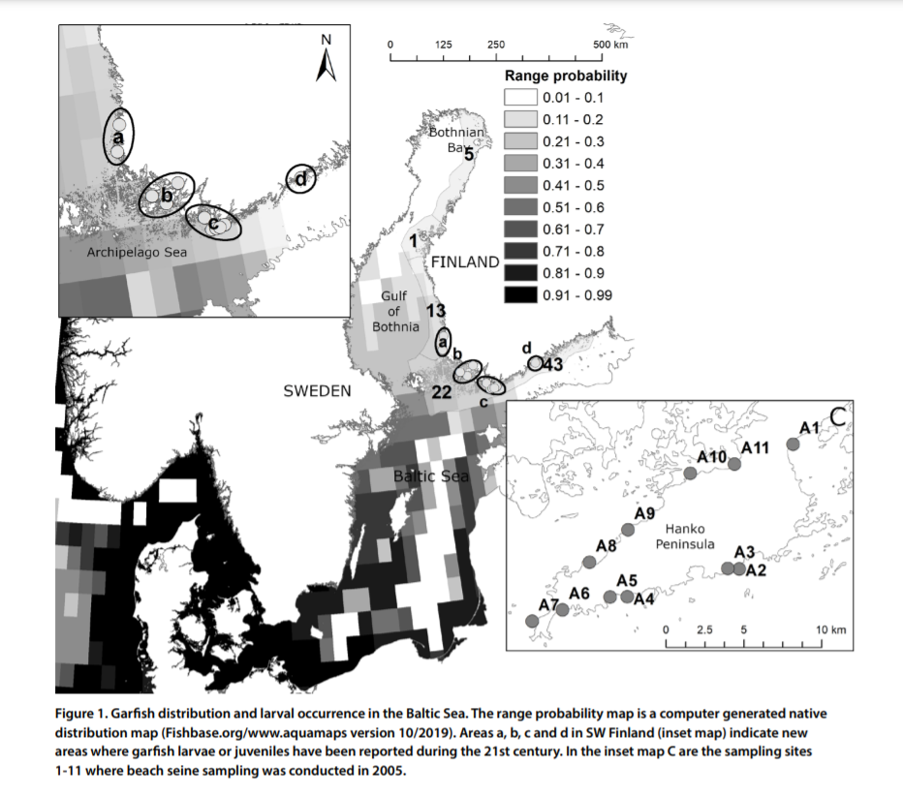 (Veneranta and Urho 2021)

|  |  |
| --- | --- |
| Sensitivity attributes | Information: Garfish |
| Habitat specificity | * Spawning in coastal waters on littoral vegetation (Fonds et al. 1974; Polte and Asmus 2006) * Shallow Seagrass beds *Zostera noltii* on shallow sandy bottoms as spawning substrate (North Sea) (Polte 2004) * Larvae: Habitats along shallow sandy shores where the temperature is higher than in adjacent open water area (Veneranta and Urho 2021) |
| Prey specificity | * Opportunistic (pelagic nekton) (Alter and Peck 2021; Dorman 1988) * Juveniles (30 mm): Cannibalism (von Westernhagen 1974) * Juvenile (post-larval) garfish feed on copepods and larval bryozoan (Dorman 1988) * Adults: Crustaceans, especially crab larvae, and juvenile fish, mostly clupeids (Dorman 1988; 1991) |
| Adult mobility | * High migratory, congregate in Skagerrak/Kattegat in April/May (Heessen et al. 2015) * Annual migration from overwintering area in the North Sea to the Baltic Proper (Dorman 1991) |
| Dispersal of early life stages | * Demersal, adhesive eggs with filaments (Russell 1976) * Planktonic larvae (Froese and Pauly 2021) * Developmental time: 28 days (d) at 15 °C (Alter and Peck 2021) * High abundance of post-larvae and 0-group juveniles in Marinas and harbor basins (P. Polte, pers. Obs.) |
| Early life stage survival & settlement requirements | * Demersal eggs with sticky filaments (Russell 1976) * Larvae start feeding immediately (few hours) after hatching (Heessen et al. 2015) * Larvae: habitats along shallow sandy shores where the temperature is higher than in adjacent open water area (Veneranta and Urho 2021) |
| Complexity of reproductive strategy | * Egg deposition in spring in coastal waters (shallow estuaries) (Fonds et al. 1974) * Spawning in May-June (North Sea), larvae hatch in July (Rosenthal and Fonds 1973) * Spawning migration is triggered by temperature (Dorman 1991) * Spawning migrations into southern Baltic Sea in April to May (Dorman 1991) |
| Population Spawning Cycle | * Annual batch spawners * Spawning in May-June (North Sea) (Rosenthal and Fonds 1973) |
| Sensitivity to increasing temperature | * Eggs: Optimum temperatures 17-19°C (Fonds et al. 1974) * Max. hatching rate larvae/egg development: 18°C (von Westernhagen 1974) * No viable hatch was observed at 9°C (von Westernhagen 1974) * Juveniles (1 to 3 cm standard length) survive at temperatures ranging from 13° to 25°C (Rosenthal and Fonds 1973) * Adults are caught in May and June at temperatures of 15-20 °C (Fonds et al. 1974) * Garﬁsh in the Baltic Sea will beneﬁt from projected increased rates of spring warming but not the concomitant increase in pCO 2 (Alter and Peck 2021) |
| Sensitivity to decreasing salinity | * Low Sal can foster uptake of pollutants * Juveniles: Salinity tolerance 7-50 (Rosenthal and Fonds 1973) * Adults are found at salinities as low as 7-9 psu (Fonds et al. 1974) * Adults are caught in salinities of 20-30 psu (North Sea) (Fonds et al. 1974) * Max. hatching rate larvae: between 15-33 psu (von Westernhagen 1974) * Salinity limit (Baltic Sea): 5-6 psu (Veneranta and Urho 2021) |
| Sensitivity to Ocean Acidification | * The proportion of embryos with morphological deformities increased with elevated pCO2 but not temperature, stable high Temperature (17°C) and pCO2 (1300 μatm, future predictions; 400 µatm present value) were lethal for embryos (Alter and Peck 2021) |
| Population growth rate | |  |  | | --- | --- | | Maximum growth rate (rmax) | * Prior r= 0.43 (Froese et al. 2017) | | Von Bertalanffy K | * 0.1 (unknown area) | | Age at maturity (tm) | * No data/information | | Maximum age (tmax) | * No data/information | | Natural mortality (M) | * No data/information | | Maximum length (Linf) | * 61.4 cm TL |  * ([www.fishbase.org](http://www.fishbase.org), (Froese and Pauly 2021) |
| Sensitivity to other stressors | * Eutrophication, indirect cascade effects |

Alter, K., and M.A. Peck. 2021. Ocean acidification but not elevated spring warming threatens a European seas predator. *Science of The Total Environment* 782: 146926.

Dorman, J.A. 1988. Diet of the garfish, *Belone belone* (L.), from Courtmacsherry Bay, Ireland. 33: 339-346.

Dorman, J.A. 1991. Investigations into the biology of the garfish, *Belone belone* (L.), in Swedish waters. *Journal of Fish Biology* 39: 59-69.

Fonds, M., H. Rosenthal, and D.F. Alderdice. 1974. Influence of Temperature and Salinity on Embryonic Development, Larval Growth and Number of Vertebrae of the Garfish, *Belone belone*, 509-525. Berlin, Heidelberg: Springer Berlin Heidelberg.

Froese, R., N. Demirel, G. Coro, K.M. Kleisner, and H. Winker. 2017. Estimating fisheries reference points from catch and resilience. *Fish and Fisheries* 18: 506-526.

Froese, R., and D. Pauly. 2021. Editors. 2021. Fishbase. World Wide Web electronic publication. www.fishbase.org (06/10.2021).

Heessen, H.J.L., N. Daan, and J. Ellis. 2015. *Fish atlas of the Celtic Sea, North Sea and Baltic Sea - Based on international research-vessel surveys*. Wageningen, Netherlands: Wageningen Academic Publishers.

Polte, P. 2004. Ecological functions of intertidal seagrass beds for fishes and mobile epibenthos in the northern Wadden Sea, University of Bremen.

Polte, P., and H. Asmus. 2006. Intertidal seagrass beds (*Zostera noltii*) as spawning grounds for transient fishes in the Wadden Sea. *Marine Ecology Progress Series* 312: 235-243.

Rosenthal, H., and M. Fonds. 1973. Biological observations during rearing experiments with the garfish *Belone belone*. *Marine Biology* 21: 203-218.

Russell, F.S. 1976. *The Eggs and Planktonic Stages of British Marine Fishes*. London: Academic Press.

Veneranta, L., and L. Urho. 2021. Reproduction range of garfish, B*elone belone* (L.), in the northern Baltic Sea. *Memoranda Societatis pro Fauna et Flora Fennica* 97: 1-10.

Von Westernhagen, H. 1974. Incubation of Garpike Eggs (*Belone Belone* Linne) under Controlled Temperature and Salinity Conditions. *Journal of the Marine Biological Association of the United Kingdom* 54: 625-634.

**Seehase - Lumpsucker (*Cyclopterus lumpus*)**

**Additional information**

|  |  |
| --- | --- |
| **Distribution range in the Western Baltic Sea** | * Skagerrak, Kattegat, western Baltic Sea and central Baltic, no catches in Gulf of Bothnia (Heessen et al. 2015) * In Spring: Lumpsucker catches with gillnets (around Hiddensee) (Expert information) |
| **Stock size** | * No information/data |
| **Recruitment** | * No information/data |
| **Growth** | * No information/data |
| * In Gillnets (set to hard substrate): massive catches (Expert information) * Distribution Atlantic to Gibraltar (Powell et al. 2018), not in the Mediterranean Sea (Expert information) | |

C:\Users\moll\Desktop\balt_ADAPT\WP1_CVA\Species PROFILES\Species Profiles\Literatur Arten\Cyclopterus lumpus_Seehase\heessen et al. 2015.tif

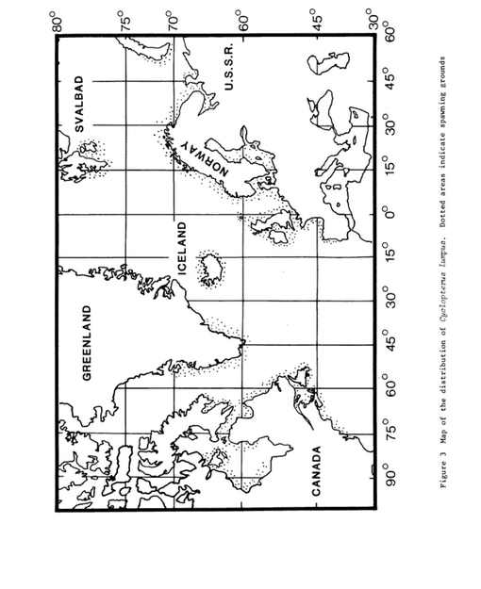

Figure 1: Distribution map of *Cyclopterus lumpus* (Davenport 1985)

|  |  |
| --- | --- |
| Sensitivity attributes | Information: Lumpsucker |
| Habitat specificity | * Oceanodromous ([www.fishbase.org](http://www.fishbase.org), (Froese and Pauly 2021) * Benthopelagic, solitary, pelagic, living in the upper 50-60 m in oceanic water on rocky bottoms, also occur on floating seaweed (Davenport 1985) * Juveniles: Seaweed beds are important habitats, living and feeding on and around weed beds (Vandendriessche et al. 2007) * Adults remained pelagic until winter before spring spawning, demersal habit occurred during that winter (Bagge 1964; Schopka 1974) * Structured hard spawning habitats along Wismar and Kiel (Expert information) * Observations of Juveniles in early spring (Feb.), on stones at the lighthouse of Bülk (Kiel) (Western Baltic Sea) (Expert information) * During breeding season, males establish territories in shallow water on rocky and/or sea-weed-covered substrate (Powell et al. 2018) * Spawning areas are located near shore shallow water (Davenport 1985) * Occurrence water depth in 10-80 m (Baltic Sea), 0-55 m (North Sea) (Heessen et al. 2015) |
| Prey specificity | * Prey mainly on large planktonic organisms living in surface/mid water, but also benthic organisms, particularly those dwelling upon weed (Davenport 1985; Powell et al. 2018) * Juveniles: motile crustaceans larger than 0.5 mm (prey items associated on seaweed) (Ingólfsson and Kristjánsson 2002) * Adults: Small crustaceans (mysids, amphipods, euphausids, isopods, decapod zoeae), ctenophores, polychaetes worms, seagrass, insects, small fish, fish eggs (Davenport 1985; Powell et al. 2018) * Feeding behavior in aquarium: Opportunistic (Expert information) * Specialized on food, but not limited (Expert information) * Prey on “Karpfenläuse” in Norway (Expert information) |
| Adult mobility | * Extensive annual migrations between feeding grounds (deeper waters in winter) and the shallower waters preferred for spawning in spring and summer (Davenport 1985; Kasper et al. 2014) |
| Dispersal of early life stages | * Demersal eggs: Females releasing eggs freely into the water on to the surface of a nest, in contact with sea water, eggs adhere to one another to form large ovoid masses (Powell et al. 2018) * Hatching after 31 days at 6.4 °C, 25 days at 9.8 °C (Atlantic) (Collins 1978) * Pelagic larvae are dispersed by water currents, early hatched larvae remain in shallow water, often attached to weed (Davenport 1985) * Older juveniles adopt semipelagic habit of adults (Davenport 1985) |
| Early life stage survival & settlement requirements | * Spawning season Jan-May, adults move inshore to spawn on rocky grounds (Heessen et al. 2015) * Larvae and juveniles are known to spend the first few months in tidal pools before migrating out into open water, but yolk sac larvae and juveniles <30 mm are also found associated with floating seaweed clumps between 10 and 30 km from land (Ingólfsson 2000; Moring 2001) * Hatchlings and juveniles appear to be almost obligate inhabitants of seaweed, living and feeding on and around weed beds (Vandendriessche et al. 2007), although young juveniles are also commonly found in parts of the intertidal zone, such as rock pools (Moring 2001) * Hatchlings tend to consume harpacticoid copepods or halacrid mites (Arachnida) (Ingólfsson and Kristjánsson 2002) * Juvenile lumpfish (c. 5–55 mm length) are apparently year-round seaweed specialists, inhabiting and feeding on surface plankton after hatching and weed-associated invertebrate fauna when larger (Powell et al. 2018; Vandendriessche et al. 2007) |
| Complexity of reproductive strategy | * Assumed to spawn at age 5-6 (citation in Davenport 1985) * Early in the breeding season, males establish territories in shallow water on rocky and/or sea-weed-covered substrate, prior to the arrival of females; females arrive asynchronously, allowing more than one pairing and breeding event to occur per animal (Powell et al. 2018) * Intensive parental care by males (fanning behavior to promote oxygen uptake by egg masses, males have been observed to spout water from the mouth during low tide; protection against predators), males guard eggs for 6-10 weeks (Davenport 1983; Davenport 1985) * Semi-pelagic status of adult females (Powell et al. 2018) * Homing behavior (Davenport 1985; Powell et al. 2018) * Females do not release all their eggs in one batch, interval spawning of 8-14 days (citations in Davenport 1985) |
| Population Spawning Cycle | * Spawning in spring and summer (Davenport 1985; Kasper et al. 2014) (rot) * Spawning season Jan-May (North Sea and Baltic Sea) (Heessen et al, 2015) * Females do not release all their eggs in one batch, interval spawning of 8-14 days (citations in Davenport 1985) * Spawning duration ~ 6 weeks in spring (around Poel island) (Expert information) |
| Sensitivity to increasing temperature | * Lumpsucker is eurythermal but capable of inhabiting very cold water (Davenport 1985; Powell et al. 2018) * Arctic-temperate distribution (Expert information) * Climate change looser: Lumpsucker will not benefit from warming (Expert information) |
| Sensitivity to decreasing salinity | * Baltic Sea population live in low salinity areas, physiologically adapted to lower salinities (Davenport 1985) * Salinity tolerance: Reproduction at 6-8 psu (Expert information) * Norway/Atlantic: Egg development was normal between 20-34 psu, death occurred at lower or higher salinities (Davenport 1985) |
| Sensitivity to Ocean Acidification | * No data/information |
| Population growth rate | * ([www.fishbase.org](http://www.fishbase.org), Froese and Pauly 2021)  |  |  | | --- | --- | | Maximum growth rate (rmax) | * Prior r= 0.17 (Froese et al. 2017) | | Von Bertalanffy K | * 0.25 (Atlantic) (Kasper et al. 2014) | | Age at maturity (tm) | * 3-4 (North Sea, Atlantic) | | Maximum age (tmax) | * 6 (Baltic Sea) | | Natural mortality (M) | * No data/information | | Maximum length (Linf) | * 52.7 cm TL (Kasper et al. 2014) | |
| Sensitivity to other stressors | * Emerging diseases by parasites, such as *Nucleospora cyclopteri* were more prevalent in females around Iceland (Atlantic) (Freeman et al. 2013) * Sensitivity to oxygen depletion increased during development, 36 day old eggs could extract oxygen from water of only 10-20% air saturation (Davenport 1985) * Early stage eggs are tolerant of hypoxic conditions and can even survive brief exposure to anoxic sea water, later eggs and larvae are much more susceptible to oxygen lack (Davenport 1983) * Fishery targeting gravid females will bias sex ratio (Powell et al. 2018) * Degradation of habitats: Will benefit from wind farms: Potential new habitats? (Expert information) |

Bagge, O. 1964. Some observations on the biology of the lumpsucker (*Cyclopterus lumpus*). *ICES Document CM 1964*.

Collins, M.A.J. 1978. Experiments on the hatching period of the eggs of the lumpfish *Cylopterus lumpus* L. in Newfoundland waters. *Naturaliste canadien* 105: 169-171.

Davenport, J. 1983. Oxygen and the developing eggs and larvae of the lumpfish, *Cyclopterus lumpus*. *Journal of the Marine Biological Association of the United Kingdom* 63: 633-640.

Davenport, J. 1985. Synopsis of biological data on the lumpsucker *Cyclopterus lumpus* (Linnaeus 1758). *FAO Fisheries Synopsis No 147.*: 31 p.

Freeman, M.A., J.M. Kasper, and Á. Kristmundsson. 2013. *Nucleospora cyclopteri* n. sp., an intranuclear microsporidian infecting wild lumpfish, *Cyclopterus lumpus* L., in Icelandic waters. *Parasites & Vectors* 6: 49.

Froese, R., N. Demirel, G. Coro, K.M. Kleisner, and H. Winker. 2017. Estimating fisheries reference points from catch and resilience. *Fish and Fisheries* 18: 506-526.

Froese, R., and D. Pauly. 2021. Editors. 2021. Fishbase. World Wide Web electronic publication. www.fishbase.org (06/10.2021).

Heessen, H.J.L., N. Daan, and J. Ellis. 2015. *Fish atlas of the Celtic Sea, North Sea and Baltic Sea - Based on international research-vessel surveys*. Wageningen, Netherlands: Wageningen Academic Publishers.

Ingólfsson, A. 2000. Colonization of floating seaweed by pelagic and subtidal benthic animals in southwestern Iceland, 181-189. Dordrecht: Springer Netherlands.

Ingólfsson, A., and B.K. Kristjánsson. 2002. Diet of Juvenile Lumpsucker *Cyclopterus lumpus* (Cyclopteridae) in Floating Seaweed: Effects of Ontogeny and Prey Availability. *Copeia* 2002: 472-476.

Kasper, J.M., B. Bertelsen, H.G. Ólafsson, J.C. Holst, J. Sturlaugsson, and S.P. Jónsson. 2014. Observations of growth and postspawning survival of lumpfish *Cyclopterus lumpus* from mark-recapture studies. *Journal of Fish Biology* 84: 1958-1963.

Moring, J.R. 2001. Intertidal growth of larval and juvenile lumpfish in Maine: A 20-year assessment. *Northeastern Naturalist* 8: 347-354, 348.

Powell, A., C. Pooley, M. Scolamacchia, and C. Garcia de Leaniz. 2018. Review of lumpfish biology. In Cleaner Fish Biology and Aquaculture Applications, pp. 90–113. Ed. by Treasurer J. 5 M Publishing, Sheffield. 515 pp.

Schopka, S.A. 1974. Preliminary results from tagging of lumpsucker (*Cyclopterus lumpus*) in Icelandic waters 1971-3. *ICES Document CM F18*.

Vandendriessche, S., M. Messiaen, S. O'Flynn, M. Vincx, and S. Degraer. 2007. Hiding and feeding in floating seaweed: Floating seaweed clumps as possible refuges or feeding grounds for fishes. *Estuarine, Coastal and Shelf Science* 71: 691-703.

**Schwarzmundgrundel - Round goby (*Neogobius melanostomus*)**

**Additional information**

|  |  |
| --- | --- |
| **Distribution range in the Western Baltic Sea** | * Pomeranian Bay (Dudko et al. 2015; Więcaszek et al. 2019), Gulf of Gdansk (Wandzel 2000) * Well-established in the Baltic Sea (up to Finland) (Schrandt et al. 2016) |
| **Stock size** | * No data/information |
| **Recruitment** | * No data/information |
| **Growth** | * Growth rates: highly variable and site-specific (Kornis et al. 2012) * Males are larger than females * Invasive round goby in southern Baltic Sea: longer life span (up to age 6) and larger sizes (Sokołowska and Fey 2011) |
| * Round goby: target of commercial fishermen (Sapota and Skóra 2005) * In Denmark, researchers, governmental institutions and fishers have joined in an effort to establish a sustainable round goby fishery (Christoffersen et al. 2019) * Local sub-populations of the species are genetically differentiating in the southern Baltic Sea, indicating fast divergence and potential adaptation to local conditions (Björklund and Almqvist 2010) | |

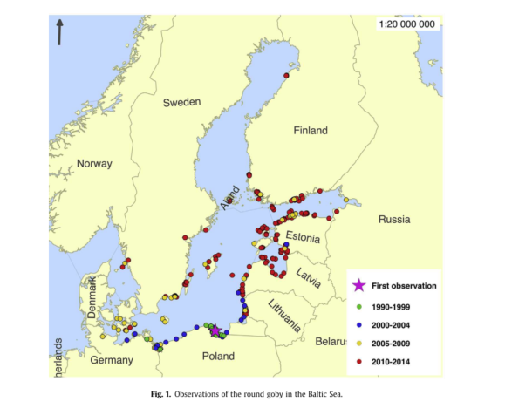(Kotta et al. 2016)

|  |  |
| --- | --- |
| Sensitivity attributes | Information: Round goby |
| Habitat specificity | * Rapidly adapt to new habitats (Kornis et al. 2012) * Hard substrates, rocky habitats preferred, however, sandy and muddy are also utilized (Kornis et al. 2012) * Juveniles (small) inhabit shallower, densely vegetated habitats (Henseler et al. 2020) * Abundance may correlate with depth and density of aquatic vegetation (Kornis et al. 2012) * Younger gobies are more abundant in the frontal areas of underwater concrete structures where the substrate is characterized by loose stones and the presence of Mya arenaria (Skora and Rzeznik 2001) * Adult round goby prefers an environment full of hiding places that also can be used for nests, submerged stones or concrete structures covered with colonies of *M. trossulus* are its preferred habitat (Skora and Rzeznik 2001) * round goby spend autumn and winter at signiﬁcantly deeper and offshore areas compared to spring and summer months; few ﬁsh were captured at depths < 25 m in these colder months (Behrens et al. 2021) * In spring and summer, round goby were not captured at depths > 25 m (Behrens et al. 2021) |
| Prey specificity | * Opportunistic: Capacity to adapt to locally abundant food sources (Kornis et al. 2012; Nurkse et al. 2016) * Invertebrates, mollusks and crustaceans (Maitland and Linsell 2007; Wandzel 2000) * Consumption of small (< 38mm TL) flounder (Schrandt et al. 2016) * Round gobies preferred *C. crangon*. *M. edulis* was preferred over herring eggs when *C. crangon* was absent, smaller gobies (< 10 cm) feed on herring eggs (Wiegleb et al. 2018) * Western Baltic: Wide range of different resident organisms (such as Nereidae, Gammaridae, Isopoda, Decapoda, Balanidae and Mollusca) (Oesterwind et al. 2017) * High interannual variability in the prey species, crustaceans had the highest importance in the diet of all examined size classes of round goby (Hempel et al. 2019) * Round goby in the Western Baltic to mainly prey on either barnacles or mollusks (Matern et al. 2021) |
| Adult mobility | * Territorial with limited swimming range (Kotta et al. 2016; Ray and Corkum 2001), high site affinity * Seasonal migrations are common, seaward return migration during winter, riverine upstream dispersal (Christoffersen et al. 2019) |
| Dispersal of early life stages | * Dispersal of larvae (nocturnally pelagic) via ballast water (Kornis et al. 2012; Kotta et al. 2016) | Early life stage survival & settlement requirements | * Eggs and larvae are large (3.2 mm diameter), hatch at ~ 5 mm TL (Kornis et al. 2012) |
| Early life stage survival & settlement requirements | * Eggs and larvae are large (3.2 mm diameter), hatch at ~ 5 mm TL (Kornis et al. 2012) * larvae feed on zooplankton (citations in Kornis et al. 2012) |
| Complexity of reproductive strategy | * Early maturity (Baltic Sea), individuals begin to reproduce at different times (Wandzel 2000) * batch spawner, which means that females do not spawn all their eggs at one time, but release them in portions throughout the reproductive season (Tomczak and Sapota 2006) * Repeated spawning throughout summer (Charlebois et al. 2001) * Parental care by males (Charlebois et al. 2001) * fish have specific reproductive behavior including repetitive spawning from spring to autumn, the establishment of territory, nest preparation and aggressive behaviour (Corkum et al. 1998; MacInnis and Corkum 2000) * Males are cavity spawners, defending territory and guard embryos and newly hatched larvae (Corkum et al. 1998; MacInnis and Corkum 2000) * April-Sept in Puck Bay (Baltic Sea) (Wandzel 2000) * In the Baltic Sea, the round goby spawns in waters at temperatures of 17-18°C and with salinity of 8- 9 psu (Tomczak and Sapota 2006) |
|
| Population Spawning Cycle | * April-Sept in Puck Bay (Baltic Sea) (Wandzel 2000) * Spawning activity intensified from March to May and then from June to August or even September (Baltic Sea) (Tomczak and Sapota 2006) * Spawning cycle is repeated five to six times throughout the year at intervals of approx. 17-28 days, length of interval between subsequent batches depends on water temperature, higher temperatures mean that intervals are shorter (Charlebois et al. 1997 and citations in Tomczak and Sapota 2006) |
| Sensitivity to increasing temperature | * Increase expansion, when temperatures close to its energetic optimum of 26°C (Kornis et al. 2012) * Spawning at 9-26°C (Kornis et al. 2012) * Wide thermal tolerance: -1 to 30°C (citation in Kornis et al. 2012) * Physiological performance unperturbed from 15-28°C (Christensen et al. 2021) |
| Sensitivity to decreasing salinity | * Native distribution of the round goby is located in the area of the Black Sea with a mean salinity of 19, the Caspian Sea with a mean salinity of 12.8 (Charlebois et al. 1997) * Smaller and slow growing fish in freshwater (Kornis et al. 2012) * Freshwater: high stress level, however round goby inhabit freshwater habitats (Puntila-Dodd et al. 2021) * Salinity tolerance <30 psu (Kornis et al. 2012) * Fish growth was low at salinity of 30 psu (Hempel and Thiel 2015) |
| Sensitivity to Ocean Acidification | * No data/information |
| Population growth rate | |  |  | | --- | --- | | Maximum growth rate (rmax) | * No data/information | | Von Bertalanffy K | * 0.5 (unknown area) | | Age at maturity (tm) | * No data/information | | Maximum age (tmax) | * 6 (Baltic Sea) | | Natural mortality (M) | * No data/information | | Maximum length (Linf) | * 15.4 cm TL |  * (Froese and Pauly 2021) |
| Sensitivity to other stressors | * Tolerance of very low oxygen levels, lethal thresholds: 0.4-1.3 mg/L (Charlebois et al. 1997) |

Behrens, J.W., M.P. Ryberg, H. Einberg, R. Eschbaum, A.-B. Florin, W. Grygiel, J.P. Herrmann, B. Huwer, K. Hüssy, E. Knospina, K. Nõomaa, D. Oesterwind, P. Polte, S. Smoliński, D. Ustups, M. van Deurs, and H. Ojaveer. 2021. Seasonal depth distribution and thermal experience of the non-indigenous round goby *Neogobius melanostomus* in the Baltic Sea: implications to key trophic relations. *Biological Invasions*.

Björklund, M., and G. Almqvist. 2010. Rapid spatial genetic differentiation in an invasive species, the round goby *Neogobius melanostomus* in the Baltic Sea. *Biological Invasions* 12: 2609-2618.

Charlebois, P.M., L.D. Corkum, D.J. Jude, and C. Knight. 2001. The round goby (*Neogobius melanostomus*) Invasion: Current Research and Future Needs. *Journal of Great Lakes Research* 27: 263-266.

Charlebois, P.M., J.E. Marsden, R.G. Goettel, R.K. Wolfe, D.J. Jude, and S. Rudnicka. 1997. The round goby, *Neogobius melanostomus* (Pallas), a review of European and North American literature. Illinois-Indiana Sea Grant Program and Illinois Natural History Survey. INHS Special Publication No. 20.

Christensen, E.A.F., T. Norin, I. Tabak, M. van Deurs, and J.W. Behrens. 2021. Effects of temperature on physiological performance and behavioral thermoregulation in an invasive fish, the round goby. *Journal of Experimental Biology* 224.

Christoffersen, M., J.C. Svendsen, J.W. Behrens, N. Jepsen, and M. van Deurs. 2019. Using acoustic telemetry and snorkel surveys to study diel activity and seasonal migration of round goby (*Neogobius melanostomus*) in an estuary of the Western Baltic Sea. *Fisheries Management and Ecology* 26: 172-182.

Corkum, L.D., A.J. MacInnis, and R.G. Wickett. 1998. Reproductive Habis of Round Gobies. *Great Lakes Research Review* 3: 13-20.

Dudko, S., S. Król, K. Wojnar, and W. Wawrzyniak. 2015. Charakterystyka rybacka ichtiofauny Zatoki Pomorskiej (w oparciu o wyniki monitoring połowowego wykonanago w latach 2011–2014). [Fisheries characteristics of ichthyofauna of Pomeranian Bay (Based on the results of fishing monitoring carried out within 2011–2014)]. Wydawnictwo Josephs’s Sons, Szczecin, Poland. [In Polish.] http://fishbayproject.pl/files/fishbay\_publikacja.pdf.

Froese, R., and D. Pauly. 2021. Editors. 2021. Fishbase. World Wide Web electronic publication. www.fishbase.org (06/10.2021).

Hempel, M., V. Magath, R. Neukamm, and R. Thiel. 2019. Feeding ecology, growth and reproductive biology of round goby *Neogobius melanostomus* (Pallas, 1814) in the brackish Kiel Canal. *Marine Biodiversity* 49: 795-807.

Hempel, M., and R. Thiel. 2015. Effects of salinity on survival, daily food intake and growth of juvenile round goby *Neogobius melanostomus* (Pallas, 1814) from a brackish water system. *Journal of Applied Ichthyology* 31: 370-374.

Henseler, C., P. Kotterba, E. Bonsdorff, M.C. Nordström, and D. Oesterwind. 2020. Habitat utilization and feeding ecology of small round goby in a shallow brackish lagoon. *Marine Biodiversity* 50: 88.

Kornis, M.S., N. Mercado-Silva, and M.J. Vander Zanden. 2012. Twenty years of invasion: a review of round goby *Neogobius melanostomus* biology, spread and ecological implications. *Journal of Fish Biology* 80: 235-285.

Kotta, J., K. Nurkse, R. Puntila, and H. Ojaveer. 2016. Shipping and natural environmental conditions determine the distribution of the invasive non-indigenous round goby *Neogobius melanostomus* in a regional sea. *Estuarine, Coastal and Shelf Science* 169: 15-24.

MacInnis, A.J., and L.D. Corkum. 2000. Age and Growth of Round Goby *Neogobius melanostomus* in the Upper Detroit River. *Transactions of the American Fisheries Society* 129: 852-858.

Maitland, P., and K. Linsell. 2007. *Süßwasserfische: Alle Arten Europas gezeichnet*: Kosmos, 2007.

Matern, S., J.-P. Herrmann, and A. Temming. 2021. Differences in diet compositions and feeding strategies of invasive round goby *Neogobius melanostomus* and native black goby *Gobius niger* in the Western Baltic Sea. *Aquatic Invasions* 16: 314-328.

Nurkse, K., J. Kotta, H. Orav-Kotta, and H. Ojaveer. 2016. A successful non-native predator, round goby, in the Baltic Sea: generalist feeding strategy, diverse diet and high prey consumption. *Hydrobiologia* 777: 271-281.

Oesterwind, D., C. Bock, A. Förster, M. Gabel, C. Henseler, P. Kotterba, M. Menge, D. Myts, and H.M. Winkler. 2017. Predator and prey: the role of the round goby *Neogobius melanostomus* in the western Baltic. *Marine Biology Research* 13: 188-197.

Puntila-Dodd, R., D. Bekkevold, and J.W. Behrens. 2021. Estimating salinity stress via hsp70 expression in the invasive round goby (*Neogobius melanostomus*): implications for further range expansion. *Hydrobiologia* 848: 421-429.

Ray, W.J., and L.D. Corkum. 2001. Habitat and Site Affinity of the Round Goby. *Journal of Great Lakes Research* 27: 329-334.

Sapota, M.R., and K.E. Skóra. 2005. Spread of alien (non-indigenous) fish species *Neogobius melanostomus* in the Gulf of Gdansk (south Baltic). *Biological Invasions* 7: 157-164.

Schrandt, M.N., L.C. Stone, B. Klimek, S. Mäkelin, K.L. Heck Jr, J. Mattila, and H. Herlevi. 2016. A laboratory study of potential effects of the invasive round goby on nearshore fauna of the Baltic Sea *Aquatic Invasions* 11: 327-335.

Skora, K.E., and J. Rzeznik. 2001. Observations on Diet Composition of *Neogobius melanostomus* Pallas 1811 (Gobiidae, Pisces) in the Gulf of Gdansk (Baltic Sea). *Journal of Great Lakes Research* 27: 290-299.

Sokołowska, E., and D.P. Fey. 2011. Age and growth of the round goby *Neogobius melanostomus* in the Gulf of Gdańsk several years after invasion. Is the Baltic Sea a new Promised Land? *Journal of Fish Biology* 78: 1993-2009.

Tomczak, M.T., and M.R. Sapota. 2006. The fecundity and gonad development cycle of the round goby (*Neogobius melanostomus* Pallas 1811) from the Gulf of Gdańsk. *Oceanological and Hydrobiological Studies* 35: 353-367.

Wandzel, T. 2000. The fecundity and reproduction of round goby *Neogobius melanostomus* in the Puck Bay (Baltic Sea). *Bulletin of the Sea Fisheries Institute* 2: 43-51.

Więcaszek, B., E. Sobecka, S. Keszka, R. Panicz, K. Górecka, A. Linowska, and S. Król. 2019. Three new records of fishes and their parasite fauna from Pomeranian Bay, Baltic Sea. *Acta Ichthyologica et Piscatoria* 49: 65-73.

Wiegleb, J., P. Kotterba, C. Hammer, and D. Oesterwind. 2018. Predation of the round goby (*Neogobius melanostomus* Pallas, 1814) on Atlantic herring eggs in the Western Baltic Sea. *Marine Biology Research* 14: 989-1003.

**Atlantischer Lachs - Atlantic salmon (*Salmo salar L.*) – focus on Baltic salmon**

**Additional Information**

|  |  |
| --- | --- |
| **Distribution range in the Western Baltic Sea** | * Diadromous, rheophilic (=favouring high flows) species in the Baltic Sea (ICES 2021a) distributed in the main Basin, Gulf of Finland up to Bothnian Bay (ICES 2021a; Kallio-Nyberg et al. 2011) * Sporadically in SD 22, SD 24 around Rügen island (ICES 2021a) |
| **Stock size** | * Total salmon catches have decreased continuously since the 1990s * Total landed (retained) catch from recreational trolling has in recent years ranged from about 15,000 to 25,000 salmon per year (ICES 2021a) * Positive development of salmon populations in AUs 1-4 (see Figure 1) since 1990s (lower fishing mortality, better habitat quality in rivers), which is reflected by the growing number of immigrating smolts from the rivers (ICES 2021a) * Populations from AUs 4 and 5 have shown little/no recovery despite lower fishing mortality. ICES Advice for 2022 in SD22-31: 0-catch quota |
| **Recruitment** | * The current (2020) total wild production in all Baltic Sea rivers is about 2.7 million smolts, corresponding to about 71% of overall potential smolt production capacity. In addition, about 4.7 million hatchery reared (marked) smolts were released into the Baltic Sea in 2020 (ICES 2021b) |
| **Growth** | * Rapid growth during seawater residency (McCormick and Regish 2018) * Maximal growth occurs at 16–17°C (citations in Jensen et al. 1989) |
| * The Baltic salmon stock is composed of several salmon populations originating from different rivers along the Baltic cost which are management under six Assessment Units (AUs) (ICES 2021b) * The largest contribution (around 60%) to the total Baltic stock comes from rivers in AUs 1 and 2 (ICES 2021b) * Very weak populations in AU 5 and in AU 4 that contribute little to salmon production in the Baltic Sea. Nevertheless, there is a risk that local populations will be lost forever, also reducing the genetic diversity of Baltic salmon (ICES 2021a; ICES 2021b) | |

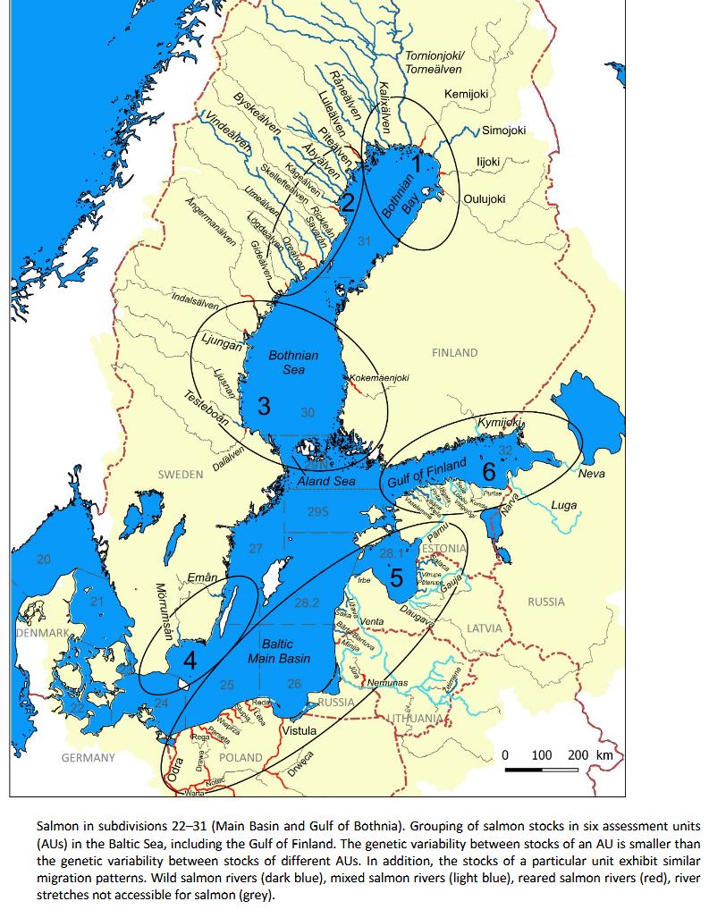 Figure 1 (ICES 2021b)

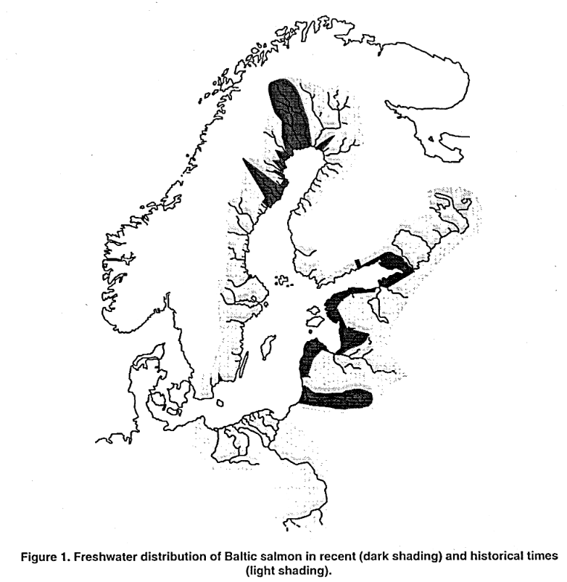(McKinnell 1997)

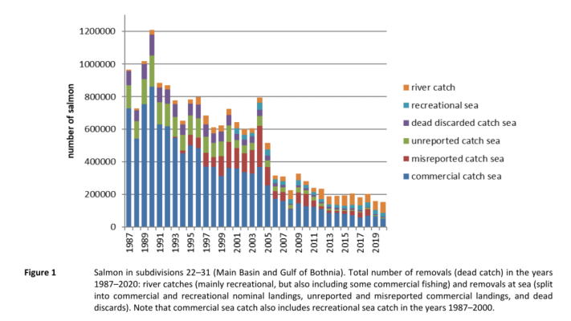(ICES 2021b)

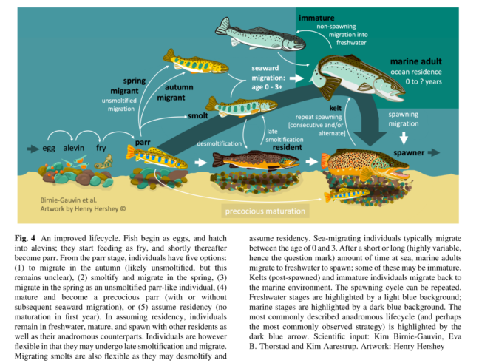

(Birnie-Gauvin et al. 2019)

|  |  |
| --- | --- |
| Sensitivity attributes | Information: Atlantic salmon (Baltic salmon) |
| Habitat specificity | * Freshwater: Free- and fast flowing rivers and streams connected to the sea, gravel banks in a pool-riffle sequence for spawning, starting life in freshwater (Heessen et al. 2015) * Juveniles remain in freshwater for 1-6 years, migrating to coastal marine waters, where they remain 1-4 years, then returning to freshwater for spawning (Froese and Pauly 2021; Hutchings and Jones 1998) * Sea: Post-smolts avoid cold deeper water, swim in surface layer (Jutila and Toivonen 1985) * In the Western Baltic Sea most abundant in 5-10 m (Heessen et al. 2015) |
| Prey specificity | * Juveniles: Invertebrates, adult piscivorous (Maitland and Linsell 2007) * Post-smolts (16-18 cm) eating various instect species of terrestrial origin in the first month at sea (Jutila andToivonen, 1985), diet shifts at about 16-25 cm from invertebrates to fish (e.g., sticklebacks, smelt) (Jutila and Toivonen 1985; Salminen et al. 1994) * Preying on herring (Kallio-Nyberg et al. 2011; Salminen et al. 2001) |
| Adult mobility | * High migratory during marine phase (Heessen et al. 2015) * Smolts: Small smolts (total length https://cdnsciencepub.com/cms/10.1139/f99-022/asset/images/ls.gif17.0 cm) were more frequently caught farther from the release site than were those released as larger smolts (>17 cm), the abundance of suitable prey (age 0+ herring) in the year of smolt release was found to be a key factor influencing the migration distance (Kallio-Nyberg et al. 1999) * The salmon released in the years of strong herring recruitment in the Gulf of Bothnia had a higher probability to stay in the Bothnian Sea for feeding and not to migrate farther south (Kallio-Nyberg et al. 1999) * Precise homing (Stabell 1984) |
| Dispersal of early life stages (ELS) | * Larvae stay in the interstitial until yolk sac is absorbed, then emerge from the gravel and drift into shallower water areas where they spend juvenile phase and change to exogenous feeding (Bardonnet et al. 1993; McCormick et al. 1998) * Salmon fry are mobile and move also upstream (Eisenhauer et al. 2021) |
| Early life stage survival & settlement requirements | * Parr (i.e. juveniles) may remain in freshwater environments for 1-7 years (depending on temperature and feeding conditions) but most stay for 2-3 years ([www.fishbase.org](http://www.fishbase.org), (Froese and Pauly 2021) * Juveniles spend 1-5 years in the river before migrating seawards (Forseth et al. 2017) * Parr undergo morphological and physiological changes called smoltification which prepares them for life in the sea (Froese and Pauly 2021) * Seaward migration starting in spring, spending 1-4 years in the ocean, in Baltic Sea they stay in Baltic Sea (Karlson and Karlström 1994) * Smolts migrate to sea at approx. 8°C (Hvidsten et al. 1998) * Juvenile period in stream, smoltification, feeding migration to sea and return to natal streams for spawning (Kallio-Nyberg et al. 2006) |
| Complexity of reproductive strategy | * Iteroparous (Froese and Pauly 2021) * Anadromous: return from ocean to natal rivers (Stabell 1984) * They can undertake extensive spawning migrations, which can exceed 100 km, or occasionally even >500 km, the same as recorded for sea trout) (Klemetsen et al. 2003) * At the transition to shallow overflowing gravel riffle stretches, the females cut spawning redds into the riverbed (Smialek et al. 2021) * Fertilized eggs sink into the redd, covered with a layer of gravel (by male) (Froese and Pauly 2021; Kottelat and Freyhof 2007) * Juveniles spend 1-5 years in the river before migrating seawards (Forseth et al. 2017) |
| Population Spawning Cycle | * In European latitudes: Spawning between November-January, local spawning events extend over two-three weeks (Armstrong et al. 2003; Crisp 1993) |
| Sensitivity to increasing temperature | * Thermal niche of cold adapted species, such as brown trout and Atlantic salmon, will result in a shift in distribution further to the north and that species in the southern part of their distributional areas are likely to go extinct (Ellender et al. 2016) * Winter spawner: An increase in water temperature can lead to a delayed spawning migration (Smialek et al. 2021) * Eggs: Incubation temperatures above 12°C :50 % mortality with 100 % mortality at 15.5 °C (Crisp 1993) * Newly hatched larvae: Thermal limit at 22 °C (Ojanguren et al. 1999) * Smolts: Optimal temperature for sea migration 8-12°C (Hvidsten et al. 1998; Kallio-Nyberg et al. 2011) * Smolt runs are strongly correlated to increasing water temperature and water flow during spring (Froese and Pauly 2021; McCormick et al. 1998) * Adults: Preferred temperature: 4-12°C (Froese and Pauly 2021) * Sexual maturity and fertility of Atlantic salmon and brown trout decrease with rising temperatures (Jonsson and Jonsson 2009) |
| Sensitivity to decreasing salinity | * Alevins (1-6 weeks post-hatch): Increased survival at 8.5 psu and 17 psu (Parry 1960) * Fry (3 month old, ~2 cm): survival decreased with increasing salinity, fish were able to survive ~8.5 psu, however with increasing salinity of 17 psu the survival decreased (Parry 1960) * From fry to smolts: Continuous increase in survival time, related to size (Parry 1960) * Smolt Salinity tolerance: Survival in 40 psu for 96 hours was low, however salinity tolerance (of fish reared under different light regimes) developed by time (Berge et al. 1995) * Smolts survived in 32 psu (McCormick and Regish 2018) |
| Sensitivity to Ocean Acidification | * Effects of OA on *S. salar* during the transition from fresh water to seawater indicates that elevated CO2 is not likely to affect osmoregulation negatively and may improve early growth in seawater (McCormick and Regish 2018) * Optimum pH range for adults: pH 6-9 (Smialek et al. 2021) |
| Population growth rate | |  |  | | --- | --- | | Maximum growth rate (rmax) | * Prior r=0.39 (Froese et al. 2017) | | Von Bertalanffy K | * 0.12-0.28 (Baltic Sea) | | Age at maturity (tm) | * 3-5 (UK Wales River) | | Maximum age (tmax) | * 5-6 (UK Scotland) | | Natural mortality (M) | * 1.1 (UK, Scotland) | | Maximum length (Lmax) | * 126 cm TL |  * (Froese and Pauly 2021) |
| Sensitivity to other stressors | * Low oxygen (Smialek et al. 2021) * Deterioration of spawning habitat, obstructions in rivers and estuaries, pollution (Heessen et al. 2015) * Parasite (*Gyrodactylus salaris*), freshwater acidiﬁcation, hydropower regulation and other habitat alterations were identiﬁed as stabilized population threats (North Sea) (Forseth et al. 2017) * Colmation and fine sediment deposition main factors for reproductive failure (Sternecker et al. 2014) |

Armstrong, J.D., P.S. Kemp, G.J.A. Kennedy, M. Ladle, and N.J. Milner. 2003. Habitat requirements of Atlantic salmon and brown trout in rivers and streams. *Fisheries Research* 62: 143-170.

Bardonnet, A., P. Gaudin, and J.E. Thorpe. 1993. Diel rhythm of emergence and of first displacement downstream in trout (*Salmo trutta*), Atlantic salmon (*S. salar*) and grayling (*Thymallus thymallus*). *Journal of Fish Biology* 43: 755-762.

Berge, Å.I., A. Berg, T. Barnung, T. Hansen, H.J. Fyhn, and S.O. Stefansson. 1995. Development of salinity tolerance in underyearling smolts of Atlantic salmon (*Salmo salar*) reared under different photoperiods. *Canadian Journal of Fisheries and Aquatic Sciences* 52: 243-251.

Birnie-Gauvin, K., E.B. Thorstad, and K. Aarestrup. 2019. Overlooked aspects of the *Salmo salar* and *Salmo trutta* lifecycles. *Reviews in Fish Biology and Fisheries* 29: 749-766.

Crisp, D.T. 1993. The environmental requirements of salmon and trout in fresh water. *Freshwater Forum,*: 176-202.

Eisenhauer, Z.J., P.M. Christman, J.-M. Matte, W.R. Ardren, D.J. Fraser, and J.W.A. Grant. 2021. Revisiting the restricted movement paradigm: the dispersal of Atlantic salmon fry from artificial redds. 78: 493-503.

Ellender, B.R., N.A. Rivers-Moore, C.R. Coppinger, T.A. Bellingan, and O.L.F. Weyl. 2016. Towards using thermal stress thresholds to predict salmonid invasion potential. *Biological Invasions* 18: 3513-3525.

Forseth, T., B.T. Barlaup, B. Finstad, P. Fiske, H. Gjøsæter, M. Falkegård, A. Hindar, T.A. Mo, A.H. Rikardsen, E.B. Thorstad, L.A. Vøllestad, and V. Wennevik. 2017. The major threats to Atlantic salmon in Norway. *ICES Journal of Marine Science* 74: 1496-1513.

Froese, R., N. Demirel, G. Coro, K.M. Kleisner, and H. Winker. 2017. Estimating fisheries reference points from catch and resilience. *Fish and Fisheries* 18: 506-526.

Froese, R., and D. Pauly. 2021. Editors. 2021. Fishbase. World Wide Web electronic publication. www.fishbase.org (06/10.2021).

Heessen, H.J.L., N. Daan, and J. Ellis. 2015. *Fish atlas of the Celtic Sea, North Sea and Baltic Sea - Based on international research-vessel surveys*. Wageningen, Netherlands: Wageningen Academic Publishers.

Hutchings, J.A., and M.E.B. Jones. 1998. Life history variation and growth rate thresholds for maturity in Atlantic salmon, *Salmo salar*. *Canadian Journal of Fisheries and Aquatic Sciences* 55: 22-47.

Hvidsten, N.A., T.G. Heggberget, and A.J. Jensen. 1998. Sea water temperatures at Atlantic Salmon smolt entrance. *Nordic Journal of Freshwater Research* 74: 79-86.

ICES. 2021a. Baltic Salmon and Trout Assessment Working Group (WGBAST). ICES Scientific Reports. 3:26. 331 pp. https://doi.org/10.17895/ices.pub.7925.

ICES. 2021b. Salmon (*Salmo salar*) in subdivisions 22–31 (Baltic Sea, excluding the Gulf of Finland). In Report of the ICES Advisory Committee, 2021. ICES Advice 2021, sal.27.22–31, https://doi.org/10.17895/ices.advice.7848.

Jensen, A.J., B.O. Johnsen, and L. Saksgård. 1989. Temperature Requirements in Atlantic Salmon (*Salmo salar*), Brown Trout (*Salmo trutta*), and Arctic Char (*Salvelinus alpinus*) from Hatching to Initial Feeding Compared with Geographic Distribution. *Canadian Journal of Fisheries and Aquatic Sciences* 46: 786-789.

Jonsson, B., and N. Jonsson. 2009. A review of the likely effects of climate change on anadromous Atlantic salmon *Salmo salar* and brown trout *Salmo trutta*, with particular reference to water temperature and flow. *Journal of Fish Biology* 75: 2381-2447.

Jutila, E., and J. Toivonen. 1985. Food composition of salmon post-smolts (*Salmo salar* L.) in the northern part of the Gulf of Bothnia. ICES Document CM, 1000, 21.

Kallio-Nyberg, I., H. Peltonen, and H. Rita. 1999. Effects of stock-specific and environmental factors on the feeding migration of Atlantic salmon (*Salmo salar)* in the Baltic Sea. *Canadian Journal of Fisheries and Aquatic Sciences* 56: 853-861.

Kallio-Nyberg, I., I. Saloniemi, E. Jutila, and E. Jokikokko. 2011. Effect of hatchery rearing and environmental factors on the survival, growth and migration of Atlantic salmon in the Baltic Sea. *Fisheries Research* 109: 285-294.

Karlson, L., and O. Karlström. 1994. The Baltic salmon (*Salmo salar* L.): its history, present situation and future. *Dana* 10: 61-85.

Klemetsen, A., P.A. Amundsen, J.B. Dempson, B. Jonsson, N. Jonsson, M.F. O'Connell, and E. Mortensen. 2003. Atlantic salmon *Salmo salar* L., brown trout *Salmo trutta* L. and Arctic charr *Salvelinus alpinus* (L.): a review of aspects of their life histories. *Ecology of Freshwater Fish* 12: 1-59.

Maitland, P., and K. Linsell. 2007. *Süßwasserfische: Alle Arten Europas gezeichnet*: Kosmos, 2007.

McCormick, S.D., L.P. Hansen, T.P. Quinn, and R.L. Saunders. 1998. Movement, migration, and smolting of Atlantic salmon (*Salmo salar*). *Canadian Journal of Fisheries and Aquatic Sciences* 55: 77-92.

McCormick, S.D., and A.M. Regish. 2018. Effects of ocean acidification on salinity tolerance and seawater growth of Atlantic salmon *Salmo salar* smolts. 93: 560-566.

McKinnell, S. 1997. Atlantic salmon in the Baltic Sea-the world's second most disturbed salmon populations. In ICES Council Meeting Papers. p. 16.

Ojanguren, A.F., F.G. Reyes-Gavilán, and R.R. Muñoz. 1999. Effects of Temperature on Growth and Efficiency of Yolk Utilisation in Eggs and Pre-feeding Larval Stages of Atlantic Salmon. *Aquaculture International* 7: 81-87.

Parry, G. 1960. The development of salinity tolerance in the salmon, *Salmo salar* and some related species. *Freshwater Fisheries Laboratory, M. A. F. F. London*: 425-434.

Salminen, M., S. Kuikka, and E. Erkamo. 1994. Divergence in the feeding migration of Baltic salmon (*Salmo salar* L.); the significance of smolt size. Nordic Journal of Freshwater Research (Sweden).

Smialek, N., J. Pander, and J. Geist. 2021. Environmental threats and conservation implications for Atlantic salmon and brown trout during their critical freshwater phases of spawning, egg development and juvenile emergence. *Fisheries Management and Ecology* 28: 437-467.

Stabell, O.B. 1984. Homing and olfaction in salmonids: A critical review with special reference to the Atlantic salmon. *Biological Reviews* 59: 333-388.

Sternecker, K., M. Denic, and J. Geist. 2014. Timing matters: species-specific interactions between spawning time, substrate quality, and recruitment success in three salmonid species. *Ecology and Evolution* 4: 2749-2758.

**Meerforelle - Sea trout (*Salmo trutta*) – focus on Baltic Sea trout**

**Additional information**

|  |  |
| --- | --- |
| **Distribution range in the Western Baltic Sea** | * Entire Baltic Sea (SD: 23-32), Western Baltic Sea (SD 22, 24) (see map Heessen et al. 2015; ICES 2021) |
| **Stock size** | * Some positive development can be seen for sea trout in the Baltic Sea region, but many populations (in Lithuania and Germany) are still considered vulnerable (ICES 2019a) |
| **Recruitment** | * Recruitment indices in SD 22 (Mecklenburg–Western Pommerania) are low and decreasing due to very low indices in German streams (mainly due adverse climatic conditions and sea fishing) (ICES 2021) * The same is the case in German streams in SD 24 (Figures 3 and 4), in the rest of assessment area South (SD 23–SD 25), there is no clear trend in development (ICES 2021) * Most sea trout stocks in the Gulf of Bothnia (subdivisions 30 and 31) are still considered weak as a result of diminished spawning runs despite a relatively good index in SD 30 (ICES 2021) * Gulf of Finland (SD 32) the overall index is high relative to other subdivisions and the trend in development positive (ICES 2021) |
| **Growth** | * Faster growth in the southern parts (Baltic Sea), with warmer and more productive areas (Degerman et al. 2012), Maximum growth occurs at 12°C (citations in Swift 1963) |
| * Sea trout is the anadromous form of the European brown trout (*Salmo trutta* L.) (Andrews 2008) * *Salmo trutta* can be divided into several subspecies, morphotypes or ecophenotypes that can exhibit distinctive life histories, particularly when it comes to migration directions and habitat preferences of adults (Kottelat and Freyhof 2007) * Most commonly, the species is subdivided into *Salmo trutta trutta (*adults living in the sea and migrating to rivers for spawning), *Salmo trutta lacustris* (living in lakes and migrating to lake tributaries for spawning) and *Salmo trutta fario* (a resident form spending its whole life cycle in rivers with migrations to spawning grounds within the river system) (Kottelat and Freyhof 2007) * Most of the sea trout in the Baltic Sea migrate to coastal areas near their home river and are therefore exploited locally, but there are stocks, subpopulations, and individuals with much longer migrations (ICES 2021) * This migratory behaviour necessitates international cooperation in management for sea trout stocks (ICES 2021) * The improvement of habitats through restoration in many Baltic Sea rivers, as well as the improvement of accessibility to spawning and rearing areas, is needed for the recovery of sea trout populations (ICES 2019b) | |

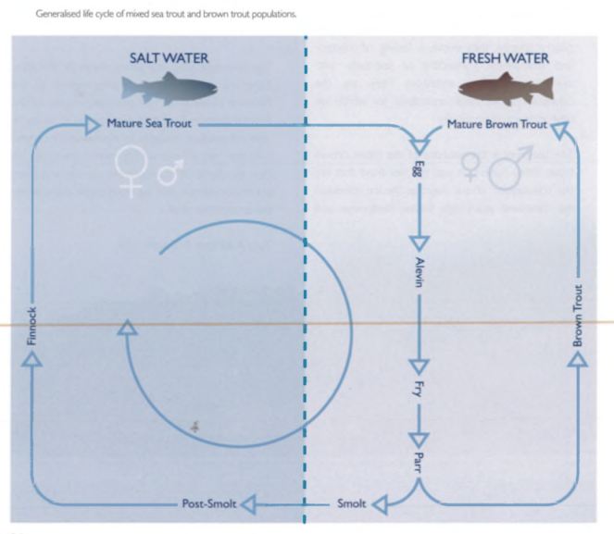(Andrews 2008)

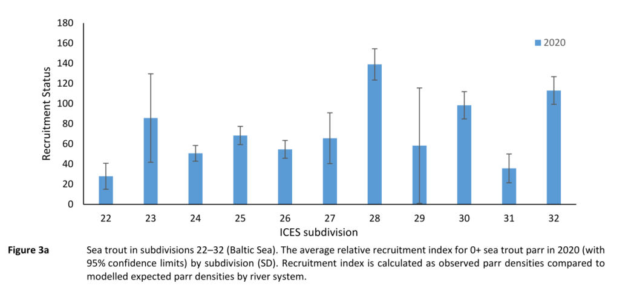(ICES 2021)

C:\Users\moll\Desktop\balt_ADAPT\WP1_CVA\Species PROFILES\Species Profiles\Literatur Arten\Salmo trutta_Forelle_Meerforelle\Salmo trutta Heessen et al. presence-absence sea trout.tif

|  |  |
| --- | --- |
| Sensitivity attributes | Information: Sea trout |
| Habitat specificity | * Freshwater spawning areas: Small brooks to large rivers, small lakes to fjords and coastal waters (Heessen et al. 2015) * Spawning depth: 8-25 m (Crisp 2000, citation in Smialek et al. 2021) * Smoltification in freshwater (Rasmussen and Pedersen 2018) * Marine: Inhabited areas close to the coast for growth, after a half to a couple of years, sea trout migrate back to the rivers for spawning (Rasmussen and Pedersen 2018) |
| Prey specificity | * Opportunistic feeder: Small crustaceans, fish (sandeel, sprat, juvenile herring) (Andrews 2008) * Juveniles feed on invertebrates and insects (Klemetsen et al. 2003; Maitland and Linsell 2007) * Adults feed on marine crustaceans, polychaetes and fish, diet changing with season and location (Heessen et al. 2015) |
| Adult mobility | * Migrations to spawning areas, few times during life (Heessen et al. 2015) * Recent genetic studies indicate that long-distance migrations are more common than previously recognized (ICES 2019b) * Hugh variations in migration pattern (Baltic Sea) (Degerman et al. 2012) * Populations in the southern Baltic Sea may undergo long-distance migrations, and overwinter in this brackish sea (Bartel et al. 2001) * Most of the sea trout in the Baltic Sea migrate to coastal areas near their home river (ICES 2021) |
| Dispersal of early life stages | * Pelagic eggs, planktonic larvae * Development time is dependent from ambient temperature: 1.5-5 months (Smialek et al. 2019) * Larvae stay in the interstitial until yolk sac is absorbed, then emerge from the gravel and drift into shallower water areas where they spend juvenile phase and change to exogenous feeding (Bardonnet et al. 1993; McCormick et al. 1998) * Scotland: spend between 1 and 4 years in fresh water before transforming into smolts, migrating to sea (Middlemas et al. 2009) |
| Early life stage survival & settlement requirements | * Egg development in winter (Nov.-Jan.), larval hatching in Feb-March (Smialek et al. 2021) * Optimum Eggs: 8-10°C; lethal limit: 16-18°C (Ojanguren and Braña 2003) * Parr stage: 8-10 cm, 9 months (Parry 1960) * Smoltification is a process of physiological, morphological and behavioral changes preparing juveniles for life in saltwater (Thorstad et al. 2016) * Juvenile period in the stream, smoltiﬁcation, a feeding migration in the sea and return migration of maturing adults to their natal river to spawn (Kallio-Nyberg et al. 2006) * Remain for one year in spawning area, than migration to bigger rivers or as anadromous migratory species into the ocean (Maitland and Linsell 2007) |
| Complexity of reproductive strategy | * Anadromous (Jonsson and Jonsson 2009) * Lithophilic fish species, they deposit their eggs in the interstitial zone of suitable gravel banks (Kondolf 2000; Sternecker et al. 2013) * At the transition to shallow overflowing gravel riffle stretches, the females cut spawning redds into the riverbed (Smialek et al. 2021) * Sea trouts require spawning habitats with a gravel bottom and a high exchange between the open water and the interstitial zone for successful reproduction (Kondolf 2000; Sternecker et al. 2013) * Eggs are incubated for one to several months, buried in gravel and hatching in the subsequent spring (Heessen et al. 2015) * Spend between 1 and 4 years in fresh water before transforming into smolts, and migrating to sea (Scotland) (Middlemas et al. 2009) * May spawn several times during their lifetime, annually after first spawning (citations within Thorstad et al. 2016) |
| Population Spawning Cycle | * Spawning time: Nov.-Jan., local spawning events extend over two to three weeks (Armstrong et al. 2003; Crisp 1993) |
| Sensitivity to increasing temperature | * Thermal niche of cold adapted species, such as brown trout and Atlantic salmon, will result in a shift in distribution further to the north and that species in the southern part of their distributional areas are likely to go extinct (Ellender et al. 2016) * Sea trout frequently are recorded at sea during winter and can tolerate full-salinity sea water at water temperatures as low as 1–2 °C (Thorstad et al. 2016) * Importance of water temperature as trigger or initiator of smolt migration (Jonsson and Jonsson 2002; Thorstad et al. 2016), migration occurred at 5-13°C (Ireland) (Byrne et al. 2004) * Small temperature increases (<2.5° C) in winter and spring would be beneficial for growth for1 year-old smolts, water temperatures would have to increase by *c.* 4° C in winter and spring, and 3° C in summer and autumn before they had a marked negative effect on trout growth (Elliott and Elliott 2010) * Optimum Eggs: 8-10°C; lethal limit: 16-18°C (Ojanguren and Braña 2003) * Adult spawners optimum: 4-19°C (Elliott 1981); 9-16°C (Piper et al. 1982) overview table in Smialek et al. 2021 * Lethal limit adults: 23-30°C (Elliott 1981) |
| Sensitivity to decreasing salinity | * Salinity tolerance increases with increasing size of the fish (Parry 1960) * Baltic Sea: Sea trout spawn in brackish water, eggs and “alevins” surviving salinities of up to 4-5 psu (Limburg et al. 2001) * Growth in the northern Baltic Sea is high with respect to the latitude and temperature conditions, possibly indicating that the low salinity is favourable for growth (Degerman et al. 2012) * No difference was observed in survival or growth rate for YOY sea trout in fresh and brackish Baltic Sea water (6.7 psu) (Landergren 2001) |
| Sensitivity to Ocean Acidification | * Freshwater acidification was one of the major environmental threats to aquatic biota, especially in northern Europe and eastern North America in calcium-poor rivers where the buffering capacity of the ecosystems naturally is rather low (Overrein et al. 1980) |
| Population growth rate | * [www.fishbase.org](http://www.fishbase.org), (Froese and Pauly 2021)  |  |  | | --- | --- | | Maximum growth rate (rmax) | * Prior r= 0.46 (Froese et al. 2017) | | Von Bertalanffy K | * 0.17-0.39 (Baltic Sea) | | Age at maturity (tm) | * 2-3 (SH, Germany) | | Maximum age (tmax) | * 8 (Sweden) | | Natural mortality (M) | * 0.31 (Norway) | | Maximum length (Linf) | * 40.6 cm TL | |
| Sensitivity to other stressors | * Deterioration of spawning habitat: Many populations are reported to be limited by poor habitat conditions, obstructions in rivers and estuaries, pollution (Heessen et al. 2015; ICES 2021) * Several wild migratory populations in the Baltic Sea have become extinct and some remaining populations are near extinction (due to fishery, hydropower regulation, inaccessibility of freshwater habitat) (Degerman et al. 2012) * Predation (e.g. cormorants, seals) (Jepsen et al. 2019) * Extreme pH values below 6 or above 9 are particularly harmful as they can activate other toxic substances (Crisp 1993; Smialek et al. 2021) * pH values above 9, the egg stages of salmonids die before hatching (Crisp 1993), the lower limit is 4.5 for Atlantic salmon, brown trout and lake trout (Crisp 1993) * Oxygen: minimum of 10 mg/L should be available to achieve >50% egg-to-fry survival (Rubin and Glimsäter 1996) |

Andrews, T. 2008. Sea Trout Facts - Atlantic Salmon Trust.

<https://atlanticsalmontrust.org/wp-content/uploads/2020/07/x118-Seatroutfacts-AST-2008.pdf>.

Armstrong, J.D., P.S. Kemp, G.J.A. Kennedy, M. Ladle, and N.J. Milner. 2003. Habitat requirements of Atlantic salmon and brown trout in rivers and streams. *Fisheries Research* 62: 143-170.

Bardonnet, A., P. Gaudin, and J.E. Thorpe. 1993. Diel rhythm of emergence and of first displacement downstream in trout (*Salmo trutta*), Atlantic salmon (*S. salar*) and grayling (*Thymallus thymallus*). *Journal of Fish Biology* 43: 755-762.

Bartel, R., E. Ikonen, and H. Auvinen. 2001. Differences in migration pattern and growth of Polish and Finnish sea trout (*Salmo trutta* L.) released in the same areas. *Archives of Polish Fisheries* 9: 105-122.

Byrne, C.J., R. Poole, M. Dillane, G. Rogan, and K.F. Whelan. 2004. Temporal and environmental influences on the variation in sea trout (*Salmo trutta* L.) smolt migration in the Burrishoole system in the west of Ireland from 1971 to 2000. *Fisheries Research* 66: 85-94.

Crisp, D.T. 1993. The environmental requirements of salmon and trout in fresh water. *Freshwater Forum,*: 176-202.

Crisp, D.T. 2000. Trout and salmon: ecology, conservation and rehabilitation. *Oxford: Wiley- Blackwell*.

Degerman, E., K. Leonardsson, and H. Lundqvist. 2012. Coastal migrations, temporary use of neighbouring rivers, and growth of sea trout (*Salmo trutta*) from nine northern Baltic Sea rivers. *ICES Journal of Marine Science* 69: 971-980.

Ellender, B.R., N.A. Rivers-Moore, C.R. Coppinger, T.A. Bellingan, and O.L.F. Weyl. 2016. Towards using thermal stress thresholds to predict salmonid invasion potential. *Biological Invasions* 18: 3513-3525.

Elliott, J.M. 1981. Some aspects of thermal stress on fresh-water teleosts. *In: Pickering, A.D. (Ed.) Stress and fish. London: Academic Press*: 43-50.

Elliott, J.M., and J.A. Elliott. 2010. Temperature requirements of Atlantic salmon *Salmo salar*, brown trout *Salmo trutta* and Arctic charr *Salvelinus alpinus*: predicting the effects of climate change. *Journal of Fish Biology* 77: 1793-1817.

Froese, R., N. Demirel, G. Coro, K.M. Kleisner, and H. Winker. 2017. Estimating fisheries reference points from catch and resilience. *Fish and Fisheries* 18: 506-526.

Froese, R., and D. Pauly. 2021. Editors. 2021. Fishbase. World Wide Web electronic publication. www.fishbase.org (06/10.2021).

Heessen, H.J.L., N. Daan, and J. Ellis. 2015. *Fish atlas of the Celtic Sea, North Sea and Baltic Sea - Based on international research-vessel surveys*. Wageningen, Netherlands: Wageningen Academic Publishers.

ICES. 2019a. Baltic Salmon and Trout Assessment Working Group (WGBAST). ICES Scientific Reports. 1:23. 312 pp. http://doi.org/10.17895/ices.pub.4979

ICES. 2019b. Sea trout (*Salmo trutta*) in subdivisions 22–32 (Baltic Sea). In Report of the ICES Advisory Committee, 2019, trs.27.22–32. https://doi.org/10.17895/ices.advice.4744

ICES. 2021. Sea trout (*Salmo trutta*) in subdivisions 22-32 (Baltic Sea). In Report of the ICES Advisory Committee, 2021. ICES Advice 2021, trs.27.22-32. https://doi.org/10.17895/ices.advice.7876.

Jepsen, N., H. Flávio, and A. Koed. 2019. The impact of Cormorant predation on Atlantic salmon and Sea trout smolt survival. *Fisheries Management and Ecology* 26: 183-186.

Jonsson, B., and N. Jonsson. 2009. A review of the likely effects of climate change on anadromous Atlantic salmon *Salmo salar* and brown trout *Salmo trutta*, with particular reference to water temperature and flow. *Journal of Fish Biology* 75: 2381-2447.

Jonsson, N., and B. Jonsson. 2002. Migration of anadromous brown trout *Salmo trutta* in a Norwegian river. *Freshwater Biology* 47: 1391-1401.

Kallio-Nyberg, I., E. Jutila, E. Jokikokko, and I. Saloniemi. 2006. Survival of reared Atlantic salmon and sea trout in relation to marine conditions of smolt year in the Baltic Sea. *Fisheries Research* 80: 295-304.

Klemetsen, A., P.A. Amundsen, J.B. Dempson, B. Jonsson, N. Jonsson, M.F. O'Connell, and E. Mortensen. 2003. Atlantic salmon *Salmo salar* L., brown trout *Salmo trutta* L. and Arctic charr *Salvelinus alpinus* (L.): a review of aspects of their life histories. *Ecology of Freshwater Fish* 12: 1-59.

Kondolf, G.M. 2000. Assessing Salmonid Spawning Gravel Quality. *Transactions of the American Fisheries Society* 129: 262-281.

Kottelat, M., and J. Freyhof. 2007. Handbook of European freshwater fishes. Publications Kottelat, Cornol and Freyhof, Berlin. 646 pp.

Landergren, P. 2001. Survival and growth of sea trout parr in fresh and brackish water. 58: 591-593.

Limburg, K.E., P. Landergren, L. Westin, M. Elfman, and P. Kristiansson. 2001. Flexible modes of anadromy in Baltic sea trout: making the most of marginal spawning streams. *Journal of Fish Biology* 59: 682-695.

Maitland, P., and K. Linsell. 2007. *Süßwasserfische: Alle Arten Europas gezeichnet*: Kosmos, 2007.

McCormick, S.D., L.P. Hansen, T.P. Quinn, and R.L. Saunders. 1998. Movement, migration, and smolting of Atlantic salmon (*Salmo salar*). *Canadian Journal of Fisheries and Aquatic Sciences* 55: 77-92.

Middlemas, S.J., D.C. Stewart, S. Mackay, and J.D. Armstrong. 2009. Habitat use and dispersal of post-smolt sea trout *Salmo trutta* in a Scottish sea loch system. 74: 639-651.

Ojanguren, A.F., and F. Braña. 2003. Thermal dependence of embryonic growth and development in brown trout. *Journal of Fish Biology* 62: 580-590.

Overrein, L., H.M. Seip, and A. Tollan. 1980. Acid precipitation-Effects on forest and fish. *Oslo-As: Final report of the SNSF-project 1972-1980, pp. 175.*

Parry, G. 1960. The development of salinity tolerance in the salmon, *Salmo salar* and some related species. *Freshwater Fisheries Laboratory, M. A. F. F. London*: 425-434.

Piper, R.G., I.B. McElwain, L.E. Orme, J.P. McCraren, L.G. Fowler, and J.R. Leonard. 1982. Fish hatchery management. *Washington: U.S. Fish Wildlife Service*.

Rasmussen, G.H., and S. Pedersen. 2018. Sea trout (*Salmo trutta* L.) in Denmark. *Brown trout: Biology, ecology and management, 483-521*.

Rubin, J.F., and C. Glimsäter. 1996. Egg-to-fry survival of the sea trout in some streams of Gotland. *Journal of Fish Biology* 48: 585-606.

Smialek, N., J. Pander, and J. Geist. 2021. Environmental threats and conservation implications for Atlantic salmon and brown trout during their critical freshwater phases of spawning, egg development and juvenile emergence. *Fisheries Management and Ecology* 28: 437-467.

Smialek, N., J. Pander, M. Mueller, R. van Treeck, C. Wolter, and J. Geist. 2019. Do We Know Enough to Save European Riverine Fish?—A Systematic Review on Autecological Requirements During Critical Life Stages of 10 Rheophilic Species at Risk. 11: 5011.

Sternecker, K., D.E. Cowley, and J. Geist. 2013. Factors influencing the success of salmonid egg development in river substratum. *Ecology of Freshwater Fish* 22: 322-333.

Swift, D.R. 1963. Influence of Oxygen Concentration on Growth of Brown Trout, *Salmo Trutta* L. *Transactions of the American Fisheries Society* 92: 300-301.

Thorstad, E.B., C.D. Todd, I. Uglem, P.A. Bjørn, P.G. Gargan, K.W. Vollset, E. Halttunen, S. Kålås, M. Berg, and B. Finstad. 2016. Marine life of the sea trout. *Marine Biology* 163: pp. 47-47-2016 v.2163 no.2013.

**Europäischer Aal - European Eel (*Anguilla Anguilla*)**

**Additional information**

|  |  |
| --- | --- |
| **Distribution range in the Western Baltic Sea** | * Throughout the Baltic Sea in coastal and adjacent freshwater habitats (HELCOM 2013) |
| **Stock size** | * Critically endangered, Stock decline, recovery will be a long-term process (FAO/ICES 2011), stock status is affected by stocking (Thiel et al. 2013) |
| **Recruitment** | * Dramatic decline in recruitment of glass and yellow eel coming to European waters since 1980, no sign of recovery (FAO/ICES 2011; ICES 2020) |
| **Growth** | * Growth rate (Atlantic): TL 0.19-0.24 mm/d; 5.3 mm/month (Boetius and Harding 1985; Lecomte-Finiger 1992), 0.26-0.30 mm/d (Lecomte-Finiger 1992) |
| * Status of European eel remains critical, reference points undefined (ICES 2020) * Listed in HELCOM Red List: critically endangered (HELCOM 2013) * All life stages of European eel, including newly arriving glass eels, growing yellow eel and maturing migrating silver eel, are commercially exploited (HELCOM 2013) | |

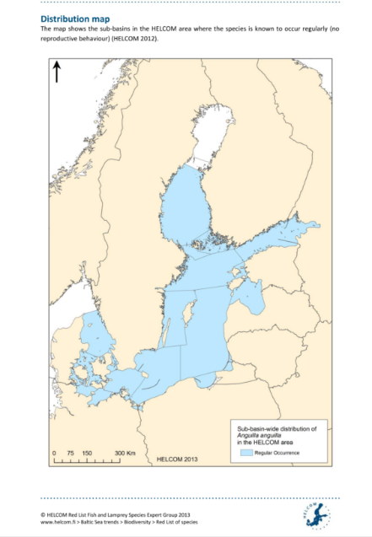(HELCOM 2013)

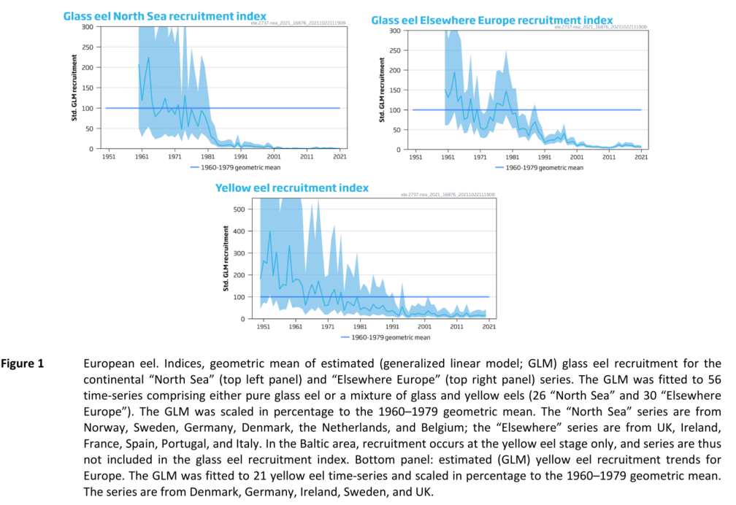

(ICES 2021a)

|  |  |
| --- | --- |
| Sensitivity attributes | Information: Eel |
| Habitat specificity | * Natal homing to the Spawning are Sargasso Sea (Lecomte-Finiger 1992) * Juveniles inhabit rivers, freshwater streams, lakes ponds, estuaries and coastal lagoons, living on the bottom, under stones, in mud (Froese and Pauly 2021; Tzeng et al. 2000) * Eels do not necessarily migrate into freshwater streams during growth (Baltic Sea) (Tzeng et al. 2000) * Juveniles prefer coarse gravel as benthic habitat (north-eastern Denmark) (Christoffersen et al. 2018) |
| Prey specificity | * Estuarine food: Amphipods and the shore crab, *Carcinus maenas* (L.), were the most important food items (Costa et al. 1992) * In more saline muddy bottom areas polychaetes, bivalves and shrimp, fish (Costa et al. 1992) |
| Adult mobility | * High migratory, migrating from freshwater habitats to the Sargasso Sea for reproduction (ICES 2021b) |
| Dispersal of early life stages | * Eggs are pelagic, newly hatched leptocephalus larvae drift with the ocean currents to the continental shelf of Europe and North Africa, where they metamorphose into glass eels and enter continental waters (ICES 2021b) * Larvae seem to be capable of active swimming (Lecomte-Finiger 1992; McCleave et al. 1998) * Migration time of leptocephali: less than one year (eastern Atlantic) (Lecomte-Finiger 1992), larval stage duration: 7- 11 months (citation in Lecomte-Finiger 1992) * Metamorphosis into glass eels takes place over the continental shelf before migrating upstream as juveniles (elvers), (33-76 d, depending from distance from the continental slope to the respective estuaries (Lecomte-Finiger 1992) |
| Early life stage survival & settlement requirements | * Pelagic eggs, planktonic larvae (Froese and Pauly 2021) * Egg fertilization success: 30-40 psu, neutral buoyancy could be sustained (Sørensen et al. 2015) * Larval stage duration: 7- 11 months (Lecomte-Finiger and Yahyaoui 1989) * Leptocephalus larvae drift with the ocean currents to the continental shelf of Europe and North Africa, where they metamorphose into glass eels and enter continental waters (ICES 2021b) * Hydrozoa plankton are important in the diet of *A. anguilla* larvae in Sargasso Sea (Ayala et al. 2018) * growth stage, known as yellow eel, may take place in marine, brackish (transitional), or freshwaters (ICES 2021b) * Yellow eel stage may last typically from two to 25 years (and can exceed 50 years) prior to metamorphosis to the “silver eel” stage, maturation and spawning migration (ICES 2021b) |
| Complexity of reproductive strategy | * Catadromous, complex life history and semelparous (death after first reproduction) (ICES 2021b) * Spawning area in the southwestern part of the Sargasso Sea (ICES 2021b) * Spawning migration to sea starts: male (30-40 cm, usually 6-12 years), females (55-65 cm (10-20 years old), spawn at ocean depths of 400-700 m in mid-winter ([www.fishbase.org](http://www.fishbase.org), (Froese and Pauly 2021)) * Panmixia is assumed, however, global genetic differentiation could be found (Atlantic, Baltic, Mediterranean Sea) (Wirth and Bernatchez 2001) * Sexual maturity: 8-18 years (Maitland and Linsell 2007) |
| Population Spawning Cycle | * Once in a life time, between March and June in Sargasso Sea (Froese and Pauly 2021) |
| Sensitivity to increasing temperature | * Optimum growth: 22-23°C (Sadler 1979) * Lethal temp: 38°C, state of torpor could be observed at 1-3 °C, when acclimated at 29-23°C (Sadler 1979) * Highest water temperature tolerated by eels: 31.5 °C (Claësson et al. 2016) * Water temperature is assumed to affect upstream migration, colder temperatures are preferred (11-12°C) (Tosi et al. 1988) |
| Sensitivity to decreasing salinity | * Anadromous, Reproduction in marine Sargasso Sea * Marine and estuarine eels grow faster than river eels (Edeline et al. 2005) |
| Sensitivity to Ocean Acidification | * No data/information |
| Population growth rate | * ([www.fishbase.org](http://www.fishbase.org), (Froese and Pauly 2021))  |  |  | | --- | --- | | Maximum growth rate (rmax) | * Prior r= 0.20 (Froese et al. 2017) | | Von Bertalanffy K | * 0.13-0.16 (Western Baltic Sea) | | Age at maturity (tm) | * 11 (SH, Germany) | | Maximum age (tmax) | * 20-23 (Finland/Germany) | | Natural mortality (M) | * No data/information | | Maximum length (Linf) | * 77.8 cm TL | |
| Sensitivity to other stressors | * Threats: Fishing, migration barriers, alien species, hydropower generation stations (HELCOM 2013; ICES 2020) * Pollution, chemical contaminants might affect spawning success, infection with parasite *Anguillicoloides crassus* (HELCOM 2013) * Hydropower, pumping stations, and other water intakes; habitat loss or degradation; pollution, diseases, and parasites; and other management actions that may affect levels of predation (e.g. conservation vs. control of predators). Climate change may have further effects, but these are not understood (ICES 2021a) * Changes in major current systems will affect recruitment of larvae and glass eels change in SST in the Sargasso Sea impact on productivity (Prigge 2013) * Eels are able to regulate and compensate to low levels of dissolved O2 (Cruz-Neto and Steffensen 1997) |

Ayala, D.J., P. Munk, R.B.C. Lundgreen, S.J. Traving, C. Jaspers, T.S. Jørgensen, L.H. Hansen, and L. Riemann. 2018. Gelatinous plankton is important in the diet of European eel (*Anguilla anguilla*) larvae in the Sargasso Sea. *Scientific Reports* 8: 6156.

Boetius, J., and E.E. Harding. 1985. A re-examination of Johannes Schmidt's Atlantic eel investigations. *Dana*: 129-162.

Christoffersen, M., J.C. Svendsen, J.A. Kuhn, A. Nielsen, A. Martjanova, and J.G. Støttrup. 2018. Benthic habitat selection in juvenile European eel *Anguilla anguilla*: implications for coastal habitat management and restoration. *Journal of Fish Biology* 93: 996-999.

Claësson, D., T. Wang, and H. Malte. 2016. Maximal oxygen consumption increases with temperature in the European eel (*Anguilla anguilla*) through increased heart rate and arteriovenous extraction. *Conservation Physiology* 4.

Costa, J.L., C.A. Assis, P.R. Almeida, F.M. Moreira, and M.J. Costa. 1992. On the food of the European eel, *Anguilla anguilla* (L.), in the upper zone of the Tagus estuary, Portugal. *Journal of Fish Biology* 41: 841-850.

Cruz-Neto, A.P., and J.F. Steffensen. 1997. The effects of acute hypoxia and hypercapnia on oxygen consumption of the freshwater European eel. 50: 759-769.

Edeline, E., S. Dufour, and P. Elie. 2005. Role of glass eel salinity preference in the control of habitat selection and growth plasticity in *Anguilla anguilla*. *Marine Ecology Progress Series* 304: 191-199.

FAO/ICES. 2011. Report of the 2011 session of the Joint EIFAAC/ICES Working Group on Eels. Lisbon, Portugal, from 5 to 9 September 2011. EIFAAC Occasional Paper. No. 48. ICES CM 2011/ACOM:18. Rome, FAO/Copenhagen, ICES. 2011. 246p.

Froese, R., N. Demirel, G. Coro, K.M. Kleisner, and H. Winker. 2017. Estimating fisheries reference points from catch and resilience. *Fish and Fisheries* 18: 506-526.

Froese, R., and D. Pauly. 2021. Editors. 2021. Fishbase. World Wide Web electronic publication. www.fishbase.org (06/10.2021).

HELCOM. 2013. Red List Fish and Lamprey Species Expert Group: Species Information Sheet *Anguilla anguilla*.

ICES. 2020. European eel (*Anguilla anguilla*) throughout its natural range. In Report of the ICES Advisory Committee, 2020. ICES Advice 2020, ele.2737.nea, https://doi.org/10.17895/ices.advice.5898. .

ICES. 2021a. European eel (*Anguilla anguilla*) throughout its natural range. In Report of the ICES Advisory Committee, 2021. ICES Advice 2021, ele.2737. nea, https://doi.org/10.17895/ices.advice.7752.

ICES. 2021b. Workshop on the future of eel advice (WKFEA). ICES Scientific Reports. 3:13. 67 pp. https://doi.org/10.17895/ices.pub.5988.

Lecomte-Finiger, R. 1992. Growth history and age at recruitment of European glass eels (*Anguilla anguilla*) as revealed by otolith microstructure. *Marine Biology* 114: 205-210.

Lecomte-Finiger, R., and A. Yahyaoui. 1989. Otolith microstructure in the study of the early life history of the European eel *Anguilla anguilla*. *Comptes Rendus de l'Academie des Sciences, Serie III. Sciences de la Vie/Life Sciences* 308: 1-7.

Maitland, P., and K. Linsell. 2007. *Süßwasserfische: Alle Arten Europas gezeichnet*: Kosmos, 2007.

McCleave, J.D., P.J. Brickley, K.M. O'Brien, D.A. Kistner, M.W. Wong, M. Gallagher, and S.M. Watson. 1998. Do Leptocephali of the European Eel Swim to Reach Continental Waters? Status of the Question. *Journal of the Marine Biological Association of the United Kingdom* 78: 285-306.

Prigge, E. 2013. Factors challenging the European Eel (*Anguilla anguilla*) stock recovery in continental waters, University of Kiel.

Sadler, K. 1979. Effects of temperature on the growth and survival of the European eel, *Anguilla anguilla* L. *Journal of Fish Biology* 15: 499-507.

Sørensen, S.R., I. Butts, P. Munk, and J. Tomkiewicz. 2015. Effects of salinity and sea salt type on egg activation, fertilization, buoyancy and early embryology of European eel, *Anguilla anguilla*. *Zygote* 24: 121-138.

Thiel, R., H. Winkler, U. Böttcher, A. Dänhardt, R. Fricke, M. George, M. Kloppmann, T. Schaarschmidt, C. Ubl, and R. Vorberg. 2013. Rote Liste und Gesamtartenliste der etablierten Fische und Neunaugen (Elasmobranchii, Actinopterygii & Petromyzontida) der marinen Gewässer Deutschlands. *Naturschutz und Biologische Vielfalt* 70: 11-76.

Tosi, L., L. Sala, C. Sola, A. Spampanato, and P. Tongiorgi. 1988. Experimental analysis of the thermal and salinity preferences of glass-eels, *Anguilla anguilla* (L.), before and during the upstream migration. *Journal of Fish Biology* 33: 721-733.

Tzeng, W.N., C.H. Wang, H. Wickström, and M. Reizenstein. 2000. Occurrence of the semi-catadromous European eel *Anguilla anguilla* in the Baltic Sea. *Marine Biology* 137: 93-98.

Wirth, T., and L. Bernatchez. 2001. Genetic evidence against panmixia in the European eel. *Nature* 409: 1037-1040.

**Flussbarsch - European perch (*Perca fluviatilis*)**

**Additional information**

|  |  |
| --- | --- |
| **Distribution range in the Western Baltic Sea** | * Southwestern Baltic Sea (Ljunggren et al. 2010), northern Baltic Sea (Finland) (Lappalainen et al. 2001) |
| **Stock size** | * Abundance has declined substantially over the last few decades (Western Baltic Sea) (Ljunggren et al. 2010) |
| **Recruitment** | * Recruitment failure is related to mortality of early stage larvae at the onset of exogenous feeding (zooplankton limitation) (Ljunggren et al. 2010) |
| **Growth** | * Growth rate is not different in estuaries and freshwater habitats (Christensen et al. 2021) * Larvae: Growth coefficient (G; 1/d): 0.173 ([www.fishbase.org](http://www.fishbase.org), Froese and Pauly 2021) |
| * It is suggested that although genetically homogenous population in the Baltic Sea, the population show differences in behavior, such as using different habitats, foraging areas, specialized in different prey types, could lead to geographically small-scaled phenotypic differences (Ahlbeck Bergendahl et al. 2017) * A regional study in the southwestern Baltic Sea suggests that the decline in pike and perch may have been caused by recruitment failure (Nilsson et al. 2004) | |

|  |  |
| --- | --- |
| Sensitivity attributes | Information: Perch |
| Habitat specificity | * Freshwater species, adapted to brackish waters (Lappalainen et al. 2001) * No special requirements for spawning areas (Lappalainen et al. 2001) * Estuarine lagoons, lakes of all types/medium streams ([www.fishbase.org](http://www.fishbase.org), (Froese and Pauly 2021)) * Juveniles (YOY): feeding areas to deeper waters with macrophytes (Urho et al. 1990) * Depth range: 1-30, usually 3-4 m (citations in [www.fishbase.org](http://www.fishbase.org), (Froese and Pauly 2021) |
| Prey specificity | * Food generalists (feed on zooplankton, zoobenthos, fish) (Lappalainen et al. 2001) * Ontogenetic diet shifts: YOY fish feed on zooplankton, as they grow they switch to benthos and become piscivorous (Ahlbeck Bergendahl et al. 2017; Thorpe 1977) * Age 1+ feed primarily on mysid shrimps and benthic invertebrates (Ahlbeck Bergendahl et al. 2017) * Adults feed mainly on macro-crustaceans and fish (gobies, herring, three-spined stickleback) (Lappalainen et al. 2001) * Northern Baltic Sea: high proportion of insects in diet (Lappalainen et al. 2001) |
| Adult mobility | * Consistent annual migration pattern, residing in a bay during summer while being in a delta during autumn, winter, and spring (Western Baltic Sea) (Christensen et al. 2021) * Perform spawning migrations within 10-30 km ranges (Collette et al. 1977), tend to return to their home area (population of Ijssel Lake (Netherlands)) (Willemsen 1977) |
| Dispersal of early life stages | * Demersal eggs are laid in sticky strings, found over submerged objects, grouped in long white ribbons ([www.fishbase.org](http://www.fishbase.org), (Froese and Pauly 2021; Maitland and Linsell 2007) * Upon hatching, larvae struggle to the surface to get air in order to inflate the swim bladder and embark on a planktonic existence for a short duration ([www.fishbase.org](http://www.fishbase.org), (Froese and Pauly 2021)) * Larvae are in close association with substrate (British Isles, North Sea) (Froese and Pauly 2021) |
| Early life stage survival & settlement requirements | * Eggs and larvae are less tolerant to brackish waters than adults (Ložys 2004) * Eggs hatch in about 8 to 16 days at normal temperatures, males mature at 2-3 years and females at 4 years * Spawning, in the Northern hemisphere, happens in spring in waters with temperatures between 7-8°C, eggs are laid in sticky strings becoming fixed to aquatic plants and rocks, egg size 2.0-2.5mm, larval length at hatching 5 mm ([www.fishbase.org](http://www.fishbase.org), (Froese and Pauly 2021)) * Larvae are in close association with substrate (British Isles, North Sea) (Froese and Pauly 2021) * Larvae and small juveniles prey on planktonic invertebrates ([www.fishbase.org](http://www.fishbase.org), (Froese and Pauly 2021)) * Age-1+ perch are sedentary at least during summer, short feeding ranges of 1-2 km with strong site fidelity (Ahlbeck Bergendahl et al. 2017) |
| Complexity of reproductive strategy | * Anadromous life in subpopulations in the Western Baltic Sea (Christensen et al. 2021) * Annual spawner with synchronous oocyte growth during fall through winter (Hokanson 1977) * Demersal, spring spawning fish (Hansson et al. 2019) * Temperate mesotherm: Gonadal growth phase in fall and winter (< 12°C), spawning temperature, lowest: 5 °C, highest 19°C (Hokanson 1977) * Spawning depths: 0.5-3m (Collette et al. 1977; Hergenrader 1969) * Eggs are found over submerged objects, grouped in long white ribbons ([www.fishbase.org](http://www.fishbase.org), (Froese and Pauly 2021; Maitland and Linsell 2007) * Homing behaviour (Christensen et al. 2021; Siddika and Lehtonen 2004) |
| Population Spawning Cycle | * Spawning frequency: One clear seasonal peak per year (Froese and Pauly 2021) * Spring spawning fish (Christensen et al. 2021; Hansson et al. 2019) |
| Sensitivity to increasing temperature | * Adapted to temperate climate, lethal temperatures from 29-35°C, physiological optimum, 20-28°C (Hokanson 1977) * High winter temperatures may retard maturation and damage oocyte formation in *Perca* spp. (Hokanson 1977) * Temperature tolerance embryo: 6-20 °C (Hokanson 1977) * Preferred warm water (18 °C) when given a choice between warm and cold water (12 °C) (Dainys et al. 2019) * positive climate effects have been documented for local perch stocks in the inner basins of the Baltic Sea (Ådjers et al. 2006) |
| Sensitivity to decreasing salinity | * Stenohaline species: European perch in the Western Baltic Sea (estuaries) lived on the edge of the species salinity tolerance (17.5 psu) (Christensen et al. 2021) * May occur at temporary salinities up to 22 (Christensen et al. 2021) * Interaction between salinity and temperature on aerobic scope shows that high salinity habitats are energetically beneficial during warm periods (summer), whereas low salinity habitats are energetically beneficial during cold periods (winter) (Christensen et al. 2017) * Brackish water (salinity 3 and 6) has neither a negative nor a positive effect on growth rates among perch young-of-the-year, when compared to freshwater, behavioral experiments demonstrated that perch prefer to remain in brackish water (salinity 6) (Dainys et al. 2019) * Eggs: Hatching occurred in 4, 7, 10, 12 psu, successful hatching at 12 psu (Christensen et al. 2016) |
| Population growth rate | * (Froese and Pauly 2021)  |  |  | | --- | --- | | Maximum growth rate (rmax) | * No data/information | | Von Bertalanffy K | * 0.19-0.27 (Sweden) | | Age at maturity (tm) | * 3-5 (Finland) | | Maximum age (tmax) | * 22 (Sweden) | | Natural mortality (M) | * 0.29 (Sweden, Scotland) | | Maximum length (Linf) | * 36.3 cm TL | |
| Sensitivity to other stressors | * Limited food availability is related to recruitment in open coasts (Western and Northern Baltic Sea) (Ljunggren et al. 2010) * Food competition with sprat or stickleback for larval perch prey: Zooplankton (Ljunggren et al. 2010) * pH: Eggs and larvae: most sensitive, adults most tolerant (at pH 3.5) * Critical acidity for perch survival: pH 5 (Hildén and Hirvi 1987) * Drainage of acidic soils, most acidic conditions are found in areas where river water dominates, in estuary of Kyrönjoki, Baltic Sea (<2 psu) (Hildén and Hirvi 1987) * Interaction between low pH (<5.1) and duration of acidic conditions, short duration (< 48h) larvae survived, lethal when longer duration (Hildén and Hirvi 1987) |

Ådjers, K., M. Appelberg, R. Eschbaum, A. Lappalainen, A. Minde, R. Repecka, and G. Thoresson. 2006. Trends in coastal ﬁsh stocks of the Baltic Sea. *Boreal Environment Research* 11: 13-25.

Ahlbeck Bergendahl, I., P.B. Holliland, S. Hansson, and O. Karlöf. 2017. Feeding range of age 1+ year Eurasian perch *Perca fluviatilis* in the Baltic Sea. *Journal of Fish Biology* 90: 2060-2072.

Christensen, E.A.F., M. Skovrind, M.T. Olsen, H. Carl, and P.R. Møller. 2016. Hatching success in brackish water of *Perca fluviatilis* eggs obtained from the western Baltic Sea. *Cybium: International Journal of Ichthyology* 40: 133-135.

Christensen, E.A.F., M.B.S. Svendsen, and J.F. Steffensen. 2017. Plasma osmolality and oxygen consumption of perch *Perca fluviatilis* in response to different salinities and temperatures. *Journal of Fish Biology* 90: 819-833.

Christensen, E.A.F., M.B.S. Svendsen, and J.F. Steffensen. 2021. Population ecology, growth, and physico-chemical habitat of anadromous European perch *Perca fluviatilis*. *Estuarine, Coastal and Shelf Science* 249: 107091.

Collette, B.B., M.A. Ali, K.E.F. Hokanson, M. Nagięć, S.A. Smirnov, J.E. Thorpe, A.H. Weatherley, and J. Willemsen. 1977. Biology of the Percids. 34: 1890-1899.

Dainys, J., E. Jakubavičiūtė, H. Gorfine, Ž. Pūtys, T. Virbickas, D. Jakimavičius, D. Šarauskienė, D. Meilutytė-Lukauskienė, A. Povilaitis, A. Bukantis, J. Kažys, and L. Ložys. 2019. Predicted climate change effects on European perch (*Perca fluviatilis* L.) - A case study from the Curonian Lagoon, south-eastern Baltic. *Estuarine, Coastal and Shelf Science* 221: 83-89.

Froese, R., and D. Pauly. 2021. Editors. 2021. Fishbase. World Wide Web electronic publication. www.fishbase.org (06/10.2021).

Hansson, S., U. Larsson, and J. Walve. 2019. Site fidelity in perch (*Perca fluviatilis*) and roach (*Rutilus rutilus*) in two Baltic Sea coastal areas. *Estuarine, Coastal and Shelf Science* 226: 106261.

Hergenrader, G.L. 1969. Spawning behavior of *Perca flavescens* in aquaria. *Copeia*: 839-841.

Hildén, M., and J.P. Hirvi. 1987. The survival of larval perch, *Perca fluviatilis* L., under different combinations of acidity and duration of acid conditions, analysed with a generalized linear model. *Journal of Fish Biology* 30: 667-677.

Hokanson, K.E.F. 1977. Temperature Requirements of Some Percids and Adaptations to the Seasonal Temperature Cycle. *Journal of the Fisheries Research Board of Canada* 34: 1524-1550.

Lappalainen, A., M. Rask, H. Koponen, and S. Vesala. 2001. Relative abundance, diet and growth of perch (*Perca fluviatilis*) and roach (*Rutilus rutilus*) at Tvärminne, northern Baltic Sea, in 1975 and 1997: responses to eutrophication? *Boreal Env. Res.* 6: 107-108.

Ljunggren, L., A. Sandström, U. Bergström, J. Mattila, A. Lappalainen, G. Johansson, G. Sundblad, M. Casini, O. Kaljuste, and B.K. Eriksson. 2010. Recruitment failure of coastal predatory fish in the Baltic Sea coincident with an offshore ecosystem regime shift. *ICES Journal of Marine Science* 67: 1587-1595.

Ložys, L. 2004. The growth of pikeperch (*Sander lucioperca* L.) and perch (*Perca fluviatilis* L.) under different water temperature and salinity conditions in the Curonian Lagoon and Lithuanian coastal waters of the Baltic Sea. *Hydrobiologia* 514: 105-113.

Maitland, P., and K. Linsell. 2007. *Süßwasserfische: Alle Arten Europas gezeichnet*: Kosmos, 2007.

Nilsson, J., J. Andersson, P. Karås, and O. Sandström. 2004. Recruitment failure and decreasing catches of perch (*Perca fluviatilis* L.) and pike (*Esox lucius* L.) in the coastal waters of southeast Sweden. *Boreal Environmental Research* 9: 295-306.

Siddika, M., and H. Lehtonen. 2004. Spawning migration of Perch, *Perca fluviatilis* (L.), in different coastal waters in the Baltic Sea: International Institute of Fisheries Economics and Trade.

Thorpe, J.E. 1977. Morphology, Physiology, Behavior, and Ecology of *Perca fluviatilis* L. and *P. flavescens* Mitchill. *Journal of the Fisheries Research Board of Canada* 34: 1504-1514.

Urho, L., M. Hildén, and R. Hudd. 1990. Fish reproduction and the impact of acidification in the Kyrönjoki River estuary in the Baltic Sea. *Environmental Biology of Fishes* 27: 273-283.

Willemsen, J. 1977. Population Dynamics of Percids in Lake IJssel and some Smaller Lakes in The Netherlands. *Journal of the Fisheries Research Board of Canada* 34: 1710-1719.

**Zander - Pikeperch (*Sander lucioperca*)**

**Additional information**

|  |  |
| --- | --- |
| **Distribution range in the Western Baltic Sea** | * The westernmost native population in the South-West Baltic: Saaler Bodden near Rügen (Lehtonen et al. 1996) * Five distinct populations in lagoons and estuaries along the German coastline of the Baltic Sea (Winkler 1991), including those in the Darss-Zingst-Bodden Chain, Stettin Lagoon, Peene River Estuary, Jasmund Bodden and Lower Warnow River (Gröger et al. 2007) * Occasionally, caught in Öresund and near Bornholm (citations in Lehtonen et al. 1996) |
| **Stock size** | * No data/information |
| **Recruitment** | * Wide interannual variations in year-class strength in Baltic Sea, high summer temperatures have positive effects on year-class strength (Lehtonen et al. 1996) |
| **Growth** | * Growth rate is higher in the southern than northern populations , potentially related to environmental factors such as water temperature and prey availability (Lappalainen and Malinen 2002) |
| * Populations from the Stettin Lagoon and the Peene River estuary are seasonally mixed, and exhibit the fastest growth and the highest body condition of the ﬁve pikeperch stocks because they have an unrestricted food supply resulting from their access to the adjacent offshore Baltic Sea (Gröger et al. 2007) * In contrast the other three stocks (Darss-Zingst Bodden Chain, Jasmund Bodden and Lower Warnow River) are usually isolated from the Baltic by locally high salinities (>10 psu) that function as a migration barrier (Gröger et al. 2007) | |

C:\Users\moll\Desktop\balt_ADAPT\WP1_CVA\Species PROFILES\Species Profiles\Literatur Arten\Sander lucioperca_Zander\Figure 1 distribution hecht WB.tif

|  |  |
| --- | --- |
| Sensitivity attributes | Information: Pikeperch |
| Habitat specificity | * Potamodromous: Large rivers, eutrophic lakes, brackish coastal lakes and estuaries (www.fishbase.org) (Froese and Pauly 2021; Riede 2004) * Spawning grounds are situated in shallow inlets and bays (Lehtonen and Toivonen 1987), in 1-3 m depth (Baltic Sea) (Lappalainen et al. 2003) * Locally abundant in coastal and littoral areas throughout the Baltic, except the most saline parts of the south-west Baltic Sea (Lehtonen et al. 1996) * Preferred habitats for young and adults: pelagic or open areas of sheltered coasts, close to shoreline (Thiel 1991; Winkler et al. 1994) * Distribution depends on areas where water warm up early in spring/summer (Lehtonen et al. 1996) |
| Prey specificity | * Adults: Piscivorous predator (oligohaline waters: smelt, ruff, roach, perch, pikeperch; mesohaline waters: herring) (Winkler 1989) * Cannibalism (Winkler 1989) * Larvae/Juveniles are feeding on zooplankton (Froese and Pauly 2021), become piscivorous in their first summer, in absence of fish larvae: mysid shrimps important prey items (Thiel 1989) |
| Adult mobility | * More migratory than perch, some long migrations are reported, but average distance does not exceed 10-20 km (Willemsen 1977), less than 35 km (Lappalainen et al. 2003) * In brackish waters, some pikeperch have been observed to migrate as far as 250 km (Lehtonen and Toivonen 1987) * Seasonal migrations between Curonian Lagoon and coastal waters of the Baltic Sea (Ložys 2004) |
| Dispersal of early life stages | * Benthic eggs: Pikeperch eggs are agglutinative and are attached on the ground or plant roots, in nests (Lappalainen et al. 2003) * Larvae live during the first two weeks post hatching near the bottom, then changing their habitat from benthic to pelagic (Western Baltic Sea) (Thiel 1991, Winkler et al. 1994) |
| Early life stage survival & settlement requirements | * Small eggs, average size: 0.9 mm (citations in Lappalainen et al. 2003) * The largest and best quality eggs are found in 5-7 age repeated spawner, larvae from small eggs show low viability after hatching (Schlumberger and Proteau 1996) * Incubation temperature < 20°C to avoid deformities and larvae lethal temperature: below 10°C (citation in Schlumberger and Proteau 1996) * Threshold salinity for normal egg development: 2.5-3 psu (Deelder and Willemsen 1964) * Optimal temperatures for hatching period: 12-18°C, values below 6°C are lethal (Western Baltic Sea) (citation in Gröger et al. 2007) * Peak larval abundance occurs between May and June (Baltic Sea) (Lehtonen et al. 1996; Winkler et al. 1989) |
| Complexity of reproductive strategy | * Guarding and nest-spawning phytophils (Balon et al. 1977) * Males build nests and protect the brood (Collette et al. 1977), spawning takes place in shallow sand and gravel bottoms, depth of 1 to several meters (Collette et al. 1977), protected from direct sunlight (Schlumberger and Proteau 1996) * Oldest and largest individuals spawn ﬁrst, younger and smaller ones follow later (citation in Lappalainen et al. 2003) * Baltic pikeperch spawn in estuaries, inlets and shallow bays (Lehtonen et al. 1996), depending on water temperature (Hokanson 1977) * During warm springs and summers, the spawning occurs earlier (citations in Lappalainen et al. 2003) * Delay in spawning due to cold weather and hard winds (Lappalainen et al. 2003) * Synchronous oocyte growth, Female spawn once a year. spawning all eggs at once (Hokanson 1977) * Age at 1st reproduction: 24-36 months (Schlumberger and Proteau 1996) * Fecundity seems to be higher in Baltic Sea than in freshwater populations (citation in Lehtonen et al. 1996) * Tendency for homing (population of Ijssel Lake (Netherlands)) (North Sea) (Willemsen 1977) * Homing is well developed with no differences within brackish or freshwater populations (Jepsen et al. 1999; Lappalainen et al. 2003) |
| Population Spawning Cycle | * Annual spawner, laying all eggs at one time (Hokanson 1977) * Spawning period is in April-May (Southern Baltic Sea), in northern areas later in June-July (Lappalainen et al. 2003; Urho et al. 1990; Winkler et al. 1989) |
| Sensitivity to increasing temperature | * Poor reproduction was reported in summer after mild winter without freezing (Southern France, Schlumberger and Proteau 1996), sufficient resting period is needed (Lappalainen et al. 2003) * Warmer summers will produce stronger pikeperch year-classes that consequently contribute significantly to the future catches (Baltic Sea) (Pekcan-Hekim et al. 2011) * Spawning can start at temperatures as low as 3-4°C (Lappalainen et al. 2003), spawning starts at 10-14°C (citations in Lehtonen et al. 1996) * Reabsorbing eggs after a cold spring delayed spawning migration in Don River (Russia) (Golovanenko et al. 1970) * 8-16°C (12°C-16°C) optimum temperature for development (Kokurewicz 1969; Lappalainen et al. 2003) * > 20°C: number of normally hatched larvae decreased (Muntyan 1977) * Sensitivity to phenological changes: During warm springs and summers, the spawning occurs earlier (citations in Lappalainen et al. 2003) * Delay in spawning due to cold weather and hard winds (Lappalainen et al. 2003) |
| Sensitivity to decreasing salinity | * Highest survival at 0.7 psu, lethal threshold: 6.7 psu in laboratory experiments (Klinkhardt and Winkler 1989) * Larvae: Lethal salinity limit > 4.75 psu (Lehtonen et al. 1996) * Threshold salinity for normal development: 2.5-3 psu (Deelder and Willemsen 1964) * Adults: tolerate relatively high salinities of 9-10 psu (Lehtonen et al. 1996), however, early life stages are not able to survive in this area |
| Sensitivity to Ocean Acidification | * No data/information |
| Population growth rate | * ([www.fishbase.org](http://www.fishbase.org), (Froese and Pauly 2021))  |  |  | | --- | --- | | Maximum growth rate (rmax) | * No data/information | | Von Bertalanffy K | * 0.09-0.34 (Baltic Sea) | | Age at maturity (tm) | * 3 (SH, Germany) | | Maximum age (tmax) | * No data/information | | Natural mortality (M) | * No data/information | | Maximum length (Linf) | * 89.8 cm TL | |
| Sensitivity to other stressors | * pH changes: Activation of pikeperch spermatozoa in water of pH 8 (Dziewulska 2020) * Newly-hatched larvae threshold for survival: 4.8-5.8 (Vuorinen et al. 1993) |

Balon, E.K., W.T. Momot, and H.A. Regier. 1977. Reproductive guilds of percids: results of the paleogeographical history and ecological succession. *Journal of the Fisheries Research Board of Canada* 34: 1910-1921.

Collette, B.B., M.A. Ali, K.E.F. Hokanson, M. Nagięć, S.A. Smirnov, J.E. Thorpe, A.H. Weatherley, and J. Willemsen. 1977. Biology of the Percids. 34: 1890-1899.

Deelder, C., and J. Willemsen. 1964. Synopsis of Biological Data on Pike-perch: *Lucioperca Lucioperca* (Linnaeus) 1758. *FAO Fisheries Synopsis* 28: 1-58.

Dziewulska, K. 2020. Effect of pH, osmolality and ion concentration on spermatozoa motility and composition parameters of sperm and seminal plasma in pikeperch (*Sander lucioperca* L.). *Aquaculture* 520: 735004.

Froese, R., and D. Pauly. 2021. Editors. 2021. Fishbase. World Wide Web electronic publication. www.fishbase.org (06/10.2021).

Golovanenko, L.F., T.F. Shuvatova, Y.P. Putina, L.S. Fedorova, and A.L. Arakelova. 1970. A physiological and biochemical description of Don pike-perch females at different stages of the sexual cycle. *Journal of Ichthyology* 10: 260-267.

Gröger, J.P., H. Winkler, and R.A. Rountree. 2007. Population dynamics of pikeperch (*Sander lucioperca*) and its linkage to fishery driven and climatic influences in a southern Baltic lagoon of the Darss-Zingst Bodden Chain. *Fisheries Research* 84: 189-201.

Hokanson, K.E.F. 1977. Temperature Requirements of Some Percids and Adaptations to the Seasonal Temperature Cycle. *Journal of the Fisheries Research Board of Canada* 34: 1524-1550.

Jepsen, N., A. Koed, and F. Økland. 1999. The movements of pikeperch in a shallow reservoir. *Journal of Fish Biology* 54: 1083-1093.

Klinkhardt, M.B., and H.M. Winkler. 1989. Einfluß der Salinität auf die Befruchtungs- and Entwicklungsfähigkeitder Eier von vier Süßwasserfischarten Plötz (*Rutilus rutilus*), Barsch (*Perca fluviatilis*), Kaulbarsch (*Gymnocephalus cernua*) und Zander (*Stizostedion lucioperca*). *Wissenschaftliche Zeitschrift der Universität Rostock* 38: 23-30.

Kokurewicz, B. 1969. The influence of temperature on the embryonic development of the perches: *Perca fluviatilis* L. and *Lucioperca lucioperca* (L.). *Zoologica Poloniae* 19: 47-67.

Lappalainen, J., H. Dörner, and K. Wysujack. 2003. Reproduction biology of pikeperch (*Sander lucioperca* (L.)) – a review. *Ecology of Freshwater Fish* 12: 95-106.

Lappalainen, J., and T. Malinen. 2002. Effects of area and location on pikeperch yields in Finnish lakes. *In: Cowx, I., ed. Management and ecology of lake and river fisheries. Oxford: Blackwell Science Ltd, pp. 34–45*.

Lehtonen, H., S. Hansson, and H. Winkler. 1996. Biology and exploitation of pikeperch, *Stizostedion lucioperca* (L.), in the Baltic Sea area. *Annales Zoologici Fennici* 33: 525-535.

Lehtonen, H., and J. Toivonen. 1987. Migration of pike-perch, *Stizostedion lucioperca* (L.), in the different coastal waters of the Baltic Sea. *Finnish Fish. Res.* 7: 24-30.

Ložys, L. 2004. The growth of pikeperch (*Sander lucioperca* L.) and perch (*Perca fluviatilis* L.) under different water temperature and salinity conditions in the Curonian Lagoon and Lithuanian coastal waters of the Baltic Sea. *Hydrobiologia* 514: 105-113.

Muntyan, S.P. 1977. Effect of constant incubation temperatures on hatching and the morphological characteristics of pike perch embryos. *In: Karzinkin G. S., ed. Metabolism and biochemistry of fishes. New Delhi: Indian National Scientific Documentation Centre*: 214-221.

Pekcan-Hekim, Z., L. Urho, H. Auvinen, O. Heikinheimo, J. Lappalainen, J. Raitaniemi, and P. Söderkultalahti. 2011. Climate Warming and Pikeperch Year-Class Catches in the Baltic Sea. *AMBIO* 40: 447-456.

Riede, K. 2004. Global register of migratory species - from global to regional scales. Final Report of the R&D-Projekt 808 05 081. Federal Agency for Nature Conservation, Bonn, Germany. 329 p.

Schlumberger, O., and J.P. Proteau. 1996. Reproduction of pike-perch (*Stizostedion lucioperca*) in captivity. *Journal of Applied Ichthyology* 12: 149-152.

Thiel, R. 1989. Food resource utilization and dietary relationships of juvenile perch (*Perca fluviatilis* L.) and pike-perch (*Stizostedion lucioperca* (L.)) in a shallow Baltic inlet. *Rapports et procès-verbaux des Réunions. Conseil International pour l’Éxploration de la Mer* 190: 133-138.

Thiel, R. 1991. Stoff-und Energieumsatz der Jung-und Kleinfische in Bodengewassern der sudlichen Ostsee. *Arbeiten Deutscher Fischereiverband* 52: 45-56.

Urho, L., M. Hildén, and R. Hudd. 1990. Fish reproduction and the impact of acidification in the Kyrönjoki River estuary in the Baltic Sea. *Environmental Biology of Fishes* 27: 273-283.

Vuorinen, M., P.J. Vuorinen, J. Hoikka, and S. Peuranen. 1993. Lethal and sublethal threshold values of aluminium and acidity to pike (*Esox lucius*), whitefish (*Coregonus lavaretus pallasi*), pike perch (*Stizostedion lucioperca*) and roach (*Rutilus rutilus*) yolk-sac fry. *Science of The Total Environment* 134: 953-967.

Willemsen, J. 1977. Population Dynamics of Percids in Lake IJssel and some Smaller Lakes in The Netherlands. *Journal of the Fisheries Research Board of Canada* 34: 1710-1719.

Winkler, H.M. 1989. The role of predators in fish communities in shallow coastal waters of the Southeast Baltic. *Rapports et procès-verbaux des Réunions. Conseil International pour l’Éxploration de la Mer* 190: 125-132.

Winkler, H.M. 1991. Der Zander (*Stizostedion lucioperca*) in den Ostseerandgewässern, Bestandssituation und Bedeutung der Nahrungsbasis. *Fischerei-Forschung Rostock* 29: 100-102.

Winkler, H.M., L.R. Debus, D. Franek, and T. Lorenz. 1994. Strukturanalyse der Fischgemeinschaft eines typischen Küstengewässers der südlichen Ostsee. *Forschungsbericht BMFT FKZ 03F0027A, Rostock. 55p.*

Winkler, H.M., M. Klinkhardt, and B. Buuk. 1989. Zur Fruchtbarkeit und Reifeentwicklung am Zander (*Stizostedion lucioperca* (L.)) aus Brackgewässern der südlichen Ostsee *Wissenschaftliche Zeitschrift der Universität Rostock* N-Reihe 38: 31-37.

**Hecht - Northern Pike (*Esox lucius*)**

**Additional information**

|  |  |
| --- | --- |
| **Distribution range in the Western Baltic Sea** | * Baltic Proper: Along the Swedish coast (Nilsson 2006) * Coastal waters of the south-western part of the Baltic (Jacobsen et al. 2017) * Western Baltic Sea: populations are restricted to lagoons and protected fjords (Jørgensen et al. 2010) |
| **Stock size** | * Over recent decades, stocks around the Baltic Sea have declined drastically (Rohtla et al. 2012) |
| **Recruitment** | * No data/information |
| **Growth** | * Growth is impeded in brackish waters compared with fresh water (Jørgensen et al. 2010) |
| * Northern pike can tolerate a wide range of environmental conditions but are primarily mesothermal, or cool-water, fish best adapted to shallow (< 12 m), productive, mesotrophic-eutrophic environments (North America) (Casselman and Lewis 1996) * It is unknown if *E. lucius* populations in the western Baltic Sea’s more saline waters are dependent on access to fresh water (e.g. lakes or small streams draining into the lagoon) for spawning and egg development or if eggs and fry have developed an increased tolerance to salinity (Jørgensen et al. 2010) * Sympatric populations of pike *Esox lucius* (Baltic Sea) (Westin and Limburg 2002) * One population is an obligate freshwater spawner and the other not only reproduces in ambient Baltic salinities, but appears not to enter fresh water at all (Westin and Limburg 2002) | |

|  |  |
| --- | --- |
| Sensitivity attributes | Information: Northern pike |
| Habitat specificity | * Freshwater-brackish environment: Spawning in streams, vegetated lakes and rivers, foraging in the Baltic Sea (Engstedt et al. 2014) * Freshwater is an important recruitment habitat for Baltic Sea pike (Engstedt et al. 2010) * Suitable spawning and nursery areas in shallow water: Wetlands should be shallow (0.2-1.5 m) and contain temporarily flooded terrestrial vegetation (Nilsson 2006; Nilsson et al. 2014) |
| Prey specificity | * Juveniles: Zooplankton, invertebrates (Froese and Pauly 2021) * Adults: Piscivorous, cannibalism is common (Froese and Pauly 2021) * Adult prey in oligohaline waters: Roach, perch, ruff; in mesohaline waters: Roach, herring, perch; minor importance in Greifswald Bay are eelpout and sandeels (Winkler 1989) |
| Adult mobility | * Show migratory behaviour spawning in streams and rivers, foraging in the sea (Engstedt et al. 2014) * Two different ecotypes: Some populations migrate from the sea into freshwater streams for spawning, whereas other populations do not display diadromy and are capable of spawning at ambient salinity (Central Baltic) (Westin and Limburg 2002) * Some adults are non-migratory, remain in brackish lagoon (Jacobsen et al. 2017) |
| Dispersal of early life stages | * Demersal eggs, benthic larvae in close association with substrate (Froese and Pauly 2021) * Hatch in freshwater and >90% migrate to the sea at size of 60 mm (Engstedt et al. 2010) * 80-95% of individuals (larvae/juveniles) left wetlands within 1 month (< 69 mm) (Nilsson et al. 2014) * Larvae remain near spawning site for several weeks, after dispersal to nearby areas (Raat 1988) |
| Early life stage survival & settlement requirements | * Deposited eggs are extremely vulnerable, factors such as oxygen conc., salinity, siltation and temperature (Nilsson 2006) * Pike yolk-sac larvae: in shallow bays (depth <1.5m) with dense vegetation (Urho et al. 1990), remain attached to the vegetation by adhesive papillae for some days (Nilsson et al. 2014) * Larvae size 11-13 mm, exogenous feeding on zooplankton (Craig 1996; Nilsson et al. 2014) * Juveniles (YOY): Feeding areas to deeper waters (Urho et al. 1990) * Larvae and juveniles left wetlands within one month (at size <6cm) (Nilsson et al. 2014) |
| Complexity of reproductive strategy | * Spawning in spring (March-June, depending on latitude) in flooded areas or wetlands within or near the coast (Engstedt et al. 2014) * Vegetation key factor for successful reproduction (Nilsson et al. 2014) * Populations in the Baltic Sea use two different reproductive strategies: spawning in shallow brackish waters or coastal freshwater streams (Nilsson 2006) * Eggs are scattered in small clutches in shallow water among vegetation, sticky eggs (Nilsson et al. 2014), nonguarders (Froese and Pauly 2021) * Spawning peaks in Swedish wetlands: 8-13° C , in brackish bay ~6-8 °C (Nilsson et al. 2014) * Natal homing in Baltic Sea (Engstedt et al. 2014) |
| Population Spawning Cycle | * Spawning in spring (March-June, depending on latitude) (Engstedt et al. 2014) * Spawning frequency: One clear seasonal peak per year (Froese and Pauly 2021) |
| Sensitivity to increasing temperature | * Growth of larvae was maximum at 26°C and negligible below 7 °C (Hokanson et al. 1973) * Lethal temperatures from 29-35°C, physiological optimum, 20-28°C (Hokanson 1977) * Fertilization and hatching rates and quality of larvae indicates that the optimal temperature for successful incubation and production of high quality larvae is in the range of 6–10°C (Bondarenko et al. 2015) * Effects of temperature differed among families within both populations, population-specific responses to temperature indicate genetic differentiation in developmental plasticity between populations (Sunde et al. 2019) |
| Sensitivity to decreasing salinity | * Stenohaline species known to tolerate salinities up to 15 psu (Jørgensen et al. 2010; Raat 1988) * Pike is also found in coastal waters of the southwestern part of the Baltic, where salinities are 10–12 psu (temporarily up to 14–15 psu) (Jacobsen et al. 2017) * Pike in the western Baltic Sea live on the edge of their salinity tolerance (Jacobsen et al. 2017) * Salinity tolerance varies during different life stages (Jørgensen et al. 2010) * Previous studies suggest that freshwater spawning pike are unable to produce offspring in brackish waters over 7 psu, brackish spawning population seems to have lost its ability to spawn in freshwater (Jørgensen et al. 2010; Raat 1988) * Migrating to freshwater from a gradient of 7 psu (south-east) to 10-25 psu in the Kattegat/Skagerrak (Engstedt et al. 2014) * Fry exhibited stress behavior and reduced growth at salinities above 13 psu (Jørgensen et al. 2010) * Population naturally spawning in the stable freshwater habitat showed signs of specialization for freshwater spawning, population exposed to fluctuating selective pressure in a spawning area with occasional brackish water intrusions tolerated higher salinities and displayed considerable variation in reaction norms (Sunde et al. 2018) |
| Sensitivity to Ocean Acidification | * No data/information |
| Population growth rate | * ([www.fishbase.org](http://www.fishbase.org), (Froese and Pauly 2021)  |  |  | | --- | --- | | Maximum growth rate (rmax) | * No data/information | | Von Bertalanffy K | * 0.17-0.27 (Lakes in Finland, Poland) | | Age at maturity (tm) | * 2-3 (UK, North Sea) | | Maximum age (tmax) | * 12 (Lake in Lithuania) | | Natural mortality (M) | * 0.24-0.46 (UK, North Sea) | | Maximum length (Linf) | * 97.5 cm TL | |
| Sensitivity to other stressors | * Eutrophication, climate change and overfishing are thought to be the reason for dramatic decline in populations (Rohtla et al. 2012) * Predation possible cause of poor recruitment in Kalmar Sound region, many pike eggs were lost to the three-spine stickleback (Baltic Sea) (Nilsson 2006) * pH: Newly hatched pike larvae: mortality was 17% (pH 6.8), 26% (pH 5.0), 97% (pH 4.2) (Johansson and Kihlström 1975) * Oxygen: 50% oxygen saturation was sufficient for survival and development of eggs and larvae (15°C, 19°C, velocities about 3.3-1.6 cm/min) (Siefert et al. 1973) |

Bondarenko, V., B. Drozd, and T. Policar. 2015. Effect of water temperature on egg incubation time and quality of newly hatched larvae of northern pike (*Esox lucius* L., 1758). *Journal of Applied Ichthyology* 31: 45-50.

Casselman, J.M., and C.A. Lewis. 1996. Habitat requirements of northern pike (*Esox lucius*). *Canadian Journal of Fisheries and Aquatic Sciences* 53: 161-174.

Craig, J.F. 1996. Population dynamics, predation and role in the community. In *Pike: Biology and exploitation*, ed. J.F. Craig, 201-217. Dordrecht: Springer Netherlands.

Engstedt, O., R. Engkvist, and P. Larsson. 2014. Elemental fingerprinting in otoliths reveals natal homing of anadromous Baltic Sea pike (*Esox lucius* L.). *Ecology of Freshwater Fish* 23: 313-321.

Engstedt, O., P. Stenroth, P. Larsson, L. Ljunggren, and M. Elfman. 2010. Assessment of natal origin of pike (*Esox lucius*) in the Baltic Sea using Sr:Ca in otoliths. *Environmental Biology of Fishes* 89: 547-555.

Froese, R., and D. Pauly. 2021. Editors. 2021. Fishbase. World Wide Web electronic publication. www.fishbase.org (06/10.2021).

Hokanson, K.E.F. 1977. Temperature Requirements of Some Percids and Adaptations to the Seasonal Temperature Cycle. *Journal of the Fisheries Research Board of Canada* 34: 1524-1550.

Hokanson, K.E.F., J.H. McCormick, and B.R. Jones. 1973. Temperature Requirements for Embryos and Larvae of the Northern Pike, *Esox lucius* (Linnaeus). *Transactions of the American Fisheries Society* 102: 89-100.

Jacobsen, L., D. Bekkevold, S. Berg, N. Jepsen, A. Koed, K. Aarestrup, H. Baktoft, and C. Skov. 2017. Pike (*Esox lucius* L.) on the edge: consistent individual movement patterns in transitional waters of the western Baltic. *Hydrobiologia* 784: 143-154.

Johansson, N., and J.E. Kihlström. 1975. Pikes (*Esox lucius* L.) shown to be affected by low pH values during first weeks after hatching. *Environmental Research* 9: 12-17.

Jørgensen, A.T., B.W. Hansen, B. Vismann, L. Jacobsen, C. Skov, S. Berg, and D. Bekkevold. 2010. High salinity tolerance in eggs and fry of a brackish *Esox lucius* population. *Fisheries Management and Ecology* 17: 554-560.

Nilsson, J. 2006. Predation of Northern Pike (*Esox lucius* L.) Eggs: A Possible Cause of Regionally Poor Recruitment in the Baltic Sea. *Hydrobiologia* 553: 161-169.

Nilsson, J., O. Engstedt, and P. Larsson. 2014. Wetlands for northern pike (*Esox lucius* L.) recruitment in the Baltic Sea. *Hydrobiologia* 721: 145-154.

Raat, A.J.P. 1988. Synopsis of Biological Data on the Northern Pike, *Esox lucius* Linnaeus, 1758. FAO, Rome 178 pp.

Rohtla, M., M. Vetemaa, K. Urtson, and A. Soesoo. 2012. Early life migration patterns of Baltic Sea pike *Esox lucius*. *Journal of Fish Biology* 80: 886-893.

Siefert, R.E., W.A. Spoor, and R.F. Syrett. 1973. Effects of Reduced Oxygen Concentrations on Northern Pike (*Esox lucius*) Embryos and Larvae. *Journal of the Fisheries Research Board of Canada* 30: 849-852.

Sunde, J., P. Larsson, and A. Forsman. 2019. Adaptations of early development to local spawning temperature in anadromous populations of pike (*Esox lucius*). *BMC Evolutionary Biology* 19: 148.

Sunde, J., C. Tamario, P. Tibblin, P. Larsson, and A. Forsman. 2018. Variation in salinity tolerance between and within anadromous subpopulations of pike (*Esox lucius*). *Scientific Reports* 8: 22.

Urho, L., M. Hildén, and R. Hudd. 1990. Fish reproduction and the impact of acidification in the Kyrönjoki River estuary in the Baltic Sea. *Environmental Biology of Fishes* 27: 273-283.

Westin, L., and K.E. Limburg. 2002. Newly discovered reproductive isolation reveals sympatric populations of *Esox lucius* in the Baltic. *Journal of Fish Biology* 61: 1647-1652.

Winkler, H.M. 1989. The role of predators in fish communities in shallow coastal waters of the Southeast Baltic. *Rapports et procès-verbaux des Réunions. Conseil International pour l’Éxploration de la Mer* 190: 125-132.

**Aalmutter - Eelpout (*Zoarces viviparus*)**

**Additional information**

|  |  |
| --- | --- |
| **Distribution range in the Western Baltic Sea** | * Abundant in the Kattegat and northeastern Baltic Sea (Heessen et al. 2015) * Gulf of Finland, Gulf of Riga, Baltic Proper (Ojaveer et al. 2004) * Western Baltic Sea (German coastal areas) (Gercken et al. 2006) |
| **Stock size** | * No data/information |
| **Recruitment** | * No data/information |
| **Growth** | * Eelpout growth rate differed between the studied sites, most likely as a result of differing environmental conditions (Bergek et al. 2012) |
| * Maximum growth performance in the Baltic Sea suggest that this environment is suitable to maintain highly productive eelpout populations, however, only if spring/summer temperatures remain below the upper thermal limits (Pörtner et al. 2001) * Adaptation of the originally cold stenotherm eelpout enabled the fish to occupy the more productive eurytherm biotope and thus facilitated an increase in the abundance of the species (Ojaveer et al. 2004) * Eelpout is a bio-indicator species for monitoring pollutant effects in marine coastal waters (Napierska and Podolska 2006), also for climate change (Expert information) * Important FFH-species (Expert information) | |

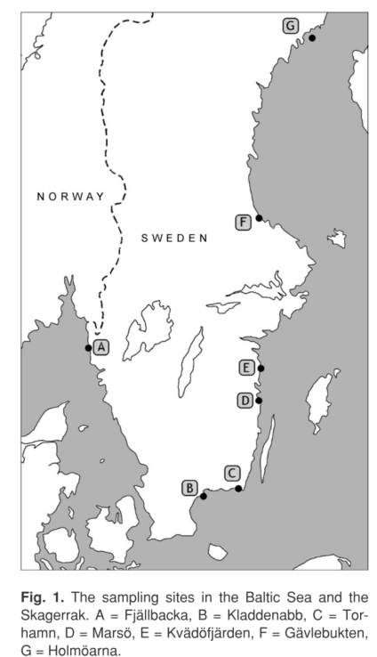(Vetemaa et al. 2006)

C:\Users\moll\Desktop\balt_ADAPT\WP1_CVA\Species PROFILES\Species Profiles\Literatur Arten\Zoarces viviparus_Aalmutter\Heessen et al. 2015 map.tif

|  |  |
| --- | --- |
| Sensitivity attributes | Information: Eelpout |
| Habitat specificity | * Sedentary species, inhabiting rocky shores under stones, among algae and in tide pools (Froese and Pauly 2021) * Habitat preferences: Stones and algae (Expert information) * Inhabiting both shallow and deep areas (Ojaveer et al. 2004) * Gulf of Riga: two ecological groups: cold deep water (below 20 m) and in the shallow coastal zone (1-2 m) (Baltic Sea) (Kreitsberg et al. 2012) |
| Prey specificity | * Differences according to different biotopes (eurytherm/cold stenotherm) * Benthic isopod crustaceans, amphipods (cold stenotherm), more diverse for the eurytherm biotope with invertebrates (mainly *Macoma balthica*), crustaceans and fish (herring, smelt, cyprinids) (Ojaveer et al. 2004) |
| Adult mobility | * Non-migrating, stationary (Baltic Sea) (Napierska and Podolska 2006; Pörtner et al. 2001) to limited migration (20-50 km) (Ojaveer et al. 2004) |
| Dispersal of early life stages | * Life bearing, no dispersal of eggs; embryos remain in the ovary 3-4 months after hatching from the egg membranes (citations in Vetemaa et al. 2006) * Young eelpouts are released in Jan-March (Southern Baltic Sea) (Napierska and Podolska 2006) |
| Early life stage survival & settlement requirements | * Internal fertilization takes place at the end of summer (June-August) (Southern Baltic Sea) (Napierska and Podolska 2006) * Development time: 2-3 weeks (Heessen et al. 2015) * After hatching inside the ovary, a 4–5-month development time follows, during which the larvae are dependent on the transfer of maternal nutrients (Vetemaa et al. 2006) * Young eelpouts are released in Jan-March (Southern Baltic Sea) (Napierska and Podolska 2006) |
| Complexity of reproductive strategy | * Viviparous (Ojaveer et al. 2004) * Internal fertilization takes place at the end of summer (Southern Baltic Sea) (Napierska and Podolska 2006) * Oocytes are fertilized immediately after ovulation in late summer, followed by 3 weeks of embryological development (Baltic Sea) (Vetemaa et al. 2006) * Maturation of eelpout from the southern Baltic begins and ends later in the year than does that of fish from the western European coast (e.g., North Sea) (Napierska and Podolska 2006) * Number of hatched embryos per female varies from less than 10 and more than 150, depending upon the size of the female (Napierska and Podolska 2006) * After hatching inside the ovary, a 4–5-month development time follows, during which the larvae are dependent on the transfer of maternal nutrients (Vetemaa et al. 2006) |
| Population Spawning Cycle | * Internal fertilization takes place at the end of summer (June-August) (Southern Baltic Sea) (Napierska and Podolska 2006) * April-May (North Sea) (Napierska and Podolska 2006) |
| Sensitivity to increasing temperature | * Distinct relationship between hot summer events and low abundance in following year (North Sea) (Pörtner et al. 2001) * “Sleeping in summer” when temperatures are too high (reduced metabolism) (Expert information) * Global warming would thus be likely to cause a shift in the distribution of this species to the North (Zakhartsev et al. 2003) * Optimal temperature: 3°C reflects winter period, 12°C for somatic growth (Zakhartsev et al. 2003) * Upper lethal temperature: 22-23°C (Zakhartsev et al. 2003) * Sub-critical temperature is about 13-15°C, above 18°C lower survival (Zakhartsev et al. 2003) |
| Sensitivity to decreasing salinity | * Euryhaline and thus tolerates the brackish water conditions of the Baltic Sea (Gercken et al. 2006) * Skagerrak population, which is the most saline environment, showed a much faster growth rate than the other Baltic Sea populations (slowest growth rate at lowest salinity levels GoF and GoB (Bergek et al. 2012) |
| Sensitivity to Ocean Acidification | * No data/information |
| Population growth rate | * ([www.fishbase.org](http://www.fishbase.org), (Froese and Pauly 2021)  |  |  | | --- | --- | | Maximum growth rate (rmax) | * Intrinsic population growth rate: 1.13 (Baltic Sea) (Bergek et al. 2012) | | Von Bertalanffy K | * 0.37-0.42 (Western Baltic Sea) | | Age at maturity (tm) | * Females: 1-2; males 1 (Baltic Sea) (citation in Bergek et al. 2012) | | Maximum age (tmax) | * 8 (Northern Baltic Sea) | | Natural mortality (M) | * No data/information | | Maximum length (Linf) | * 34.5 cm TL | |
| Sensitivity to other stressors | * Chemicals have been observed to increase ovarian atresia in fish species (Bergek et al. 2012), although it is not clear whether environmental pollution and toxic substances lead to increased atresia in the eelpout * Increasing concentration in contaminants (mercury, PCB) in eelpout, increase coincided with the introduction of an invasive deep-burrowing polychaetes, contributed the release of contaminants through bioturbation (Baltic Sea) (Hanson et al. 2020) * Impaired larval development was associated with the state of environmental pollution (Gercken et al. 2006) * Reproductive performance significantly reduced in female blenny exposed to petrochemical effluents, larval growth significantly lowered, and the proportion of females carrying dead juveniles was higher than at the reference site (North Sea) (Vetemaa et al. 1997) * mean number of dead juveniles per female was significantly higher in the effluent area (Vetemaa et al. 1997) * Well adapted to environmental short-term hypoxia, are able to survive under anoxic conditions for 1 h; ability to reduce activity and respiration at a very early phase of oxygen depletion and rests motionless on the bottom (Fischer et al. 1992) |

Bergek, S., Q. Ma, M. Vetemaa, F. Franzén, and M. Appelberg. 2012. From individuals to populations: Impacts of environmental pollution on natural eelpout populations. *Ecotoxicology and Environmental Safety* 79: 1-12.

Fischer, P., K. Rademacher, ad U. Kils. 1992. In situ investigations on the respiration and behaviour of the eelpout *Zoarces viviparus* under short-term hypoxia. *Marine Ecology Progress Series* 88: 181-184.

Froese, R., and D. Pauly. 2021. Editors. 2021. Fishbase. World Wide Web electronic publication. www.fishbase.org (06/10.2021).

Gercken, J., L. Förlin, and J. Andersson. 2006. Developmental disorders in larvae of eelpout (*Zoarces viviparus*) from German and Swedish Baltic coastal waters. *Marine Pollution Bulletin* 53: 497-507.

Hanson, N., Å. Larsson, J. Parkkonen, S. Faxneld, E. Nyberg, A. Bignert, H.E. Henning, A. Bryhn, J. Olsson, A.M.L. Karlson, and L. Förlin. 2020. Ecological changes as a plausible explanation for differences in uptake of contaminants between European perch and eelpout in a coastal area of the Baltic Sea. *Environmental Toxicology and Pharmacology* 80: 103455.

Heessen, H.J.L., N. Daan, and J. Ellis. 2015. *Fish atlas of the Celtic Sea, North Sea and Baltic Sea - Based on international research-vessel surveys*. Wageningen, Netherlands: Wageningen Academic Publishers.

Kreitsberg, R., A. Tuvikene, J. Baršienė, N.F. Fricke, A. Rybakovas, L. Andreikėnaitė, K. Rumvolt, and S. Vilbaste. 2012. Biomarkers of environmental contaminants in the coastal waters of Estonia (Baltic Sea): effects on eelpouts (*Zoarces viviparus*). *Journal of Environmental Monitoring* 14: 2298-2308.

Napierska, D., and M. Podolska. 2006. Field studies of eelpout (*Zoarces viviparus* L.) from Polish coastal waters (southern Baltic Sea). *Science of The Total Environment* 371: 144-155.

Ojaveer, H., M. Eero, and A. Lankov. 2004. Microevolution of eelpout, *Zoarces viviparus*, in the Baltic Sea. *Proc. Estonian Acad. Sci. Biol. Ecol.* 53: 292-305.

Pörtner, H.O., B. Berdal, R. Blust, O. Brix, A. Colosimo, B. De Wachter, A. Giuliani, T. Johansen, T. Fischer, R. Knust, G. Lannig, G. Naevdal, A. Nedenes, G. Nyhammer, F.J. Sartoris, I. Serendero, P. Sirabella, S. Thorkildsen, and M. Zakhartsev. 2001. Climate induced temperature effects on growth performance, fecundity and recruitment in marine fish: developing a hypothesis for cause and effect relationships in Atlantic cod (*Gadus morhua*) and common eelpout (*Zoarces viviparus*). *Continental Shelf Research* 21: 1975-1997.

Vetemaa, M., E. Neuman, G. Thoresson, and M. Pihlak. 2006. Trade-off between number and intraovarian growth rate of offspring in *Zoarces viviparus*. *Annales Zoologici Fennici* 43: 303-309.

Vetemaa, M., O. Sandström, and L. Förlin. 1997. Chemical industry effluent impacts on reproduction and biochemistry in a North Sea population of viviparous blenny (*Zoarces viviparus*). *Journal of Aquatic Ecosystem Stress and Recovery* 6: 33-41.

Zakhartsev, M.V., B. De Wachter, F.J. Sartoris, H.O. Pörtner, and R. Blust. 2003. Thermal physiology of the common eelpout (*Zoarces viviparus*). *Journal of comparative physiology. B, Biochemical, systemic, and environmental physiology* 173: 365-378.